Innovations and applications of 3D printing in food sector-A review

Akriti Taneja¹, Ruchi Sharma¹, Krishna Ayush¹, Anshu Sharma², Amin Mousavi Khaneghah³, Joe M.Regenstein⁴, Francisco J. Barba⁵, Yuthana Phimolsiripol⁶,* and Somesh Sharma¹,*

¹*School of Bioengineering and Food Technology, Shoolini University, Solan, Himachal Pradesh, India 173229
²Department of Food Science and Technology, Dr.Y.S.Parmar University of Horticulture and Forestry, Nauni, Solan HP, India, 173230
³State University of Campinas Faculty of Food Engineering, Campinas, São Paulo, Brazil
⁴Department of Food Science, Cornell University, Ithaca, New York, 14853-7201, USA
⁵ Department of Preventive Medicine and Public Health, Food Science, Toxicology and Forensic Medicine, Faculty of Pharmacy, Universitat de València, Avda. Vicent Andrés Estellés s/n, 46100 Burjassot, Spain
⁶Faculty of Agro-Industry, Chiang Mai University, Chiang Mai, 50100 Thailand

Abstract
Background: 3-D printing is a neoteric technology that can make existing food value chains client-desirable and sustainable by providing on-demand food production, enabling automated food personalization, and minimizing food wastage. However, its applicability is currently limited, and many researchers are investigating the technique' utility.
Scope and Research: This review paper provides a holistic outlook of the technology beginning with the various techniques utilized for 3-D printing and printers commercially available in the market. Substantial raw ingredients used for printing and the components which could be used soon are discussed. The pros and cons of this technology along with its potential applications and future perspectives of 3-D food printing are also evaluated. The aim of the review is to draw more attention to 3-D printing among researchers in order to improve the printing process and to provide some valuable knowledge for future research.
Key Findings and conclusion: Food printing has a huge impact on food processing
methods, allowing designers/users to change forms and materials with remarkable capability. It can address hunger issues in countries where affordable and fresh ingredients are inaccessible by integrating nutrient-rich substrates, probiotics, bioactive compounds, and functional ingredients into complex fabricated foods. More research is needed to identify alternative materials that could be manufactured using this process. Furthermore, dissemination of information and knowledge about the rise of 3-D printing in food should be well organized and corroborated by relevant and logical scientific findings that will improve consumers or users understanding and acceptance of the technology.
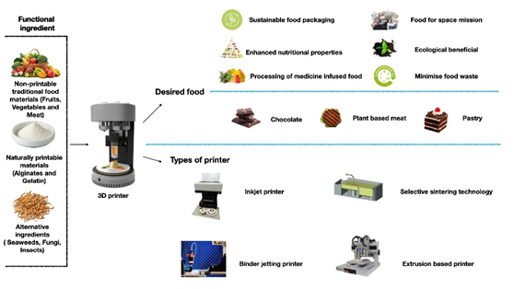
Recent Publications
- Varvara, R., Szabo, K., & Vodnar, D. (2021). 3D Food Printing: Principles of Obtaining Digitally-Designed Nourishment. Nutrients, 13(10), 3617. https://doi.org/10.3390/
- Escalante‐Aburto, A., Trujillo‐de Santiago, G., Álvarez, M., & Chuck‐Hernández, C. (2021). Advances and prospective applications of 3D food printing for health improvement and personalized nutrition. Comprehensive Reviews In Food Science And Food Safety, 20(6), 5722-5741. https://doi.org/10.1111/1541-4337.12849

- Carvajal-Mena, N., Tabilo-Munizaga, G., Pérez-Won, M., & Lemus-Mondaca, R. (2022). Valorization of salmon industry by-products: Evaluation of salmon skin gelatin as a biomaterial suitable for 3D food printing. LWT, 155, 112931. https://doi.org/10.1016/j.lwt.2021.112931

- Watkins, P., Logan, A., & Bhandari, B. (2022). Three-dimensional (3D) food printing—an overview. Food Engineering Innovations Across The Food Supply Chain, 261-276. https://doi.org/10.1016/b978-0-12-821292-9.00003-0

Biography
Akriti Taneja is a 3rd year Btech food technology student at Shoolini university, Solan, H.P, India. She is a highly pragmatic, methodological and hard working person who aim to bring revolution in food Industry through innovation and creativity. She is the executive member of Student outreach program under NSS (National Social Service)-Bapu Dham colony, Sec-26 Chandigarh, has an experience of organizing many cultural programs and food drive for the residents, as this colony is espoused by her school. She is the Class Representative of her batch and a volunteer at YOUWECAN, which is a non-profit organization established by Indian cricketer and cancer survivor Yuvraj Singh and its mission is to empower people to fight cancer through awareness, prevention, early detection, patient support and survivor empowerment.

