Management of tooth hypersensitivity using Diode laser and nano hydroxyapatite toothpaste
Mohamed Shamel PhD, The British University in Egypt, Egypt
Sara Elbanna PhD, MSA, Egypt

Abstract

Introduction

Dentin hypersensitivity is a very common problem that faces many patients and maintaining treatments with a long term effectiveness remains a challenge. Based on hydrodynamic theory, the main approach of overcoming DH are tubular occlusion. At home nano hydroxyapatite tooth pastes and in-office diode lasers are among the treatment options. Main aim of this study was to discover the efficacy of diode laser alone and in combination with a desensitizing toothpaste containing nano hydroxyapatite to evaluate dentinal tubular occlusion after acid challenge under scanning electron microscope

Material and methods

Forty dentin discs were divided into 4 groups; Group I control, Group II dentin disc treated with nHap tooth paste for one week, Group III discs treated with diode laser in non contact mode for 60 seconds, Group IV discs treated with nHap tooth paste for one week followed by laser application. SEM analysis was performed after acid challenge to the discs.

Results

Tubular occlusion was evident in all groups after acid challenge, however, Group IV, the laser and nano hydroxyapatite combination, showed the most occluded tubules which was the most resistant to the acid challenge.

Conclusions

Combination of diode laser and tooth paste containing nHap has a greater effect on occluding dentinal tubules rather than each treatment alone.
Image
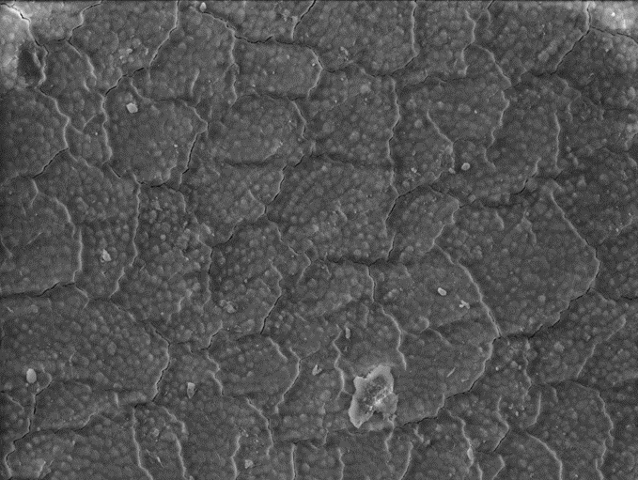

Figure 1: SEM image (2500×) of a dentin sample in group IV (Biorepair+ diode laser) the tubules of the irradiated dentin are not visible where some areas show deposition of some minerals from the toothpaste and multiple microcracks are seen.

Recent Publications
- MM Bakr, MM Al-Ankily, SM Shogaa, M Shamel (2021) Bioengineering 8 (12), 219
- SS El-Bahnasy, M Youakim, M Shamel, H El Sheikh (2021) Mandibular Canal Location and Cortical Bone Thickness in Males and Females of Different Age Groups: A Cone-beam Computed Tomography Study. Open Access Macedonian Journal of Medical Sciences 9 (A), 1117-1122
- M Shamel, D Riad, M Al Ankily (2021) Histological and Ultrastructural Study Of Silver Nanoparticles Toxicity and The Possible Protective Effect Of Vitamin C On Submandibular Salivary Glands Of Albino Rats. Int J Dentistry Oral Sci 8 (04), 2166-2171.
- M Al Ankily, F Makkeyah, MM Bakr, M Shamel (2020) Effect of different scaling methods and materials on the enamel surface topography: An in vitro SEM study. Journal of International Oral Health 12 (6), 579.
- B Ashraf, D Ghazy, M Shamel (2020) Effects of aflatoxin B1 on the submandibular salivary gland of albino rats and possible therapeutic potential of Rosmarinus officinalis: a light and electron. F1000Research 9 (752), 752.
- M Shamel, MM Al-Ankily, MM Bakr (2019) Influence of different types of whitening tooth pastes on the tooth color, enamel surface roughness and enamel morphology of human teeth. F1000Research 8.
- M Shamel, MM Al Ankily, MM Bakr (2017) Proliferative Capacity and Differentiation Potential of Isolated Postnatal Human Dental Pulp Stem Cells in Diabetic Patients. Stem Cells Regen Med 1 (3), 1-6.

Biography
Mohamed Shamel, associate professor of Oral Biology, has his expertise in studying different diseases affecting the oral cavity tissues. Corelating the research work with the clinical implications is a main focus in his studies. Research areas include stem cell and regenerative dentistry, preventive dentistry and salivary gland diseases.
Email: Mohamed.shamel@bue.edu.eg

Notes/Comments:

Presenting author details
Full name: Mohamed Shamel Elkady
Contact number: +201229332616
Linked In account:
Session name/ number:
Category: Oral presentation

