Evaluation of two CAD software on the adaptation of digitally constructed maxillary complete denture
Fardos N. Rizk, Eman G. Abd El Galil, Marwa E. Sabet
Department of Prosthodontics, Faculty of Dentistry, The British University in Egypt

Abstract (300 word limit)

Aims: This study was conducted to evaluate the adaptation of maxillary complete denture designed by two different open computer-aided design software programs (3Shape and Exocad) using Geomagic surface matching software. Settings and Design: This was a nonrandomized crossover clinical trial. Materials and Methods: Twenty completely edentulous patients were selected in this study. Forty complete dentures were designed using two different software programs: twenty dentures were designed by 3Shape software, and the other twenty dentures were designed by Exocad software. Maxillary dentures were evaluated regarding their adaptation by measuring the deviations that occurred between the fitting surface of the three-dimensional printed dentures, and the scanned master casts using Geomagic surface matching software. Statistical Analysis Used: An unpaired t-test was used for statistical analysis. Results: According to the positive average deviation value that represented pressure areas, 3Shape-designed maxillary dentures showed significantly lower mean deviation values (0.041115 ± 0.018165 mm) than Exocad‑designed maxillary dentures (0.500665 ± 0.032619 mm). Regarding the negative average deviation values that represented the gap areas, Exocad-designed maxillary dentures showed significantly lower mean deviation values (0.161555 ± 0.007842 mm) than 3Shape‑designed maxillary dentures(0.231350 ± 0.009146 mm). The results of the total average deviation values showed significantly lower mean deviation values (0.096950 ± 0.008868 mm) of 3Shape‑designed maxillary dentures than Exocad-designed maxillary dentures (0.250755 ± 0.021154 mm). Conclusion: 3Shape and Exocad software programs produced acceptable maxillary dentures regarding denture adaptation. However, maxillary dentures designed by 3 Shape software showed better adaptation than maxillary dentures designed by Exocad software.
Keywords: 3Shape software, computer‑aided design, denture adaptation, digital complete dentures, Exocad software, Geomagic software

Image
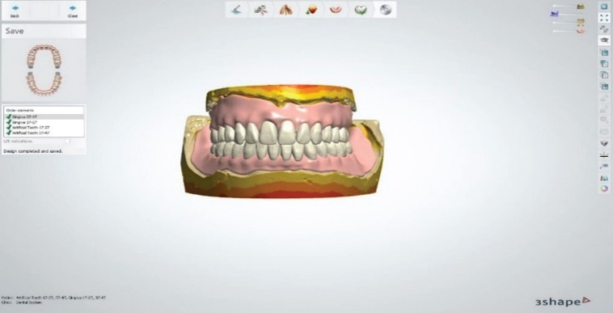
Figure 1: Final design of 3Shape dentures
Recent Publications (minimum 5)
- Snosi AM, Lotfy SM, Thabet YG, Sabet ME, Rizk FN. Subtractive versus additive indirect manufacturing techniques of digitally designed partial dentures. J Adv Prosthodont. 2021 Oct;13(5):327-332.
- Moussa A et al., Effect of using Polyether Ether Ketone versus Metal Mesh Reinforcement on Fracture Resistance of Maxillary Polymethyl Methacrylate Denture Bases. An In-Vitro study . British Journal of Medical and Health Research 2021.
- Eldahmy LS et.al (2021), The Effect of Different Scanning Protocols on the Retention of Digitally Constructed Complete
Denture Bases. Int J Dent & Ora Hea. 7:2.
- Amin, A.A., Fikry, G.F., Rizk, F.N., & Ismail, A.B. (2019). Comparative Study of Two Different Telescopic Crown Materials Retaining Lower Partial Overdenture. Indian Journal of Public Health Research & Development.
- FN Rizk ,S F El Shafei. Radiographic Bone Height Changes Surrounding Implants of Different Attachment Systems. Dentistry. Volume 10, Issue 4. 2020.
- Rizk F.N. and Taha E.R. Radiographic evaluation of marginal bone levels around platform-switched implants and non-platform-switched implants immediately loaded to support mandibular overdenture. E.D.J. Vol. 59, No. 2.
- Rizk F.N. Comparative evaluation of two different castable bar attachments in implant retained mandibular overdenture cases. E.D.J. Vol. 59, No. 3.
- Rizk F.N. and Abdelhaleam E.A. radiographic evaluation of accuracy of surgical stent for implant placement in knife edge posterior mandibular ridge in cases of ridge splitting. E.D.J. Vol. 60, No. 3.
- Rizk F.N. Effect of two different attachments on the supporting structures and masticatory capacity of implant retained mandibular overdenture. E.D.J. Vol. 60, No. 2.

Photograph

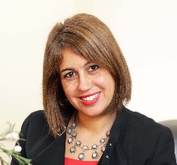
Biography (150 word limit)
Vice Dean for Teaching and Learning, Faculty of Dentistry, The British University in Egypt, 2019-present.
Program Director and Head of Prosthodontics Department at Faculty of Dentistry, British University in Egypt, 2012-present.
Professor of Prosthodontics at Faculty of Dentistry, British University in Egypt, 2017-present.
A. Professor of Prosthodontics at Faculty of Dentistry, British University in Egypt, 2012-2017.
Ph.D. Prosthodontics, Faculty of Dentistry, Ain Shams University 2007.
M.Sc. Prosthodontics, Crown and Bridge and Dental Materials, Faculty of Dentistry, Cairo University, 2000.
B.D.S, Oral and Dental Medicine, Faculty of Dentistry, Caro University 1994.
Email: fardos.rizk@bue.edu.eg

