Abstract for World Dermatology Conference – Paris 2022
Isabelle Hansenne-Cervantes, PhD, PharmD, Modern Meadow

Potential of a Recombinant 50 kDa Protein in Dermatology and in Cosmetics.

Abstract
Collagen and its derivative proteins have been widely used as a major compound for skin care products as a natural ingredient and moisturizer. Most commercially available collagens are animal-derived collagen type I and other forms of collagen, such as type III collagen, are far less prevalent in animals, making extraction and purification extremely difficult and expensive. We report the production of a 50 kDa protein produced in yeast that is 100% identical to the N-terminus of the human type III collagen. This recombinant protein has a larger molecular weight than most incumbent recombinant collagen proteins available for personal care applications. We have managed the industrialization of both the fermentation and purification processes to produce a final recombinant protein product. This final protein product was shown to be safe for application to human skin and compatible with common formulations. This recombinant collagen type III protein was also shown to uniquely stimulate both collagen type I and type III production and secretion by primary human dermal fibroblasts. The unique combination of biostimulation, compatibility with beauty product formulations and demonstrated commercial production, make this novel recombinant type III collagen a good candidate for broad application in dermatology and in cosmetics.

Image

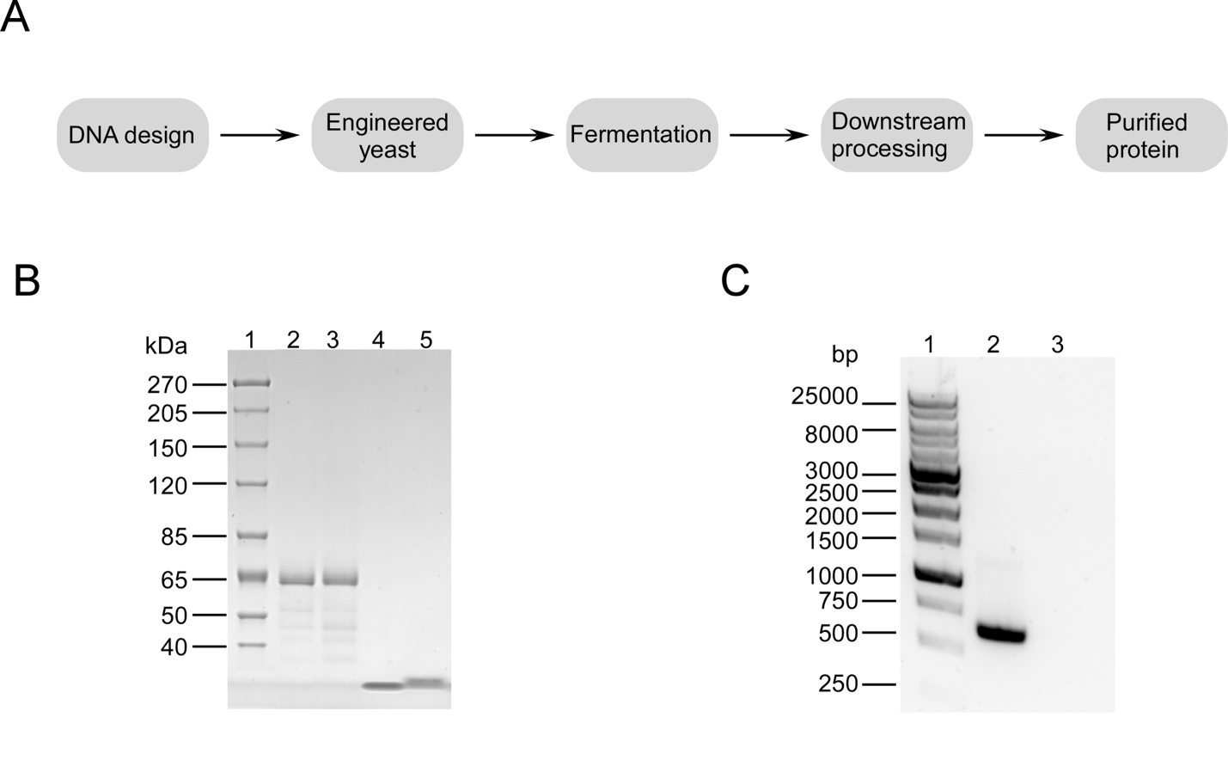

Figure 1. (A) Workflow to produce 50 kDa protein. (B) SDS PAGE analysis of 50 kDa protein and other commercially available collagen proteins

Biography of the author
Isabelle Hansenne-Cervantes , phD, Pharm D is a Global R&D Executive with extensive experience in Personal Care, Skin Care and Dermatology products. International Leader of Multiple Functions including Research Innovation, Product Development, Clinical and Safety Studies. She is passionate about bringing new innovative products to market and she is now working for Modern Meadow where she can leverage her biochemistry background and her experience from the cosmetic industry (L’ Oreal, Colgate & Coty).

Picture



