Crowdsourcing Cyber Security Experts to Determine Relevant Topics During Cyber Security Curriculum Development Efforts
Brian K. Ngac, C|CISO, CISSP
Parsons Corporation & George Mason University, USA

Abstract (300 word limit)

The cyber security environment, its threats, and its defense strategies are constantly changing. Educational programs and their curriculum are known to be slow changing and at times out-of-date, resulting in content that may not be as relevant to their students and the industry. This presentation will 1 – present an overview of the curriculum development process when using curriculum committees and their hindrance, 2 – describe the concept of crowdsourcing and its benefits when using domain experts, 3 – propose the Curriculum Development using Crowdsourcing Framework (CDC-F) to integrate expert crowdsourcing into parts of the curriculum development process (specifically the identification of industry-relevant topics and sub-topics for further curriculum content development), 4 – present the process and results of an experiment utilizing the CDC-F, and 5 – discuss how the Parsons Digital Engineering Framework (PDEF) can utilize the expert crowd’s inputs to optimize a relevant list of Topics and Subtopics for the curriculum development decision-makers.

While this particular experiment was a smaller effort consisting of around 30 domain experts over two rounds of crowdsourcing, it yielded many semi-structure and unstructured inputs that needed to be analyzed, aggregated, categorized, and decided on. Overall, it was found that including domain experts in the curriculum development process benefited the curriculum development effort in identifying more relevant domain topics – which were not initially identified by the curriculum owner. It was also determined that implementing the CDC-F through a more automated effort is necessary to scale the effort for efficiency purposes. This may be through using technologies like PDEF or Argupedia to better retrieve inputs, categorize and aggregate the inputs, as well as present visualizations for easier decision making.
Image
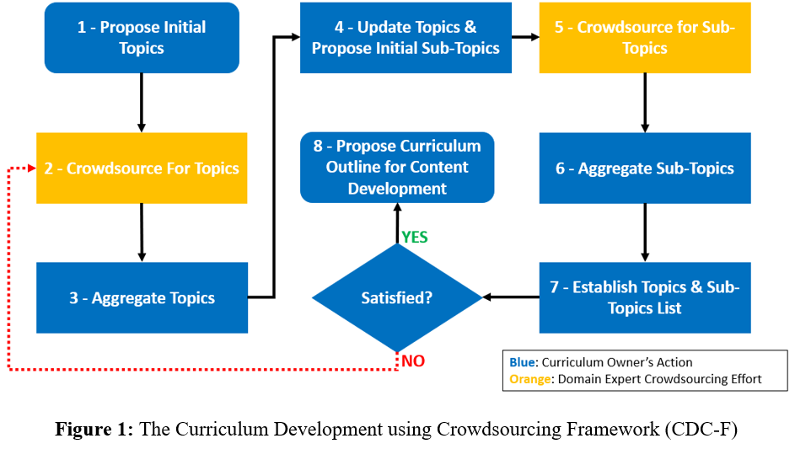
Recent Publications (minimum 5)
- Brian Ngac & Mihai Boicu (2022). Crowdsourcing Cyber Experts to Determine Relevant Topics During Cyber Curriculum Development Efforts. Innovations in Education & Teaching International. 59(2): DOI: 10.1080/14703297.2022.2063924
- Brian Ngac (2021). Virtual CISOs: Security Leader or Security Risk?. ISACA Journal. Volume 5: The Human Element of Security: 22-27.
- Brian Ngac (2021). Direct From the Practitioner: Crowdsourcing for Cybersecurity Curriculum. ISACA Journal. Volume 4: Do Algorithms Make the World Go Round?: 1-5.
- Brian Ngac (2020). From Intern To Cyber Professional – Building A Career At Parsons. Parsons Corporation.
- Brian Ngac (2020). Training The Next Generation Of Cyber Warriors. Parsons Corporation.
- Brian Ngac (2020). Cyber Professionals can be the Best Cyber Teachers. Information Systems Security Association Journal. 18(2): 30-33.





Biography (150 word limit)
Brian Ngac is Deputy to the Vice President of Digital Engineering Research & Development Programs at Parsons Corporation’s Defense & Intelligence Unit, and a PhD Candidate (ABD) at George Mason University’s College of Engineering & Computing. He holds 12 internationally recognized cyber security and management certifications including the C|CISO, CISSP, ISSMP, CISM, and PMP. His areas of expertise are in cyber security, digital engineering (RDT&E), and business process improvement (solving business challenges with technology solutions). His research focus are in cyber executive management, expert crowdsourcing, and decision analytics. The ultimate goal of Brian’s research endeavors is to publish rigorous papers that are impactful to the area of cyber security management so that his findings will be read, understood, shared, and practiced by cyber professionals, managers, executives, and leaders. He has also developed an experiential learning course for students to work on real projects with real clients prior to their graduation.
Email: bngac@gmu.edu

Notes/Comments:
I am responding to an email invitation to speak at the 9th International Conference on Big Data Analysis and Data Mining (from Suzane Jones). I will be submitting a recorded presentation if my abstract is accepted since I won’t be able to attend in person, and I’ve been corresponding with Suzane Jones to ensure the presentation is properly submitted.
Presenting author details
Full name: Brian K. Ngac
Contact number: 1-571-830-0633 (WhatsApp)
Mail id: bngac@gmu.edu
Category: Recorded Presentation

