A Smart Personalised Nutrition service as a determinant in modifying Gut Microbiota composition: protocol of nutritional intervention of the Stance4Health project
Fabio Lauria
Institute of Food Science National Research Council, Italy

Abstract
Our Gut Microbiota (GM) has recently been shown to play a role in the pathogenesis of “civilization diseases” such as obesity, cancer, cardiovascular disease, diabetes1,2 and immune disorders like coeliac disease3 and food allergy4. Evidence demonstrates that GM enhances the efficiency of energy harvest from foods and influences the synthesis, bioavailability, and function of nutrients. This activity produces different beneficial metabolites and microbial compounds such as short-chain fatty acids, polyphenol metabolites, neuroactive chemical species, acting as signaling molecules for metabolically active organs5,6. The close relationship between GM and diet-related diseases suggests focusing research attention on evaluating their interactions to improve our health by modulating our diet. The Stance4Health (S4H) project, using a nutritional intervention program, aims at evaluating the efficacy of a Smart Personalised Nutrition (SPN) service in modifying GM composition and metabolic function and improving consumer empowerment through technology adoption7. SPN will be delivered to consumers through the nutritional software mobile app i-Diet Stance4Health, a wearable band capable to measure daily activity, and the tailored production and delivery of foods for individuals or specific groups of population (Figure 1). The nutritional intervention will include the implementation of a multicentre, parallel group randomised controlled trial. A statistical model was developed to predict nutrients that must be incorporated into the diet of participants to transform their gut microbiota back into a healthy state, close to that of normal weight subjects. Based on the statistical model, the nutritional software mobile app i-Diet Stance4Health will suggest food choices in retailers and give participants specific advice about nutrition and lifestyle (taking or not into account GM composition). The app will generate personalised diets based on Mediterranean dietary patterns and participants’ health status, objectives, and habits (desired daily intakes, dishes that make up these intakes).


Biography
He is a researcher of the Epidemiology and Population Genetic Unit. He has expertise in molecular biology and nutritional epidemiology. His activity is focused on the understanding of the multifactorial causes of
nutrition-related diseases, the discovery of new
biomarkers to study the association between diet and health and the dissemination of results. The experimental approach of the Epidemiology and Population Genetic Unit in the epidemiological and nutritional field is based on the assessment of genetic, nutritional and metabolic risk factors for nutrition related diseases.

The eligible participants will be randomly assigned to a 12-weeks intervention with two different levels of personalised nutrition. The entry-level intervention will consist of the use of the “i-Diet Stance4Health” app and the analysis of gut microbiota and metabolites. The advanced level intervention will comprise activities of the entry-level plus the use of a wearable band, and the intake of tannins extracts in pills (adults treated groups), fortified foods (children treated groups) or placebo (control groups).
In detail, 200 Spanish and German adults will follow the entry- level intervention and 200 will follow the advanced level intervention equally divided into control and treated groups. The same criteria will be used for 400 Greek children equally divided into four groups.

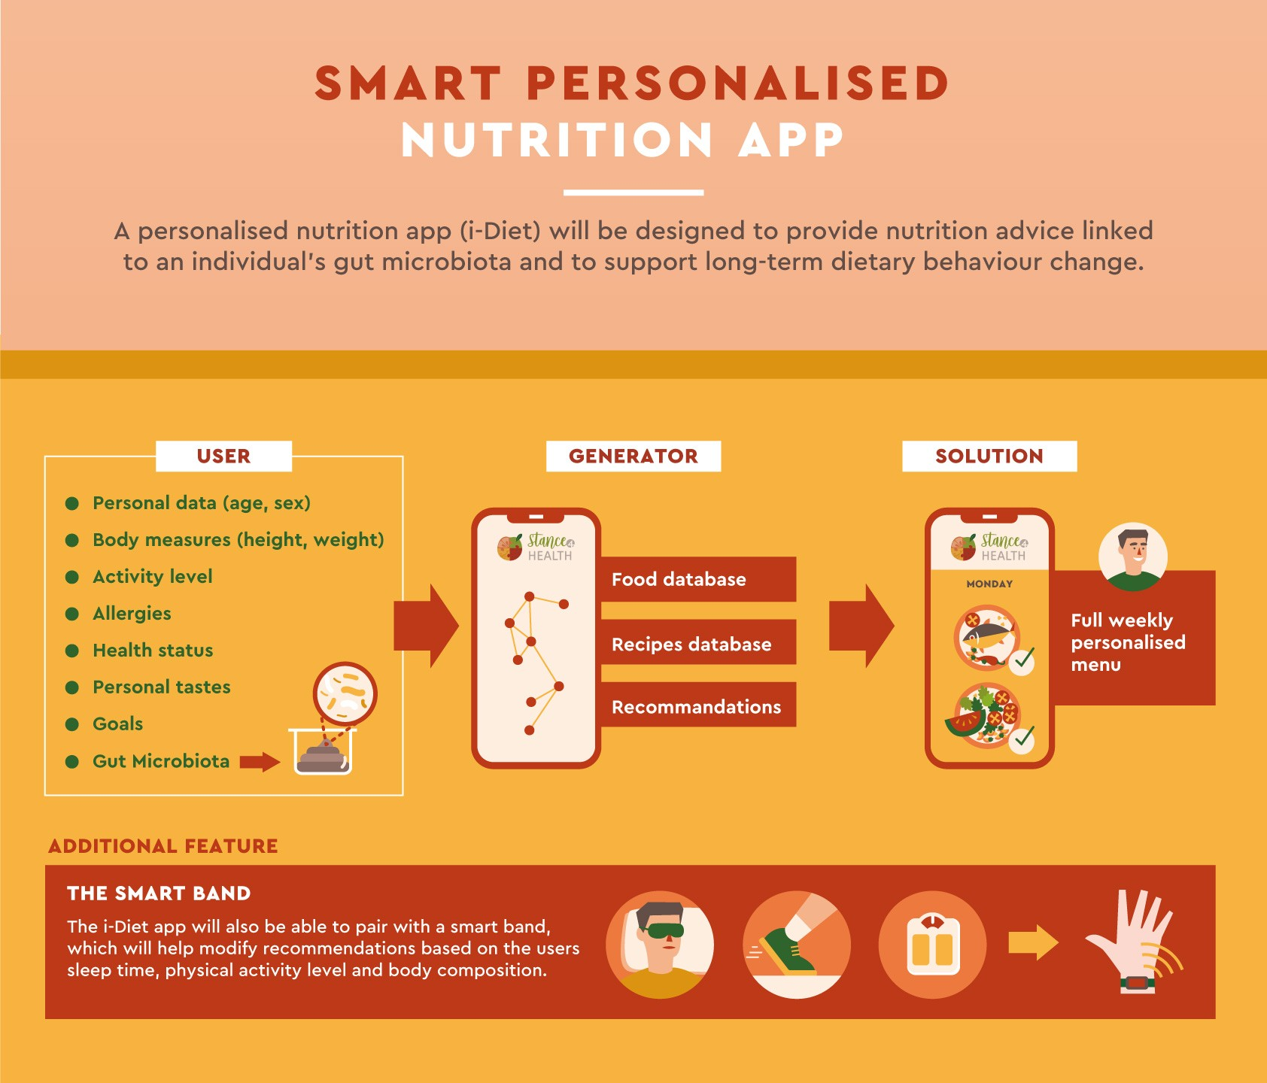
Figure 1

The results of the trial will be important to understand if the SNP service proposed by the S4H project will be capable of ameliorating the intestinal microbiota and empowering consumers to allow them to make healthy and sustainable dietary choices. The SPN will be provided to consumers through different tools like the nutritional mobile app i-Diet Stance4Health, wearable bands to measure daily activity, and the production and delivery of food supplements and fortified foods for individuals or specific groups of the population.

Importance of Research

The novelty of Stance4Health, compared with the current state- of-the-art, is established on three pillars: i) a novel and comprehensive approach/concept to study the diet-gut microbiota interaction, taking into account cooking processes;
ii) a revolutionary new nutritional software (i-Diet Stance4Health) well beyond those existing in the market, integrating diet and gut microbiota metabolic networks to deliver proper counselling about food choice in the shop, cooking and integration within a long-lasting healthy, pleasurable and sustainable diet; iii) a new complete smart personalised nutrition service based on a mobile app interacting with a wearable to follow changes in body composition, an in vitro diagnostic tool to follow changes in gut microbiota activity and the customised production of cereal-derived products for targeted groups such as overweight people and children with gluten-related disorders or allergy/intolerance to cow’s milk.


About Hospital
The Institute is hosted in a modern eight floors building of about 10,000 square meters. Common technological facilities, a well-equipped animal facility house and a parking area are located in the building basement levels.

The Institute holds a unique position within the National Research Council. In fact, it was established in 1994 to meet the need for a research center in which physicians, biochemists, food technologists and other different trained scientists could synergistically collaborate to understand how to improve human health through innovative nutritional approaches. The research activities of CNR-ISA are focused on the study of food quality and safety, as well as the relationship between food composition and health. They are described in details under the “Research activities” page. In addition, technology transfer is a particularly relevant activity in the mission of CNR-ISA. Many research activities of the Institute are well integrated with the productive activities
of local and national SMEs operating in the agro-food sector. In this respect, relevant scientific achievements have been reached by the ISA scientists as testified by the number of national and international patents and/or industrial collaborations. For instance, novel food for celiac patients produced by an enzymatic detoxification process has been developed by ISA-CNR scientists. Similarly, an international patent focused on the rapid mycotoxins and antibiotics detection in milk and dairy products has been filled in collaboration with a national leader industry operating in the milk sector. The design and development of new optical bio/sensors for food safety and quality is a new research line established at the Institute as a consequence of the moving to CNR-ISA of the Laboratory for Molecular Sensing. The research activities performed at CNR-ISA are mainly funded by competitive national and international grants as well as by contracts of collaborations with food industries. These performances have attracted a high number of students and junior researchers trained at different levels of their academic and/or scientific career.

References
- Rabassa, M.; Zamora-Ros, R.; Urpi-Sarda, M.; Bandinelli, S.; Ferrucci, L.; Andres-Lacueva, C.; Cherubini, A. Association of habitual dietary resveratrol exposure with the development of frailty in older age: The Invecchiare in Chianti study. Am. J. Clin. Nutr. 2015, 102, 1534–1542.
- Hills, R.D., Jr.; Pontefract, B.A.; Mishcon, H.R.; Black, C.A.; Sutton, S.C.; Theberge, C.R. Gut Microbiome: Profound Implications for Diet and Disease. Nutrients 2019, 11, 1613
- Pecora, F.; Persico, F.; Gismondi, P.; Fornaroli, F.; Iuliano, S.; De’Angelis, G.L.; Esposito, S. Gut Microbiota in Celiac Disease: Is There Any Role for Probiotics? Front. Immunol. 2020, 11, 957.
- Zhao, W.; Ho, H.-E.; Bunyavanich, S. The gut microbiome in food allergy. Ann. Allergy Asthma Immunol. 2019, 122, 276–282.
- Heiss, C.N.; Olofsson, L.E. Gut Microbiota-Dependent Modulation of Energy Metabolism. J. Innate Immun. 2018, 10, 163–171.
- Torres-Fuentes, C.; Schellekens, H.; Dinan, T.G.; Cryan, J.F. The microbiota–gut–brain axis in obesity. Lancet Gastroenterol. Hepatol. 2017, 2, 747–756.
- Dello Russo, M.; Russo, P.; Rufián-Henares, J.Á.; Hinojosa-Nogueira, D.; Pérez-Burillo, et al. (2022) The Stance4Health Project: Evaluating a Smart Personalised Nutrition Service for Gut Microbiota Modulation in Normal- and Overweight Adults and Children with Obesity, Gluten-Related Disorders or Allergy/Intolerance to Cow’s Milk. Foods, 11, 1480.

