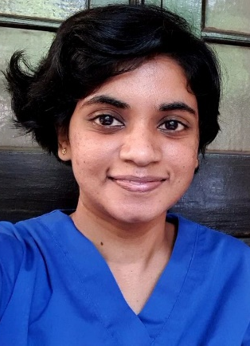

Title - A Case Report of Severe Ovarian Hyperstimulation Syndrome
Name – Dr. Punhiru Udeshika
Registrar in Emergency Medicine. Post Graduate Institute of Medicine, University of Colombo, Sri Lanka.
Ovarian hyperstimulation syndrome (OHSS) is a gynaecological emergency which occurs when the ovaries are hyper stimulated and enlarged most commonly due to fertility treatments or sometimes rarely due to mutations in the follicle stimulating hormone (FSH) receptor. Vasoactive substances released by the ovary thought to be responsible for increased vascular permeability associated with OHSS though exact pathology is not fully understood. 26-year-old lady who was primary sub fertile for 3 years and underwent inutero insemination (IUI) one week prior to the onset of symptoms was admitted with severe abdominal pain and increasing difficulty in breathing for 05 days. On admission she had gross ascites and bilateral moderate pleural effusions with haematocrit of 45.9. Clinical suspicion of OHSS was made. There was neutrophil leucocytosis, mild hyponatremia, mild elevated liver enzymes, hypoalbuminemia, normal clotting and normal serum osmolality. She was managed with oral cabergoline 0.5 mg daily, daily dose of steroids, fluid management to maintain urine output of 0.5-1 mL/kg/hr, prophylactic anticoagulants and abdominal paracentesis for symptomatic relief, supplementary oxygen, coupled with intensive care monitoring. Later in the course she was found to have intra uterine pregnancy (IUP) and OHSS regressed with clinical improvement and normalization of laboratory parameters. She made a full recovery and discharged on day 11 of admission after antenatal clinic registration. This case demonstrated that early diagnosis and intensive supportive care which include steroids and oral inhibitors of vascular endothelial growth factor phosphorylation, effective fluid management and symptomatic abdominal paracentesis are important in successful management of severe OHSS.
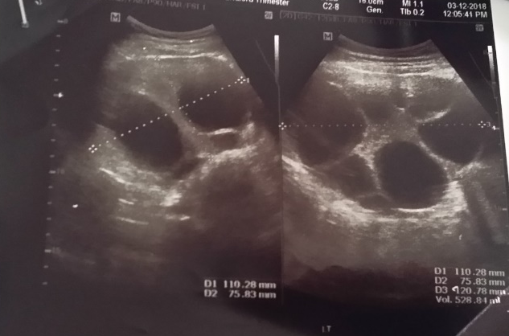
Figure 01: Enlarged Right Ovary (volume 500 mL) with multiple ovarian cysts on Abdominal Ultrasound Scan

Biography
Dr. Punhiru Udeshika earned her primary medical degree – MBBS – from the University of Ruhuna – Sri Lanka and currently working as a registrar in Emergency Medicine in Accident Service Unit of National Hospital of Sri Lanka. She is completing her MD in Emergency Medicine in October 2020.
Presenting author details
Full name: Punhiru Udeshika
Contact number: +94767683691
Twitter account: @PunhiruUdeshika
Linked In account: Punhiru Udeshika
Session name/ number:
Category: (Oral presentation/ Poster presentation) ; Poster presentation

