Synthesis, Electronic Structure of New tetranuclear cyclopalladated bearing thiosemicarbazone scaffold ligand: DNA/ Serum Protein Binding, COVID-19 and molecular modeling studies
Zohreh Mehri Lighvan, PhD, Department of Polymer Processing, Iran Polymer and Petrochemical Institute, Iran.
Rouhollah Daei, PhD, Department of Qom, Iran.

Abstract
The COVID-19 epidemic has caused in a global health emergency and has spread to 213 countries and is uncontrollable so far. The RNA-dependent RNA polymerase (RdRp, also named nsp12) is the central component of coronaviral replication/transcription machinery and appears to be a primary target for the antiviral drug, remdesivir. It has been reported that TSCs possess antiviral as well as anti-HIV properties. Thiosemicarbazones (TSCs) scaffold as ligands, are an important class of bioactive compounds with a wide range of properties ranging from their use as anticancer agents to antiviral, antimalarial, and antiparasitic agents. As part of our on-going research, novel thiosemicarbazone scaffold ligand [4-OMeC₆H₄CHN=NC(S)NHPh] and organometallic tetranuclear cyclopalladated complex [Pd(4-OMeC₆H₄CHN=NC(S)NHPh)_{4]} have been synthesized, fully characterized by elemental analysis, 2D NMR, HRMS and IR spectroscopic techniques and their biological activities such as antitumor activity, DNA–protein interactions have been investigated. The interaction of the compounds with calf thymus DNA (CT-DNA) has been explored by UV-Vis spectroscopy, emission titration and helix melting methods, which have revealed these compounds interact with DNA through threading intercalators mode. Competitive studies with methylene blue (MB) have shown the ability of the compounds to displace the DNA-bound MB, suggesting a competition with MB. Furthermore, the microenvironment and the secondary structure of BSA are changed in the presence of the compounds. Competitive binding using Warfarin, Digoxin and Ibuprofen site markers, which have definite binding sites, demonstrated that the compounds bind to site I on BSA. Notably, the compounds exhibit significant in vitro selective cytotoxicity against two human cancer cell lines (JURKAT and SKOV3) with IC50 values varying from 2.4 to 4.7 μM, this indicates that they are more active than cisplatin and showing low cytotoxic activity on normal cells. Finally, the molecular modelling studies have been conducted to determine the binding site of the DNA, BSA and coronavirus interactions with the compounds.

Image
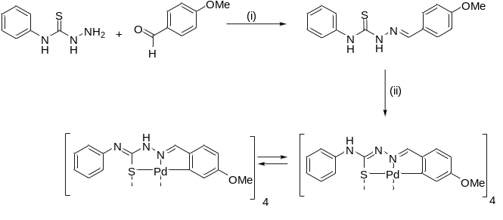

Scheme 1. Synthesis of thiosemicarbazone ligand and tetranuclear cyclopalladated complex. Reaction conditions: (i) MeOH, 25 °C, 24 h; (ii) K₂[PtCl₄], EtOH-H₂O, 40 °C, 4 days

Recent Publications
- A. G. Quiroga, J. M. Pérez, E. I. Montero, J. R. Masaguer, C. Alonso and C. Navarro-Ranninger, J. Inorg. Biochem., 1998, 70, 117–123.
- L. Zhang and R. Zhou, .2020. DOI: 10.1021/acs.jpcb.0c04198
- T. R. Bal, B. Anand, P. Yogeeswari and D. Sriram, Bioorg. Med. Chem. Lett., 2005, 15, 4451–4455.
- Z. M. Lighvan, H. A. Khonakdar, A. Heydari, M. Rafiee, M. D. Jahromi, A. Derakhshani and A. A. Momtazi‐Borojeni, Appl. Organomet. Chem., 2020, e5839.
- K. Karami, M. Rafiee, Z. M. Lighvan, M. Zakariazadeh, A. Y. Faal, S.-A. Esmaeili and A. A. Momtazi-Borojeni, J. Mol. Struct., 2018, 1154, 480–495.
- E. J. Siddiqui, I. Azad, A. R. Khan and T. Khan, J. Drug Deliv. Ther., 2019, 9, 689–703.
- P. Genova, T. Varadinova, A. I. Matesanz, D. Marinova and P. Souza, Toxicol. Appl. Pharmacol., 2004, 197, 107–112.
- S. A. Khan and M. Yusuf, Eur. J. Med. Chem., 2009, 44, 2270–2274.

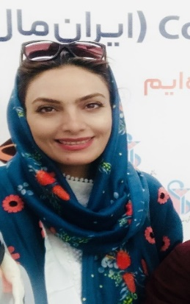
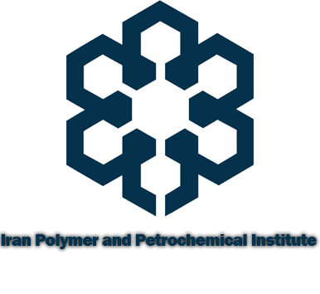

Zohreh Mehri Lighvan has her expertise in synthesis on organometallic palladium amine metallacycles and cluster oxime palladium complexes and their biological evaluation and nano-drug delivery. She has been researching and studying the synthesis of organometallic compounds and the biological study of these compounds in the treatment of breast and gastric cancers for more than 10 years. During the Corona Pandemic, she began research into organometallic compounds and the efficacy of thiosemicarbazones (TSCs) ligands against the Corona virus.
Email: z.mehri@ippi.ac.ir

Notes/Comments:

Presenting author details
Full name: Zohreh Mehri Lighvan
Contact number: 00989126520249
Twitter account:
Linked In account: Zohreh Mehri Lighvan
Session name/ number:
Category: (Oral presentation/ Poster presentation): Oral presentation

