
https://doi.org/10.1007/s00289-022-04221-2
ORIGINAL PAPER

Highly sensitive, stretchable, piezoresistive auxetic sensor based on graphite powders sandwiched between silicon rubber layers

Bahman Taherkhani¹ · Javad Kadkhodapour¹ · Ali Pourkamali Anaraki¹

Received: 23 October 2021 / Revised: 18 March 2022 / Accepted: 30 March 2022
© The Author(s), under exclusive licence to Springer-Verlag GmbH Germany, part of Springer Nature 2022

Abstract
As a measuring device, an auxetic piezo-resistant sensor must have the character- istics of the measuring equipment. One of these features is to have the correct and same answer in different strains and directions (same answer in different condi- tions). This issue should be considered in the case of auxetic piezo-resistant sen- sors because of having different Poisson’s ratios at different strains and also being generally anisotropic. In this paper, the problem of instability of Poisson’s ratio during the strain for auxetic structures was investigated and showed that the sens- ing performance of re-entrant auxetic piezo-resistant sensors is nonlinear due to the nonlinearity of Poisson’s ratio over a broad range of stain values. To investigate this issue, highly sensitive, stretchable, piezoresistive sensors based on graphite powders sandwiched between silicon rubber layers were prepared using a re-entrant auxetic structure. The sensing performance of the auxetic sensors was identified and com- pared with previous sensors. The presented sensor showed piezoresistive enhance- ment under tension loading, with improvement up to 176 and 380% (in terms of gauge factor) in comparison with previous mix auxetic and conventional composite sandwich sensors, respectively. Furthermore, we proposed an auxetic structure that has a constant Poisson’s ratio over a broad range of strains. Using this auxetic struc- ture made it possible to design an auxetic sensor with linear sensitivity over a broad spectrum of strain values. The auxetic sensor with a constant value of Poisson’s ratio has stable sensitivity changes at different strains. It means that the sensor sensitivity has a fixed slope. In the next works, we intend to use isotropic auxetic structures to make piezo-resistant auxetic sensors.
Keywords Auxetic sensor · Strain value · Gauge factor · Constant Poisson’s ratio · Sensitivity

 Bahman Taherkhani bahman.taherkhani@sru.ac.ir
1 Department of Mechanical Engineering, Shahid Rajaee Teacher Training University, Tehran, Iran

Introduction

Highly sensitive, pliable, stretchable porous strain sensors are applicable in a large number of areas which include electronic skins, footwear, soft robotics, transporta- tion, and so on [1]. Several mechanisms of sense have been identified during the last decades for applications of strain sensing that can be generally categorized as capacitive [2, 3], transistor [4], piezoelectric [5, 6], and piezoresistive [7–13]. The materials used for sensor design have a great effect on the thermal, electrical, and mechanical properties of the sensors [1]. One of the restrictions of conventional sen- sors is their incapability to retain conformal tangency between the sensor and the body parts. This is due to that human skin expands biaxially under bending, mus- cle tension, and exhalation, it has a negative Poisson’s ratio depending on the body parts, while Poisson’s ratio of elastomer films and polymer elastomers is positive (typically 0.6) [14]. Piezoresistive sensors which rely on auxetic structure as the sensing element can address this problem [1, 14–17]. Newly, flexible piezoresistive auxetic sensors have been studied by the researchers which have higher sensitivity and gauge factor in comparison with their conventional counterparts. There are dif- ferent conductive elements for these types of sensors such as conductive polymers [11, 18], carbonaceous nanomaterials, and nanoparticles [19–23]. The methods for manufacturing conductive auxetic sensors are dip coating, foaming, chemical reduc- tion, chemical vapor deposition (CVD), and so forth [24–31].
Auxetic materials are a group of metamaterials that have a negative Poisson’s ratio and have some improved mechanical properties including; penetration resist- ance, fracture toughness, shear modulus, vibration, acoustic, and deformation behav- ior [32–45]. Recently, the application of auxetic structures in the sensor field has been interested in many researchers [1, 14–17]. According to [17], the auxetic sen- sor with a Poisson’s ratio of −0.5 shows 500 and 300% improvement in gauge factor and piezoresistive sensitivity, respectively [17]. However, it is noticeable that the auxetic sensors depend on their materials and geometries have good performance until the specific strain called shifting strain [15] in which the auxetic sensors have negative Poisson’s ratio until the shifting strain and after that have positive Poisson’s ratio and their performance will be similar to conventional sensors.
Kim et al. [14] achieved an auxetic hygroscopic sensor which solves synchro- nously the important issues for utilizing in everyday life, for example; frequent use by simple handling, use for a long time, and stable performance in different environments. Ahmed et al. [1] presented silver nanowire (AgNW) based flexi- ble, stretchable, and compressible piezoresistive sensors by implementing auxetic porous substrates. The piezoresistive performance of the auxetic foam sensor in comparison with the conventional counterpart was elevated under both compres- sion and tension loading up to 165 and 290% (in terms of gauge factor), respec- tively. Jiang et al. [16] illustrated that the sensitivity performance of the auxetic sensor is largely increased with a 24-fold enhancement. The sensitivity improve- ment is because of the synergistic effect of structural negative Poisson’s ratio and strain concentration. Moreover, microcracks are stretched out as a basic mecha- nism, validated experimentally and numerically.

The use of auxetic structures in the field of piezo-resistant sensors improves the sensing performance of these sensors. This article tries to discuss about the mechanical behavior of auxetic structures used in the field of sensors and introduce the auxetic structures that are more appropriate for this area. So, the application of the produced sensors is similar to previous sensors like human body monitoring, earthquake identification, vibration, and so on. In this work, a composite auxetic sensor was proposed which has high-sensitivity performance and its deformation behavior was investigated and connected to its sensing performance. The sensing performance of the presented sensor was compared with previous sensors. To use another generation of sensors, we need to know the behavior of auxetic structures well so that we can use auxetic structures correctly and accurately in this field. It is important to design an auxetic structure that can maintain its auxetic properties over a wide range of strains, but it is noteworthy that the Poisson’s ratio of the struc- ture increases with increasing strain, indicating that the sensing performance of the auxetic sensor will also change nonlinearly. This issue has not been investigated in previous works which presented auxetic sensor. We showed that changing the value of Poisson’s ratio at different strain levels will change the sensitivity of the sensor at different strains with different slopes. We proposed an auxetic structure with con- stant Poisson’s ratio over a broad range of strains which will be useful to remove this problem and design auxetic sensors with linear sensitivity.

Experiment

Material property

Five dog bone composite structures were manufactured according to the ASTM D412-06a standard for identifying the mechanical properties of the sensor parent material. The sandwiched composite structure is comprised of two layers of sili- con rubber and one layer of graphite powders. Zwick/Roell z100 universal testing machine with a displacement rate of 5 mm/min, a 5 KN load cell, and a capacity of 100KN was utilized for tensile loading test. To manufacture dog bone and sensor die, polylactic acid (PLA) filament was implemented with a thickness of 2 mm by using the FDM 3D printing technique. BISIL 4514, room temperature vulcanized silicone rubber (RTV2), the base polymer was mixed with its hardener with a ratio of 20:1 as the polymer matrix. The graphite powders with a thickness of 1 mm sup- plied by Shenzhen Xiangu High-Tech Co. (china) were utilized as a conductive ele- ment in piezoresistive composites. Figure 1 shows (a) dimensions of the test sample and the die used to create test samples, (b) test specimens, (c) experimental setup, and (d) stress–strain diagram of the parent material of the auxetic sensor.

Sensor preparation

To obtain a composite piezoresistive auxetic sensor, two layers of silicone rub- ber as the base material and one layer made of graphite powder as the sensing

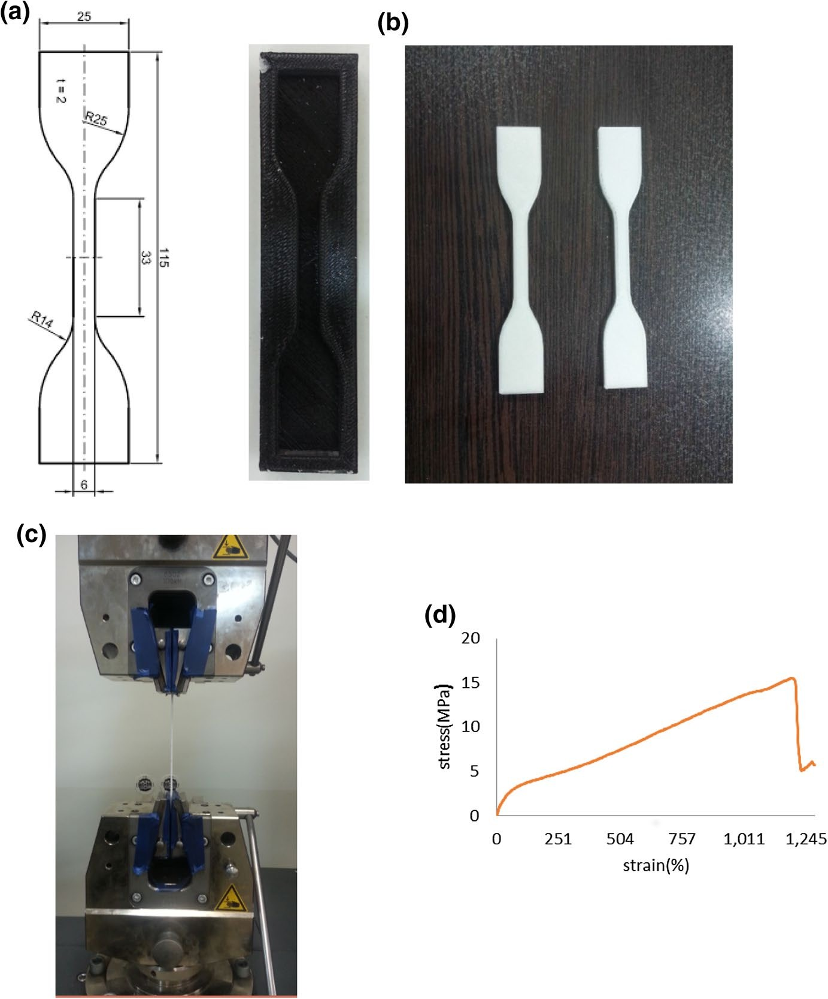

Fig. 1 a Dimensions of the test sample according to the ASTM D412-06a standard and the die manufac- tured by 3D printing technique and used to create test samples, b test specimens, c experimental setup for the tensile test of produced dog bones by using Zwick/Roell z100 universal testing machine, and d stress–strain diagram of the parent material of the auxetic sensor

layer, each 2 mm thick, were provided. To obtain layers, a die was designed by Solidworks 2014 software and printed by 3D printing technique according to Table 1. To obtain the layers of the substrate material, a combination of silicone rubber R2V2 with a hardening material with a ratio of 20: 1 was used, which was placed inside the mold for 2 h in the open space, and then peeled off from the mold. To obtain a conductive layer, graphite powder is made as a conductive paste with silicone glue and molded using the designed mold and placed in the

Table 1 3D printing technique setup

Parameters Values

Nozzle diameter 0.5 mm
Primary layers height 0.2 mm
Percentage of internal filling 100
Outline overlap 99%
Nozzle temperature 240 °C
Bed temperature 60 °C
Default print speed 240 mm/min

open air for 24 h to dry the glue completely. To obtain the sandwich structure, a sensing layer is placed between two silicone layers, and a connection is made with silicone glue. Jaws of Zwick machine insulated with plastic glue. To save electrical resistance variation of the auxetic sensor, the Victor 86C digital mul- timeter that can connect to a computer was implemented. Simultaneously, the data was recorded by implementing Hand DMM Data software. Figure 2 shows a schematic view of preparing the sandwich composite auxetic sensor. Table 2 shows specification of PLA in 3D printing.
In this paper, the in-plane mechanical properties and deformation behavior of auxetic structures are investigated and the thickness of the structure does not have effect. It is noticeable that if the thickness of the structure is small, it will buckle during the pressure test. To solve this problem, in reference [43], we have provided a glass frame to prevent buckling of the structure under pressure. On the other hand, if the thickness of the structure is large, then the printing time of the structure die will be high. So, the thickness of the structure is usually considered between 2 and 3 mm. The thickness of the structure is considered as 2 mm for tensile loading.
The strength of the middle layer, which is composed of a mixture of silicon and graphite powder, is very weak and the graphite particles separate with the slightest pressure. To increase the strength of the overall structure, the auxetic sensor was made as composite structure and three layers were tightly bonded together with silicone adhesive.

Simulation procedure

Finite element analysis of the auxetic composite structure was done by commercial ABAQUS2017 software. Figure 3a shows boundary conditions, Fig. 3b mesh of the structure, and Fig. 3c magnified view of the mesh of the structure. Marlow criterion was utilized to import experimental data to the software and static general step was used to analyze. To apply uniform strain equal to 12%, one side of the structure was fixed and a displacement of 6.6 mm according to Fig. 3a was applied to the opposite side. The number of mesh was 186,000 of type S4R.

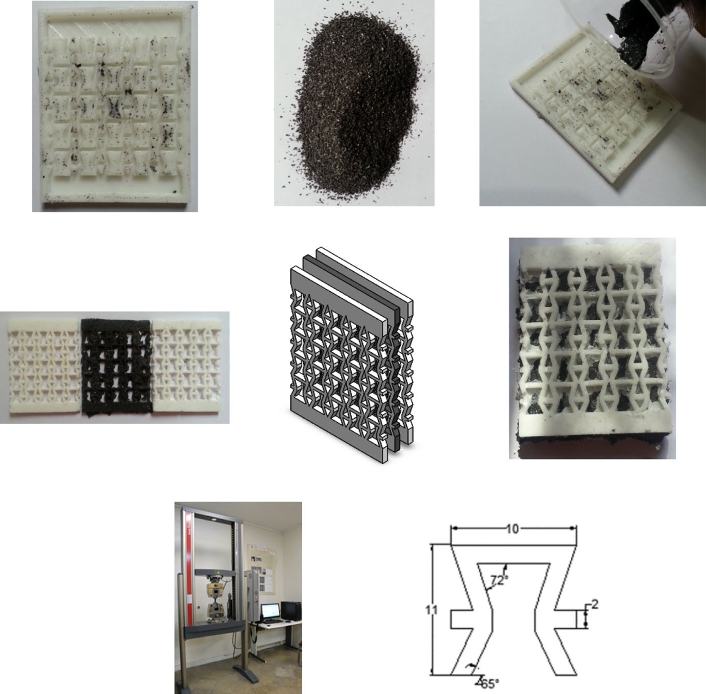
Layers die
Graphite powders
Molding method
Substrates and sensing layers
Arrange the layers
Sandwiched composite sensor
Test setup Unite cell dimensions

Fig. 2 Auxetic sandwich piezoresistive sensor preparation. To make an auxetic sandwich sensor, its mold was designed using SolidWorks 2014 software and manufactured by 3D printing method. Then three separate layers consisting of two layers of RTV2 silicon and one layer of a mixture of silicon and graph- ite powder were made and the three layers were sandwiched together. This connection was made using silicone adhesive. The jaws of machine were insulated by using plastic glue. The test method and cell dimensions of the auxetic sensor unit cell are shown

Table 2 Specification of PLA in 3D printing

Specification Value

Tensile strength 61.5 MPa
Heat resistance 110 ºC
Extruded temperature 160–220 °C
Impact strength 30.8 (kJ/m2)
Elongation at break 6%
Density 1.25 g/cm3

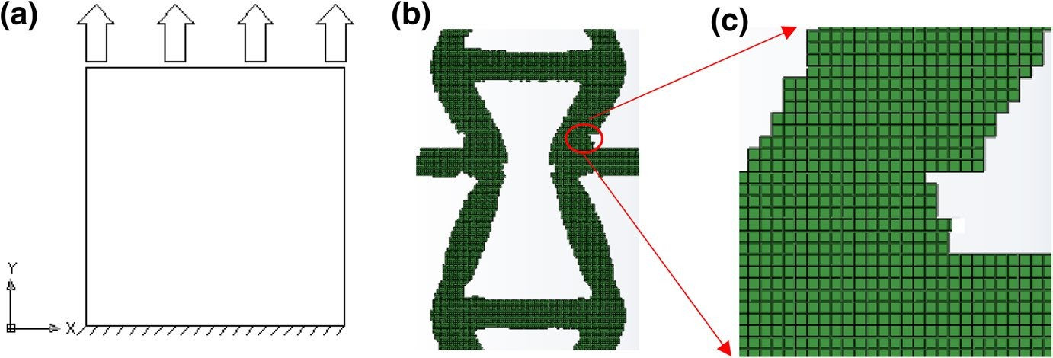

Fig. 3 a Boundary conditions for simulation in which one side was completely fixed and another side was displaced, b mesh of auxetic structure which has 186,000 S4R meshes, and c magnified view of mesh structure

Results and discussion

Auxetic sensor performance

In this work, a high-sensitivity sandwiched composite auxetic sensor was pre- sented. Figures 4 and 5 show the time-sensitivity graphs of the sensor for strains 1–6% and 7–12%, respectively. Figure 6 shows the sensitivity of the sensor for the strains of 1–12 in one figure. The sensing performance of the proposed sensor has been compared with those of the mixed auxetic sensor [15] and the conven- tional sandwiched composite sensor [8]. Figure 7 shows a graphical comparison between the two previous sensors and the presented one, which shows the sensi- tivity improvement in the proposed sensor. The presented sensor can detect low strains (lower than 7%) better than the mixed auxetic sensor, although the conven- tional sandwiched composite sensor is unable to detect strains less than 10%. The shifting strain for the mixed auxetic sensor and the presented senor is 6 and 12%, respectively. The sensitivities related to the mix auxetic sensor are displayed up to a strain of 6% because, in the previous study, the sensitivity of this sensor until the shifting strain (6%) was investigated. The results show that the sensitivity of the proposed sensor has been improved up to 176 and 380% (in terms of gauge factor) compared to the mixed auxetic sensor and the conventional sandwiched composite sensor, respectively. To obtain the improvement percentage values, the mean sensitivity of each sensor was obtained and the calculated value for the pre- vious sensors was compared with the presented one. To this calculation, the strain range for mix auxetic, the conventional sandwiched composite, and the presented sensor are 1–6%, 6–12%, and 1–12%, respectively. Table 3 shows the statisti- cal treatment for the sensitivity data corresponding to Fig. 7 for the mentioned sensors.

0.5
0.4
Sensitivity
0.3
0.2
0.1
0

2
1.5
1
0.5
0
-0.5 0
100 200 300 400 500 600
Sensitivity
1%

0 50 100 150 200 250
Time(s)
3%

1.2

2
1.5
1
0.5
0
-0.5 0
200
400 600 800 1000
Sensitivity
Sensitivity
2%

Time(s)
1
0.8
0.6
0.4
0.2
0
-0.2 0 100 200 300 400 500

4%

Time(s) Time(s)

5% 6%
Sensitivity
Sensitivity
0 2
1
Time(s)

Fig. 4 Performance of the proposed sensor at the strains of 1–6%. The numbers above each graph indi- cate the amount of strain

Validation of the simulation by experimental data

In this section, the results of the numerical study are verified with the results of experimental work. For this purpose, the Poisson’s ratio and transverse dis- placement diagram in terms of strain are shown in Fig. 8a and b numerically and experimentally, respectively, and a good agreement is observed between the results. Also, the unit cell of the structure at different strains is shown. The shift- ing strain of the auxetic structure is 12%. The deformation behavior of the re- entrant auxetic structures is rotation of the oblique struts and the structure will be auxetic until the oblique struts transformed totally to vertical struts. Figure 8 will be discussed in the next section.

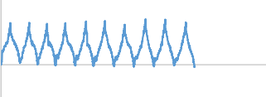
₄ 7% 3
2
1
0
-1 0
500
1000 1500 2000
Sensitivity
2
Sensitivity

0
0 500 1000 1500 2000
-2 Time(s)

3 9% ₄

0 500 1000 1500 2000 2500
3
2
1
0
-1 0
500 1000 1500 2000 2500
2
Sensitivity
Sensitivity

1

0

-1
Time(s)
11% ₄
4
3
2
1
0
-1 0
500
1000 1500 2000 2500
3
Sensitivity
2
Sensitivity
1
0
8%

Time(s)

10%

Time(s)

12%

Time(s)
-1 0 1000 2000 3000
Time(s)

Fig. 5 Performance of the proposed sensor at the strains of 7–12%. The numbers above each graph indi- cate the amount of strain

4.5
4
3.5
3
Sensitivity
2.5
2
1.5
1

0.5
0
-0.5
1%-12%

Time(s)
1
383
765
1147
1529
1911
2293
2675
3057
3439
3821
4203
4585
4967
5349
5731
6113
6495
6877
7259
7641
8023
8405
8787
9169

Fig. 6 Comparison of performance of the proposed sensor at the strains of 1–12%

Relation between Poisson’s ratio and sensitivity at different strain values

To investigate the relation between Poisson’s ratio and the sensitivity of the pro- posed auxetic sensor, a diagram of the sensitivity in terms of applied strain is shown in Fig. 9. The volume fraction and Poisson’s ratio of the selected auxetic structure are 40% and − 1.8, respectively. According to Li et al. [17], the per- formance of a particular conventional sensor could be estimated well by a linear

3.5
3
2.5
Sensitivity
2
1.5
1
0.5
0
Conventional sandwich Sandwich auxetic Mix Auxetic

1 2 3 4 5 6 7 8 9 10 11 12
Strain (%)

Fig. 7 Comparison of the performance between conventional sandwich sensor, mix auxetic sensor, and sandwich auxetic sensor. Conventional sensors are not able to detect strains less than 7% well and the mix auxetic sensor detects only up to a strain of 6% but the sandwich auxetic sensor has detected a strain of up to 12% and has better sensing performance in comparison with the two previous counterparts

Table 3 Statistical treatment for the sensitivity data of the conventional sandwich, sandwich auxetic, and mix auxetic sensors

Sensor type Mean Median Standard deviation
Coefficient of variation
Variance

Conventional sandwich 0.344 0.04 0.573 166.6 0.328
Sandwich auxetic 2.21 2.4 0.842 38.1 0.709
Mix auxetic 0.872 0.715 0.431 49.42 0.186
function under the entire range of applied strain with a constant GF of 0.49. In contrast, a particular auxetic sensor revealed distinct behaviors in three strain regimes including one in compression and two in tension. The auxetic sensor showed importantly better performance over a broad range of applied strains in comparison with the conventional counterparts. The compressive GF for three strain regimes is 1.45 (three times better than the conventional one), 2.63 (five times better than the conventional one), and 0.464 (similar to the conventional one), respectively. It is noticeable that the performance of the auxetic sensor in the third regime is similar to the conventional one. The reason for this phenom- enon would be justified by considering the relation between Poisson’s ratio and the strain (Fig. 8). According to our previous study [41], Poisson’s ratio increases sharply at the beginning of applied strain (corresponding to the second regime), and then increases with smoother slope (corresponding to the third regime) and finally, the diagram is transformed similar to a horizontal line (similar to conven- tional one due to crossing of the shifting strain). Using auxetic structures with a constant value of Poisson’s ratio over a broad range of strains could remove this different performance at different values of strains and made it possible to

(a)

0

-0.5
Simulation Experiment

0 2 4 6 8 10 12 14

strain Unit cell

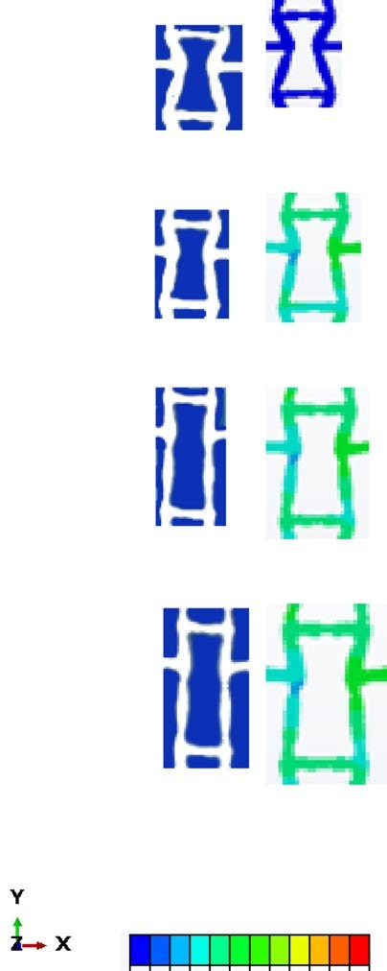-1
0%
3%
9%
12%
Displacement (mm)
Poisson's ratio

-1.5

-2

Strain(%)

(b)
7
6
Transverse direction
5
4
3
2
1
Simulation Experiment

0
0 2 4 6 8 10 12 14
Strain(%)

-6.7

-1.4

7.7

Fig. 8 a Poisson’s ratio and b lateral displacement of the sandwiched auxetic sensor in terms of strain. Poisson’s ratio and lateral displacement both change first with a high slope and then with a low slope. The sequence images of re-entrant auxetic sensor deformation are shown at the corresponding strains. For this sensor, the shifting strain is 12% that the oblique struts are transformed to vertical struts

design auxetic sensors with a constant value of sensitivity over a broad spectrum of strains.
When an auxetic structure is subjected to tension (pressure), due to the increase (decrease) in the length in the direction of loading, it also increases (decreases) in the transverse direction, which makes the surface of the auxetic structure wider (compressive) in tensile (compressive) loading. It means that in auxetic structures, increase or decrease in dimension are parallel in both longitudinal and transverse directions in both of tension or compression. In contrast, in conventional structures, this deformation is inverse in two directions (increase the length in the longitudinal direction and decrease the width in the transverse direction under tensile loading and vice versa). By considering this point, and since the number of sensory elements in the sensor structure is constant, it causes that the sensitivity performance of the aux- etic sensor will be better than the conventional counterparts. In previous studies, it has been shown that the use of auxetic structures as a substrate material in the appli- cation of piezoresistive sensors due to having a negative Poisson’s ratio will cause

3.5
0.15
0.4

3

2.5

2
Sensitivity

1.5

1

0.5

0
0 2 4 6 8 10 12 14
Strain (%)
Fig. 9 Relation between sensitivity and strain for the sandwich composite auxetic sensor. Sensitivity changes during strain occur with different slopes, meaning that the sensitivity is high at first and then gradually decreases. To illustrate this, tangent lines have been used to estimate the sensitivity gradient

improvement in the sensing performance. The reason for this improvement is that in auxetic structures during tensile loading, there is an expansion in both longitudinal and transverse directions, which will increase the number of sensing material sepa- rations from each other and consequently increase the sensitivity. In our previous work [15], we showed that auxetic piezoresistive sensors have good sensing perfor- mance up to the shifting strain, and then because the Poisson’s ratio of structure will be positive, their sensing performance will decrease and their performance will be the same as conventional sensors. It is worth noting that shifting strain is the strain at which the Poisson’s ratio of the structure changes from negative to positive. In this work, we want to show that auxetic sensors have different sensing performances at different values of strains, and their sensing properties will change as the strain changes. The reason for this phenomenon is shown in Fig. 9.
The Poisson’s ratio is inversely related to the sensitivity of the sensor, meaning that the more negative the Poisson’s ratio of the structure, the greater the sensitiv- ity of the sensor. Therefore, the sensitivity of the auxetic sensor will not be con- stant during the strain and will change due to changes in the Poisson’s ratio. Fig- ure 9 shows that the slope of the sensitivity changes decreases with increasing strain. Here the graph is estimated with two lines in two strain ranges including; 1–6% and 6–12% with two lines with two slopes of 0.4 and 0.15, respectively. The reduction of the slope of the second line is due to the decrease in the Poisson’s ratio for the grater strain values, which is consistent with the explanations given for the behavior of the Poisson’s ratio of the structure during the strain.
Figure 10 shows SEM images of the proposed sensor. Figure 10a illustrates the sensor before tensile loading (graphite particles were collided with each other) and Fig. 10b indicates the sensor during tensile loading (graphite particles were sepa- rated from each other) and these variations in the number of collided graphite parti- cles change the structure resistance.

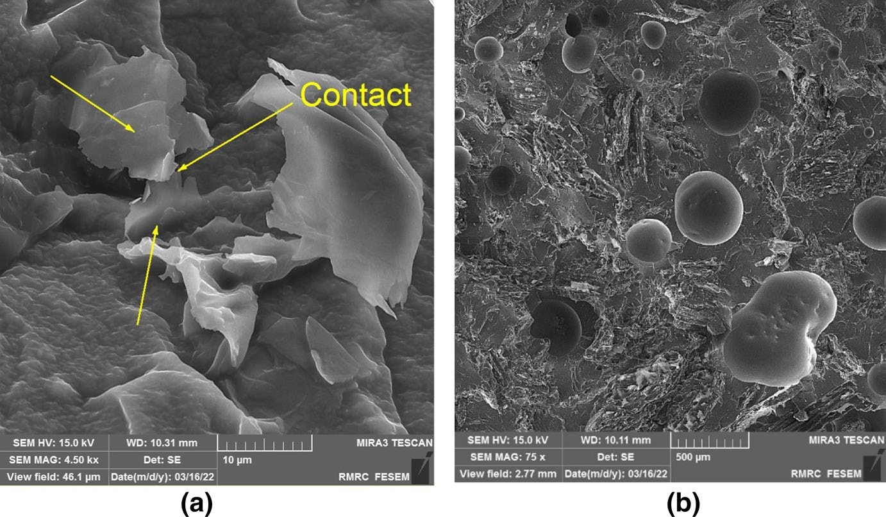

Fig. 10 SEM images of graphite particles that were a collided with each other and b separated from each other under tension

Auxetic structure with a constant value of Poisson’s ratio

In this section, an auxetic structure with a constant Poisson’s ratio for a wide range of strains is presented. As discussed in the previous sections, the use of auxetic structures with variable Poisson’s ratio during the strain causes the created auxetic sensor to have a different sensing performance during the strain, and this for the sensor as a means of measuring is considered a defect. The structure presented here has the same Poisson’s ratio along with the strain, and the use of this structure in the construction of auxetic sensors will eliminate the mentioned problem. In the next work, we want to use these structures to build piezoresistive auxetic sensors with uniform sensing performance during strain. Figure 11a shows the geometry of the structure and Fig. 11b shows the cell geometry of the unit structure. The Poisson’s ratio diagram and the transverse dis- placement of the structure in terms of strain are shown in Fig. 11c and d, respectively. As shown in Fig. 11c, the Poisson’s ratio of structure to a strain of 20% is a constant value, after which the strain value (shifting strain) of the auxetic properties of the struc- ture disappears and the structure becomes a conventional structure after this strain. Figure 11c shows how the structure deforms at different strains. As can be seen, the mechanism of deformation of the structure is the rotation of oblique struts, which after the inclined struts become vertical struts, the deformation of the structure is the same as conventional structures.

Poisson's ratio
Transverse direction (mm)

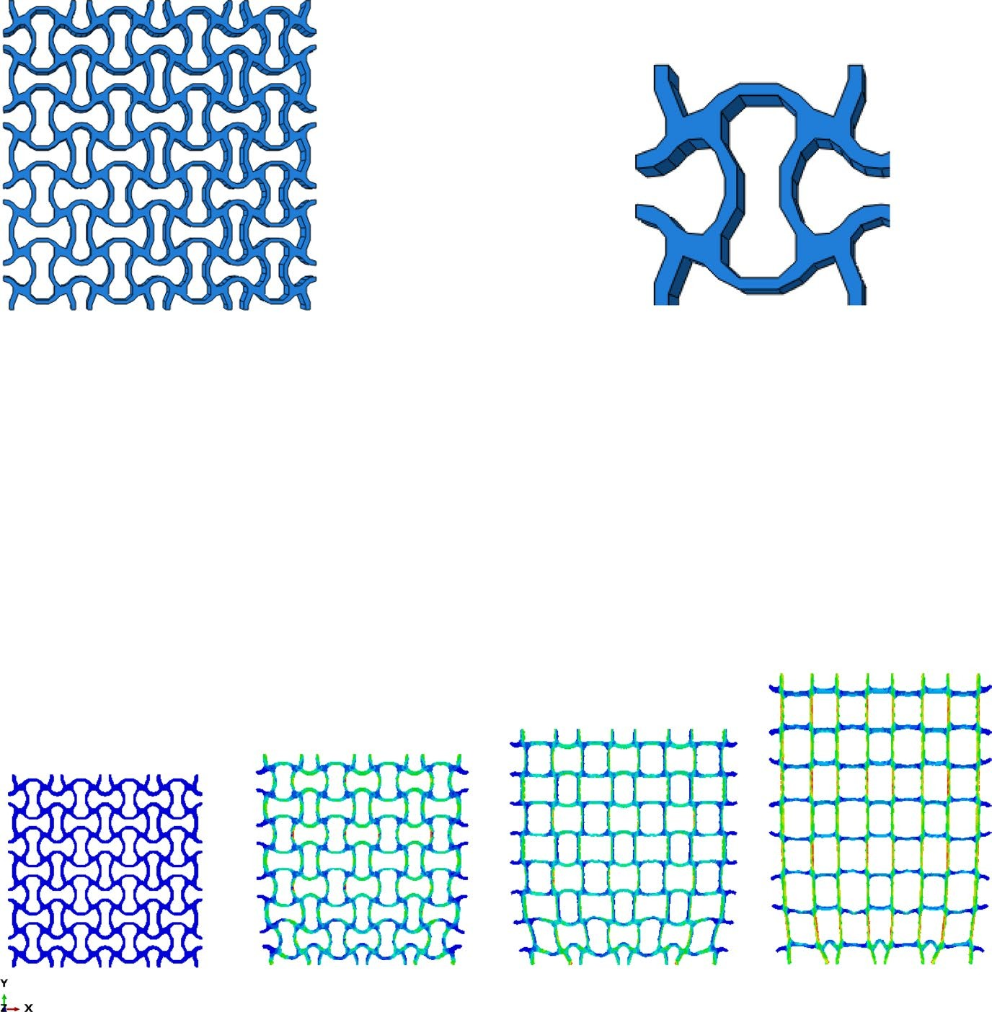(a) (b)
(c)
(d)
0
-0.2 0
-0.4
-0.6
-0.8
-1
10
20 30 40 50
20
15
10
5
0
0 10 20 30 40 50
Strain (%) Strain(%)
(e)
0%
10%
23%
39%

Fig. 11 a Auxetic structure with constant Poisson’s ratio during strain, b unit cell of auxetic structure, c Poisson’s ratio in terms of the strain, d transverse displacement in terms of the strain, and e sequence of images of the unit cell deformation of the presented auxetic structure. Deformation mechanism of the auxetic structures is rotation of the struts. Unit cell of the repetitive structures is represented the mechani- cal properties of the structure

Conclusion

As a measuring device, sensor must have the same response in different strains and directions (different test conditions), and this issue in the use of auxetic structures in the field of sensors is a point that should be addressed and examined. In this work, we have tried to address this main feature of the sensor, and in the next work, we intend to use isotropic auxetic structures to manufacture sensors. In this article, we proposed a highly sensitive, stretchable, piezoresistive auxetic sensor based on graphite powders sandwiched between silicon rubber layers. By mixing silicon RTV2 and graphite powder, the base material of the middle layer of auxetic sensor

is made into a paste, and after molding inside the die manufactured by using 3D printing technology, it becomes as re-entrant auxetic sensor. The proposed sensor is compared with the previous auxetic sensors and it has improved up to 176% and 380% in terms of the gauge factor in comparison with previous mix auxetic sen- sor and sandwich composite conventional sensor, respectively. Auxetic sensors have high sensitivity until shifting strain and after that their performance is similar to con- ventional sensors. The shifting strain of the proposed sensor is 12%. Furthermore, it is shown that sensitivity of auxetic sensors is different at different values of strains due to the nonlinearity of Poisson’s ratio during the strain. We proposed an auxetic structure with a constant value of Poisson’s ratio during the strain to use in the sen- sor field. The use of this auxetic structure as a sensor made it possible to design an auxetic sensor with linear sensitivity.

References

- Ahmed MF, Li Y, Zeng C (2019) Stretchable and compressible piezoresistive sensors from auxetic foam and silver nanowire. Mater Chem Phys 229:167–173
- Wang J et al (2015) Silver nanowire electrodes: conductivity improvement without post-treatment and application in capacitive pressure sensors. Nano-Micro Letters 7(1):51–58
- Kim Y, Kim J-W (2016) Silver nanowire networks embedded in urethane acrylate for flexible capacitive touch sensor. Appl Surf Sci 363:1–6
- Cai L et al (2016) Fully printed stretchable thin-film transistors and integrated logic circuits. ACS Nano 10(12):11459–11468
- Chang C et al (2010) Direct-write piezoelectric polymeric nanogenerator with high energy conversion effi- ciency. Nano Lett 10(2):726–731
- Li Y, Zeng C (2013) Low-temperature CO2-assisted assembly of cyclic olefin copolymer ferroelectrets of high piezoelectricity and thermal stability. Macromol Chem Phys 214(23):2733–2738
- Azizkhani MB et al (2019) Highly sensitive, stretchable chopped carbon fiber/silicon rubber based sensors for human joint motion detection. Fibers and Polymers 20(1):35–44
- Azizkhani MB et al (2019) Highly sensitive and stretchable strain sensors based on chopped carbon fib- ers sandwiched between silicone rubber layers for human motion detections. J Composite Mater, 0021998319855758.
- Samad YA et al (2015) Novel graphene foam composite with adjustable sensitivity for sensor applications. ACS Appl Mater Interfaces 7(17):9195–9202
- Qin Y et al (2015) Lightweight, superelastic, and mechanically flexible graphene/polyimide nanocom- posite foam for strain sensor application. ACS Nano 9(9):8933–8941
- Li M et al (2014) Stretchable conductive polypyrrole/polyurethane (PPy/PU) strain sensor with netlike microcracks for human breath detection. ACS Appl Mater Interfaces 6(2):1313–1319
- Gong S et al (2014) A wearable and highly sensitive pressure sensor with ultrathin gold nanowires. Nat Commun 5(1):3132
- Amjadi M et al (2014) Highly stretchable and sensitive strain sensor based on silver nanowire-elastomer nanocomposite. ACS Nano 8(5):5154–5163
- Kim HW et al (2018) Hygroscopic auxetic on-skin sensors for easy-to-handle repeated daily use. ACS Appl Mater Interfaces 10(46):40141–40148
- Taherkhani B et al (2020) Highly sensitive, piezoresistive, silicone/carbon fiber-based auxetic sensor for low strain values. Sensors Actuat A Phys 305:111939.
- Jiang Y et al (2018) Auxetic mechanical metamaterials to enhance sensitivity of stretchable strain sen- sors. Adv Mater 30(12):1706589
- Li Y et al (2016) Poisson ratio and piezoresistive sensing: a new route to high-performance 3D flexible and stretchable sensors of multimodal sensing capability. Adv Func Mater 26(17):2900–2908
- Seyedin MZ et al (2015) Achieving outstanding mechanical performance in reinforced elastomeric composite fibers using large sheets of graphene oxide. Adv Func Mater 25(1):94–104
- Gao S-L et al (2010) Glass fibers with carbon nanotube networks as multifunctional sensors. Adv Func Mater 20(12):1885–1893

- Zhang J et al (2011) Single MWNT-glass fiber as strain sensor and switch. Adv Mater 23(30):3392–3397
- Jakubinek MB et al (2014) 3D chemically cross-linked single-walled carbon nanotube buckypapers. RSC Adv 4(101):57564–57573
- Lipomi DJ et al (2011) Skin-like pressure and strain sensors based on transparent elastic films of carbon nanotubes. Nat Nanotechnol 6(12):788–792
- Yamada T et al (2011) A stretchable carbon nanotube strain sensor for human-motion detection. Nat Nanotechnol 6(5):296–301
- Li C, Shi G (2012) Three-dimensional graphene architectures. Nanoscale 4(18):5549–5563
- Ge J et al (2013) Stretchable conductors based on silver nanowires: improved performance through a binary network design. Angewandte Chemie (International ed. in English) 52(6):1654–1659.
- Muthukumar N, Thilagavathi G, Kannaian T (2016) Polyaniline-coated polyurethane foam for pressure sensor applications. High Perform Polym 28(3):368–375
- Chen Y et al (2015) Fabrication of stretchable, flexible conductive thermoplastic polyurethane/graphene composites via foaming. RSC Adv 5(100):82034–82041
- Liu H et al (2016) Piezoresistive behavior of porous carbon nanotube-thermoplastic polyurethane con- ductive nanocomposites with ultrahigh compressibility. Appl Phys Lett 108(1):011904.
- Shah S et al (2018) 3D printing of electrically conductive hybrid organic–-inorganic composite materi- als. Microsyst Technol 24(10):4341–4345
- Khosla A et al (2018) Carbon fiber doped thermosetting elastomer for flexible sensors: physical proper- ties and microfabrication. Sci Rep 8(1):12313
- Sajjad Husain Mir LAN, Thomas Thundat, Parvaneh Mokarian-Tabari, Hidemitsu Furukawa, Ajit Kho- sla (2018) Review organic-inorganic hybrid functional materials: an integrated platform for applied technologies. J Electrochem Soc 165(8):B3137--B3156.
- Bertoldi K et al (2010) Negative Poisson’s Ratio behavior induced by an elastic instability. Adv Mater 22(3):361–366
- Chetcuti E et al (2014) Modeling auxetic foams through semi-rigid rotating triangles. Phys Status Solidi (b) 251(2):297–306
- Huang H-H, Wong B-L, Chou Y-C (2016) Design and properties of 3D-printed chiral auxetic metama- terials by reconfigurable connections. Phys Status Solidi (b) 253(8):1557–1564
- Ingrole A, Hao A, Liang R (2017) Design and modeling of auxetic and hybrid honeycomb structures for in-plane property enhancement. Mater Des 117:72–83
- Saxena KK, Das R, Calius EP (2016) Three decades of auxetics research—materials with negative Poisson’s ratio: a review. Adv Eng Mater 18(11):1847–1870
- Shan S et al (2015) Design of planar isotropic negative Poisson’s ratio structures. Extreme Mech Lett 4:96–102
- Shufrin I, Pasternak E, Dyskin AV (2015) Hybrid materials with negative Poisson’s ratio inclusions. Int J Eng Sci 89:100–120
- Wang X-T, Li X-W, Ma L (2016) Interlocking assembled 3D auxetic cellular structures. Mater Des 99:467–476
- Yang W et al (2004) Review on auxetic materials. J Mater Sci 39(10):3269–3279
- Zhang J et al (2018) Large deformation of an auxetic structure in tension: Experiments and finite ele- ment analysis. Compos Struct 184:92–101
- Zhang X-c et al (2014) Numerical investigation on dynamic crushing behavior of auxetic honeycombs with various cell-wall angles. Adv Mech Eng 7(2):679678.
- Rezaei S et al (2021) Design and modeling of the 2D auxetic metamaterials with hyperelastic properties using topology optimization approach. Photon Nanostructures Fundamentals Applications 43:100868.
- Taherkhani B et al (2021) Large deformation of TPU re-entrant auxetic structures designed by TO approach.J Elastomers Plast 0(0):0095244320938411.
- Taherkhani B, Pourkamali Anaraki A, Kadkhodapour J (2021) Design of structures using level set topology optimization and strain energy methods. J Ultrafine Grained Nanostructured Mater 54(2):163–172.
Publisher’s Note Springer Nature remains neutral with regard to jurisdictional claims in published maps and institutional affiliations.

