Best Oxygen Transfer Agent Organic Chemistry Has to Offer – HOF/CH3CN

Shlomo Rozen PhD, Tel Aviv University, Israel

Abstract (300 word limit)
Most oxidants are metal oxides such as CrO3, KMnO4 and alike. Compounds containing the peroxide moiety (-O-O-) serve occasionally either as oxidants or oxygen transfer agents, mainly as reagent for epoxidation of certain olefins. The problem with most orthodox oxygen transfer agents is that they are relatively weak (a weak electrophilic oxygen) and need a strong nucleophilic center in order to react successfully. The only imaginable compound with a strong electrophilic oxygen is one where the oxygen is bound to an element which is more electronegative than itself and this is possible only when it is bonded with fluorine. HOF is known for more than 50 years and made by passing F2 through ice. It is very unstable and decomposes in 10 minutes even at -100 ºC making it unsuitable for any synthetic purposes. When however, we passed dilute fluorine in nitrogen (about 10%) through aqueous acetonitrile an oxidative solution was obtained which proved to be the complex of HOF with CH3CN (HOF•CH3CN). This complex is stable at 0 ºC for more than an hour allowing a wide array of chemical syntheses to be executed. This complex is able to transfer its oxygen to many substrates and produce many unknown oxides which could not be made before despite continues efforts for many years. Among these reactions we will mention phenanthroline-N,N-dioxide, perfluorinated sulfones, All-S,S-dioxo-thiophenes including their oligomers (important ingredients in electronics), epoxidation of electron poor olefins, oxidation of vicinal amines to vic-dinitro derivatives, succes in making the elusive N,N-dioxopyridazine and many more. In addition, since the reacting oxygen originates from the water molecule, it is relatively simple and cheap to constructing alcohols with the [18]O isotope.

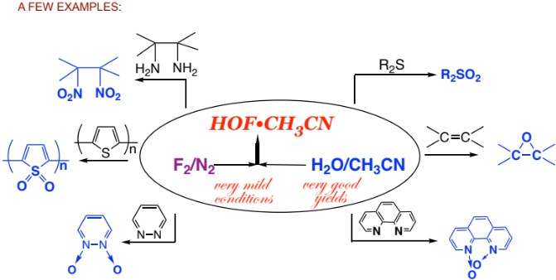
Recent Publications (minimum 5)
1. Shlomo Rozen,* Inna Vints, Ana Lerner, Oded Hod, Edward N.
Brothers,* and Salvador Moncho (2021). The Chemistry of Short-Lived α‑Fluorocarbocations. J. Org. Chem. 86: 3882-3889
2. Shlomo Rozen and Avshalom Shaffer (2017). Synthesis of N,N-
Dioxopyridazines. Org. Lett 19: 4707-4709.
- Francesca Di Maria, Alberto Zanelli, Andrea Liscio, Alessandro Kovtun, Elisabetta Salatelli, Raffaello Mazzaro, Vittorio Morandi, Giacomo Bergamini, Avshalom Shaffer, and Shlomo Rozen (2017). Poly(3-hexylthiophene) Nanoparticles Containing Thiophene- S,S-dioxide: Tuning of Dimensions, Optical and Redox Properties, and Charge Separation under Illumination ACS Nano 11: 1991-1999
- Cheryl Aharon, Fernando G. Guijarro, Samara M. Rivero, Francisco J. Ramirez, Ruben Caballero, Juan Casado, Fernando Langa and Shlomo Rozen (2019) [All]-S,S-dioxide Oligo-Thienylenevinilenes: Synthesis and Structural/Electronic Shapes from Their Molecular Force Fields. Chemistry A European Journal 25: 464-468.
- Shay Potash and Shlomo Rozen (2013) A General and Efficient Method for Converting Selenides to Selenones by Using HOF•CH₃CN. European J. Org. Chem. 5574-5579

Biography 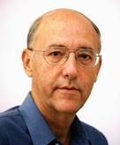

Shlomo Rozen was born in Bulgaria and immigrated to Israel as a small child. He received his Ph.D. from the Hebrew University of Jerusalem and
then spent 3 years in the Research Institute for Medicine and Chemistry, Cambridge, MA, under Nobel laureate D. H. R. Barton, where he began work with elemental fluorine. In 1976, he joined the School of Chemistry at the Tel Aviv University where he assumed the position of Professor of Chemistry in 1989. On multiple occasions he had held a position of visiting scientist at the Central Research Department of the DuPont Company. His main goal in chemistry is to demonstrate that elemental fluorine and reagents derived from it are very useful in general organic chemistry, as well as in fluorine chemistry, and chemists should discard their unjustified fears and prejudice against this long known but somewhat neglected element.
Email: rozens@tauex.tau.ac.il

Notes/Comments:

Presenting author details
Shlomo Rozen:
Contact number: +972524434467
Mail id: rozens@tauex.tau.ac.il
Category: Oral presentation

