Na, K-ATPase as a receptor that modulates neuroplasticity
Ana Maria M Orellana
University of Sao Paulo, Brazil
Abstract
Statement of the problem: The Na, K-ATPase (NKA) is a heterodimeric integral plasma membrane protein, ubiquitously expressed in mammalian cells that differ from other ion transporters. The difference is not only due to its capacity to maintain an electrochemical gradient across plasma membrane, but also as a receptor for Ouabain (OUA), a cardiotonic steroid. Studies from the last two decades, have demonstrated that OUA, can activate a network of signaling molecules through NKA that will serve as a signal transducer in the cell. The purpose of this study is to verify whether OUA can modulate neural plasticity as well as adult neurogenesis.
Methodology & theoretical orientation: In vivo and in vitro assays were performed using Wistar rats. All the protocols were performed according to the ARRIVE guidelines and following Ethical Committee for Animal Use from University of Sao Paulo. Intrahippocampal injection of OUA 10 nM was performed in adult male rats as previously described. Animals were submitted to Morris Water Maze test, to verify the effects of OUA in spatial long-term memory. Furthermore, a neural precursor cell culture obtained from neonatal hippocampus was treated with OUA 10 nM. Microscopy, flow cytometry and biochemical assays were performed.
Findings: Indeed, intrahippocampal injection of OUA, in male adult rats, activated the Wnt/β-Catenin signaling pathway and increased CREB/BDNF and NFᴋB levels, in CA1 neurons. These effects contributed to important changes in the cellular microenvironment, resulting in enhanced levels of dendritic branching in hippocampal neurons, in association with an improvement in spatial reference memory and the inhibition of long-term memory extinction. Furthermore, in vitro assays suggest that OUA can enhance hippocampal neurogenesis (Figure 1).
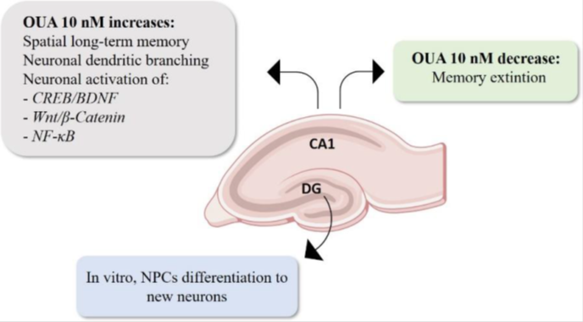
Figure 1. Effects of OUA 10 nM on the adult hippocampus. OUA improve spatial long term-memory and decrease memory extinction. It also increases new neurons generation from Neural Precursor Cells (NPCs), in NPC cell culture.
Conclusion: Na, K-ATPase as a receptor for OUA can modulate neural plasticity related to hippocampal dependent memory in adults.
Biography
Orellana studied Pharmaceutical Sciences at the University of Campinas. She had her PhD degree in Neuropharmacology at University of Sao Paulo, where she started studying the different roles of Na, K-ATPase in the Central Nervous System. From 2015-2016 she worked at Karolinska Institute, Sweden, in the group of Dr. Anita Aperia. Since 2017 she has been studying the effects of Na, K-ATPase signaling in neurogenesis and has been doing scientific work at the Institute of Biomedical Science (ICB-USP) in Brazil. In 2022, she was selected to participate in Interstellar Initiative, organized by New York Academy of Science and Japan Agency for Medical Research and Development. Since 2021, she belonged to the editorial board of the Journal Frontiers in Aging Neuroscience.

