Treatment of shingles with acyclovir in combination with an immunostimulatory vaccine virus
Tibor Bakacs
Alfred Renyi Institute of Mathematics, Hungary
Abstract
Statement of the problem: Herpes simplex viruses 1 and 2 and Varicella Zoster Virus (VZV) establish latency in sensory neurons and then reactivate to infect epithelial cells in the mucosa or skin, resulting in a vesicular rash. On reactivation, VZV causes herpes zoster (shingles). A year ago, the 76-year-old medical doctor author of this lecture suffered from a severe facial herpes zoster infection with orbital edema, which is an emergency condition.
Methodology & theoretical orientation: Conventional Acyclovir (ACV) treatment was complemented with an experimental immunostimulatory viral therapy. The live-attenuated Infectious Bursal Disease Vaccine virus (IBDV) was orally administered, which delivers its double-stranded RNA cargo to host cells and activates the natural antiviral interferon defense system. IBDV has been safe and effective against five different families of viruses, hepatitis A virus, hepatitis B virus, hepatitis C virus, Severe Acute Respiratory Syndrome Corona Virus 2 (SARS-CoV-2) and VZV.
Findings: Full crustation was achieved within five days by the combination therapy (Figure 1), while the average time to crustation with ACV monotherapy is 15 days. To confirm the case report, we proposed a short phase I/II trial in elderly shingles patients to determine whether the difference between the time to full crusting of herpes zoster lesions in the ACV monotherapy and ACV plus IBDV-R903/78 combination therapy groups is clinically meaningful. All patients will receive standard ACV monotherapy, while half of the patients will be treated with ACV plus an “add-on” IBDV therapy. The primary endpoints will be safety, but the efficacy of the combination therapy will also be assessed.
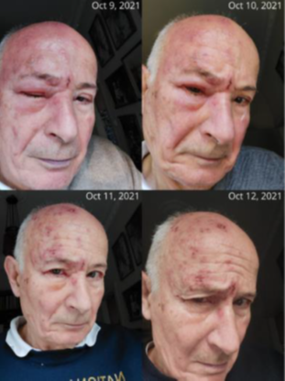
Figure 1. The author’s HZO with orbital edema at the peak of disease and in recovery. The “selfie” pictures were taken between 9 October 2021 and 12 October 2021.
Conclusion: As one out of every three people will suffer an episode of shingles during their lifetime, the new combination treatment could help many millions of patients with HZ infection.
Biography
Tibor Bakacs is a medical doctor, a clinically trained scientist with over 40 years of experience, publisher of 94 scientific papers, several addressing unmet medical needs. His interest is (1) using an apathogenic attenuated vaccine virus, the Infectious Bursal Disease Virus (IBDV), which is one of the strongest interferon inducer among viruses, for the post-infection therapy of viral diseases and (2) using an off-label low-dose immune checkpoint blockade in combination with IBDV for the treatment of advanced cancer. He spent long periods abroad, at the Karolinska Institute in Stockholm, Sweden, Christie Hospital in Manchester, UK and the National Cancer Institute of the USA. Currently, he is the Chief Scientific Officer of HepC Inc. He is consultant at the Department of Probability, Alfred Renyi Institute of Mathematics, Budapest, Hungary.

