Resistant lichen planopilaris: Expect the unexpected
Yasmin Divecha¹* and Arshan Dadrewalla²
¹Havering and Redbridge University Hospitals NHS Trust, United Kingdom
²London North West University Healthcare NHS Trust, United Kingdom
Abstract
Introduction: Lichen Plano-Pilaris (LPP) is a rare, chronic inflammatory scarring alopecia, primarily affecting women aged 40-60 years. It classically presents as pruritic, painful polygonal patches of alopecia with follicular hyperkeratosis and perifollicular erythema. Although, predominantly affecting scalp, this case highlights extra scalp involvement which is scarce. Pathogenesis is not well characterized and progression unpredictable. Treatment is difficult because of significant relapse-rates along with the psychological impact. Presently treatment does not result in hair regrowth, however, systemic treatment should be considered at the early stages.
Case report: Here, we aim to bring to light a 66-year-old female with a 21-year history of biopsy-proven LPP and her agonizing course of treatments, seeking multiple dermatologists’ opinions, initially presenting with brown comedone-like follicular papules on her trunk. Histopathology diagnosed LPP. Dermovate was applied, after 6-months lesions resolved. She represented 18-months later with diffuse scalp hair loss. Unusually, there was no itching, pain or sensitivity, delaying diagnosis. Dermoscopy showed follicular-miniaturisation, varying hair shaft thickness and telangiectasias. Biopsy revealed perivascular lymphocytic inflammation, follicular hyperkeratosis and mid-isthmic fibroplasia, indicating LPP. Initially, numerous topical- regimes and Prednisolone were prescribed, without improvement. Hydroxychloroqiune was then started, after a 6-month trial hair thinning, scaling and erythema continued (Figure 1). The patient was initiated on Mycophenolate Mofetil (MMF), Oxytetracycline and Dermovate, showing improvement. After 15-years MMF was tapered and stopped, 6-months later hair loss reoccurred. MMF and Prednisolone were reintroduced, stabilising LPP activity (Figure 2).
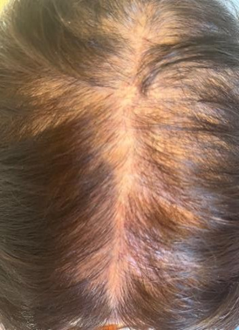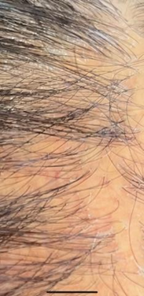
Figure 1. (a) Diffuse thinning of the hair at the vertex and mid-frontal area. (b) Erythema and localised scaling on vertex.
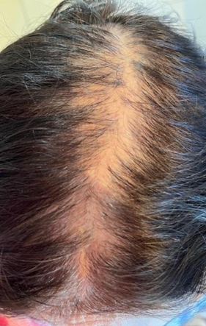
Figure 2. Multiple scarring alopecic patches on the frontal, mid-scalp and vertex regions.
Conclusion: To conclude, it is important to appreciate the broad clinical spectrum of LLP, occasionally affecting hair follicles on areas besides scalp and not always presenting with classical symptoms of pruritis and trichodynia. Due to LLP’s recalcitrant nature and difficulty diagnosing, it is important to initiate treatment promptly with consideration of systemic agents early to prevent scarring. Poor understanding of this disease and lack of standardized treatments necessitates further study of this condition.
Biography
Yasmin Divecha completed her medical training at King’s College London and is currently a Foundation Doctor at Queen’s Hospital, with a keen interest in Medical Research and Education, especially in Dermatology. She believes amplifying trainee’s views and experiences has an important role in improving medical education, leading to advances in Dermatology and ultimately revolutionizing skin and hair research.

