Study of blood flow in the skin vascular using laser Doppler imaging
Ammar A. Oglat
The Hashemite University, Jordan
Abstract
Laser Doppler Imaging (LDI) is a non-invasive method of measuring microcirculatory blood flow in tissues. The aim of this study is to measure the Doppler shift induced by moving red blood cells toward the illuminating coherent light. The study was done by a Laser Doppler Vibrometer (LDV) that measures the surface of tissues by moving a mirror. And single-point measurement gives (40 Hz) temporal resolution. So, this enables rapid blood flow changes to be recorded. The magnitude of the Doppler shift is related to the optical geometry and the velocity of the scattering object. The measurement of vibration mode shapes is made by sensing the structural response at a series of locations on the structure. As a result, when using an LDV system, the straightforward solution is to translate the test object or the complete LDV system so that various points of interest can be probed. Furthermore, when the diameter of the circular scan is small, it will give the angular vibration of the structure at the center of the circle [Figure 1].
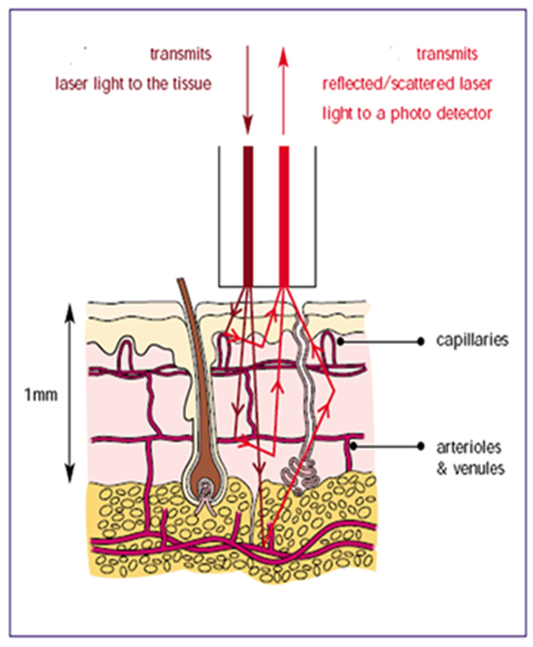
Figure 1. An incident light from the laser inside the small micro-circulate capillary which it is reflected/scattered because of movement of blood flow and this movement because vibration leads to reflect the beam light.
Biography
Ammar A. Oglat received the B.Sc. in Medical Imaging from the Jordan University of Science and Technology in 2014, The MSc in medical imaging and the PhD in medical diagnostic imaging from Universiti Sains Malaysia (USM) in 2016 and 2019, respectively. Currently, he is an assistant professor and chairman at the Hashemite University (HU) in Jordan. His current research interest focuses on all medical imaging modalities and applications.

