Abdominal flap for crushed fingertip amputation
Tae Hyung Kim
Soonchunhyang University Seoul Hospital, South Korea
Abstract
Statement of the problem: The amputation at the level of distal phalanx is a common hand injury and is normally treated with revision amputations, local flaps and skin grafts. (1) Despite its advantages of local flaps and amputations for quicker return to work while maintain functions, shortening of finger after injury is very frustrating to patients. (2) Replantation of fingertip amputation is also very difficult even if the stump is clean-cut and if the vessels of the stump were crushed by injury, replantation could not be the considerable option. (3) The aim of the study is to evaluate functional and aesthetic outcome of ‘Hybrid Abdominal Flap’ which is composed of random-pattern abdominal skin flap and autologous bone graft.
Methodology & theoretical orientation: An autologous bony stump was harvested if it was intact and if not, autologous bone graft was harvested from olecranon. After the bony fixation, the abdominal flap was utilized for soft tissue coverage. Division of pedicle had undergone three weeks after surgery and the debulking procedure was carried out. Functional and aesthetic outcome was assessed three months after debulking procedure.
Findings: A total of six patients had undergone Hybrid Abdominal flap. All the flaps survived without complications such as nonunion and flap necrosis. Patients were satisfied with the appearance and the function of their finger including range of motion and sensory [Figure 1].
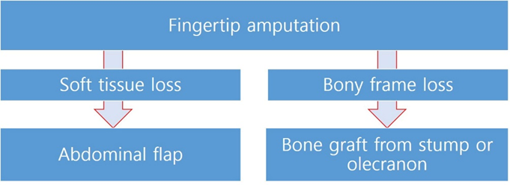
Figure 1. A brief flow-chart of abdominal hybrid flap for fingertip amputation.
Conclusion: Despite immobilization of the arm for three weeks can be considered as disadvantages, our novel Hybrid Abdominal Flap is functionally and aesthetically considerable option for fingertip amputations with crushed stump.
Biography
Tae Hyung Kim studied chemical engineering at the University of Sungkyunkwan, South Korea. He had a master degree of medical doctor in South Korea. He has been working as a medical doctor in the department of Plastic and Reconstructive Surgery at Soonchunhyang University Hospital, Gumi, South Korea. He is pursuing clinical fellowship in craniofacial at Asan Medical Center in 2023.

