Synthesis and cytotoxicity study on 3-Piperazino-2(3H)-Benzoxazolone derivative
Seid Emamu Gelan
Bio and Emerging Technology Institute (BETin), Ethiopia
Abstract
Statement of the problem: The World Health Organization (WHO) has prepared a list of the top 10 threats to global health to focus on in 2019; Non-communicable diseases are among the listed threats, where diseases such as diabetes, heart disease and cancer are collectively accountable for more than 70% of all deaths occurred worldwide (41 million people). The role of cancer research in the control of these diseases is significant. Globally, both the incidence and mortality rates in cancer cases are increasing rapidly, making it the second leading cause of death worldwide and the estimated death, as a result of it in only 2018 was 9.6 million. Furthermore, the Cancer incidence and mortality statistics reported by the American Cancer Society showed that the most common type of cancer on the list is breast cancer, with over 287,850 new cases expected nationally in 2022, followed by lung and prostate cancers respectively. Including the fast-growing cancer cases, the world is facing multiple health challenges; drug effectiveness problems and side effects are still some of the motivations to look for new and effective drugs to increase the treatment choice and tackle people’s health problems. 2(3H)-Benzoxazolone derivatives have been used in the synthesis of new effective potential drug candidates. These derivatives are getting a lot of attention from different scholars due to their affordability and availability issues in addition to their susceptibility to structural and chemical modifications. Above all, they have a wide variety of properties biologically. Some of the pharmacological activities of the derivatives are; antibacterial, anti-HIV, analgesics-anti-inflammatory antifungal and anti-cancer. The aim of this study is to synthesize a compound with 2(3H)-Benzoxazolone backbone, through adjustment on the 3rd and 6th positions and to evaluate their effects on the viability of the human breast cancer cell line.
Methodology: 3-substituted 5-chloro-2(3H)-Benzoxazolone derivative was synthesized using the Mannich reaction as shown [Figure 1]. Melting point and Thin Layer Chromatography (TLC) were used to check the purity of the compound. Characterization was done using proton Nuclear Magnetic Resonance (H1-NMR) spectroscopy and Fourier Transform Infrared (FT-IR). The cytotoxicity assay was done by the MTT assay method.
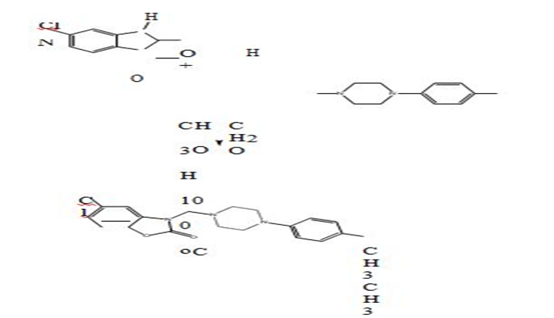
Figure 1. Synthesis of 3-((4-(4-methyl phenyl)piperazin-1-yl) methyl)-5-chloro-2(3H)-benzoxazolone (white crystalline solid with a percent yield of 61.4 % and 141.5 °C MP).
Findings: After characterization, the synthesized compound was found to be a Mannich base, 3-((4-(4-methyl phenyl)piperazin-1-yl)methyl)-5-chloro-2(3H)-benzoxazolone. The assay result showed a decrease in cell proliferation on the MCF-7 cell line in a dose and time-dependent manner: 5,10,20,50 and 100 μg/ml for both 24 and 48 hours [Figure 2].
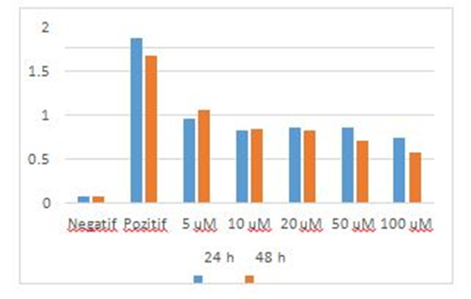
Figure 2. Cytotoxicity on MCF-7 cell line at different concentration and time and measured UV absorbance.
Conclusion: Ten μM concentrations were found to be more effective at inhibiting MCF-7 cell growth when compared to other dilutions for a 48 hrs incubation period. Further study on the molecular interaction of the compound with the receptors is recommended.
Biography
Seid is a researcher who is interested in medicinal chemistry and pharmaceutical biotechnology. He has been working at the Bio and Emerging Technology Institute (BETiN) for more than four years now. He has been participating in research activities in the health biotechnology directorate focusing on traditional medicine and synthetic drug development research. Participating in research activities focused on cancer has been his interest ever since he has come to know what cancers are and how they affect us. Currently, he and his team at BETiN are working on cervical cancer; understanding and identifying the genotypes of the different types of Human Papilloma Virus (HPV) responsible for cervical cancer here in Ethiopia. He has a bachelor’s degree in pharmacy from Addis Ababa University, Ethiopia. In addition, he has received a master's degree in pharmaceutical chemistry from Near East University, Turkish Republic of Northern Cyprus. During his master's study, he was able to successfully synthesize benzozxzolone derivatives and check for their potential cytotoxicity activity against the mcf-7 human breast cancer cell line; the result was promising. He completed his MSC with a CGPA of 4.00.

