Spruce and beech sawmill waste as a source of nanolignin
Girard Victor, PhD, University of Lorraine, France
Brosse Nicolas, Professor, University of Lorraine, France
Ziegler-Devin Isabelle, Lecturer, University of Lorraine, France

Abstract:

Wood processing produces large amount of residues such as barks, shavings, sawdust, chips... For instance, to produce 1m3 of sawn timber, 1.7 to 2 m3 of log are required, generating nearly 50% of waste. The valorization of 1m3 of a log by sawing produces then about 8-10% ok barks, 10-13% of sawdust and 20-30% of other wood chips (data for beech and spruce). Pulping and wood energy are the main outlet for these wastes, while many other valorization possibilities could be envisaged. Wood is a lignocellulosic material mainly composed of three polymeric fractions, cellulose, hemicellulose and lignin, which are highly entangled. As much as cellulose and hemicelluloses are well valorized today, lignin remains completely under-valued (thermal valorization). Thanks to its aromatic structure, lignin has many properties (biocide, antioxidant, UV-light blocker...) which could be useful in technical applications. One of the ways of valorization of lignin still poorly explored is the production of nanolignins. Usually, the usefulness of nanoparticles lies in their size (< 100 nm), which provides them a high surface reactivity as well as physic and chemical properties that the materials would not have at a macroscopic scale. Nanoparticles are nowadays intentionally incorporated in many consumer-products as for example sunscreens, toothpastes... as well as in electronic devices and new medicinal treatments. The two goals of this work are to optimize a green extraction process of macrolignin from wood waste and then to optimize nanolignin production from lignin for a future valorization in both pharmaceutical and cosmetics applications.
Image
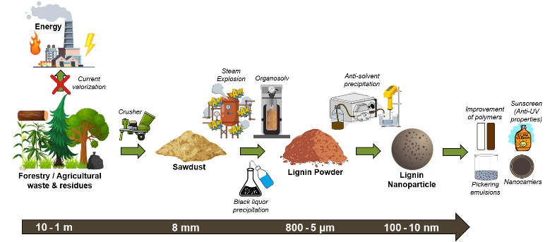
Recent Publications
- Zhang Z, Terrasson V, Guenin E (2021) Lignin Nanoparticles and Their Nanocomposites. Nanomaterials 11, 1336.
- Richter A, Bharti B, Armstrong H (2016) Synthesis and Characterization of Biodegradable Lignin Nanoparticles with Tunable Surface Properties. Langmuir.
- Yang W, Rallini M, Puglia D (2017) Role of lignin nanoparticles in UV resistance, thermal and mechanical performance of PMMA nanocomposites prepared by a combined free-radical graft polymerization/masterbatch procedure. Composites Part A.
- Nair S, Sharma S, Pu Y (2015) High Shear Homogenization of Lignin to Nanolignin and Thermal Stability of Nanolignin-Polyvinyl Alcohol Blends. ChemSusChem.
- Ma M, Dai L, Si C (2019) A facile approach to prepare super long-term stable lignin nanoparticles from black liquor. ChemSusChem.


Biography:
Victor Girard began his PhD in 2021 at the University of Lorraine within the LERMAB after obtaining an ENSTIB engineering degree specializing in biorefining. The theme of his research is the extraction and valorization of nanolignins by coupling organosolv process and steam explosion.
Email: victor.girard@univ-lorraine.fr

Notes/Comments:

Presenting author details
Full name: Victor Girard
Contact number: +33629457296
Linked In account: www.linkedin.com/in/victor-girard-273470162
Session name/ number: Nano Biotechnology / Track 10
Category: Oral presentation

