External validation of a risk prediction tool in determining early death among elderly patients initiated on dialysis
Rachelle Zolla S. Ciudadano-Manalaysay* and Trisha Michelle V. Manalaysay
Southern Philippines Medical Center, Philippines
Abstract
Aim: This study aimed to validate if the Thamer Risk Scoring Tool is a significant predictor in determining risk of early mortality among elderly patients initiated on dialysis in a tertiary hospital in Davao City, Philippines.
Background: The increase in the senior population is one of the factors that have contributed to the rise in the number of dialysis patients in the Philippines. The elderly generally has an increased risk for poor dialysis-associated outcomes and studies have been conflicting if they have better survival with dialysis as compared to conservative management. The Thamer Risk Scoring tool uses simple variables to predict early mortality in these patients; however this has not been validated in the Philippine setting.
Methods: A retrospective cohort research design was used. Patients ≥ 60 years old, diagnosed with end-stage renal disease and initiated on dialysis from 2018 to 2021 were subjected to the tool to predict 3-month, 6-month and over-all mortality after dialysis initiation, Patients with <90 days dialysis duration, recovery of kidney function and incomplete data to meet all the variables for the tool were excluded.
Results: In comparison to the Thamer study with an AUROC=0.691 for the tool in their validation cohort, this study showed an AUROC=0.6245, 0.2847 and 0.5993 in the 3-month, 6-month and over-all mortality groups respectively [Figure 1]. As the score increased for the three groups, the tool became less sensitive and more specific with a concomitant increase in accuracy for predicting mortality.
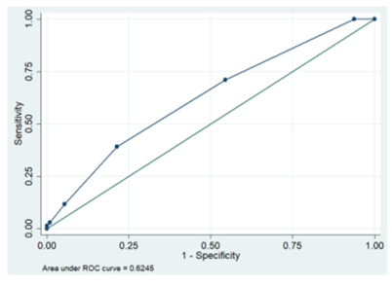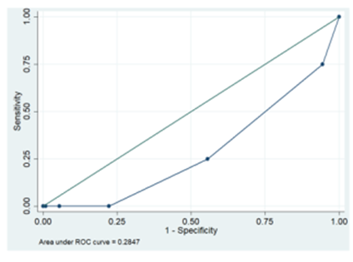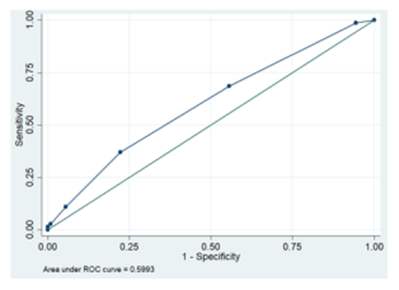
Figure 1. Area under the ROC curve of risk prediction tool to predict 3rd, 6th month and overall mortality.
Conclusion: Despite the poor performance of the tool in predicting mortality in terms of AUROC in this study, the sensitivity and specificity had a similar performance in the Thamer study. Furthermore, the consistent trend of accuracy of predicting mortality in these groups reflects that a higher score portends to a higher accuracy in predicting mortality.
Biography
Rachelle Zolla S. Ciudadano-Manalaysay is a young nephrologist who was trained in Davao City, Philippines. Her interests include dialysis, renal transplantation, critical care nephrology and glomerular diseases.

