Corrugated steel fiber-reinforced renewable waste rubber sustainable concrete: Mechanical and durability performance
Linlin Zhang¹, Baodong Liu¹, Haibo Sun² and Zhihong Wang³
¹Beijing jiaotong University, China
²Shandong Provincial Transportation Planning and Design Institute, China
³Hengshui Yitong Pipe Industry Co., Ltd, China
Abstract
Statement of the problem: Due to environmental problems like the depletion of natural resources and the creation of massive wastes, modern civilization is currently moving toward sustainability. Tire waste, such as abandoned cars, causes great environmental worry; therefore recycling them into new concrete aggregates is a steadfast step towards sustainability. Researchers have reported that the presence of waste rubber particles in concrete has a negative impact on its mechanical properties. Notably, adding fibers to Rubberized Concrete (RuC) has shown to be a novel approach to overcoming its shortcomings. Although numerous studies have concentrated on RuC, there is a significant research gap in Corrugated Steel Fiber-Reinforced Rubber Concrete (CSFRRuC) because so few studies have looked into it. The purpose of this study is to investigate the mechanical and durability properties of corrugated steel fibers reinforced waste rubber concrete to advance the construction sector.
Methodology & theoretical orientation: Investigations were done into how five different corrugated steel fiber and rubber volume ratios affected the mechanical and durability properties of the CSFRRuC specimens. The compressive, flexural, splitting tensile, impact, capillary permeability and elevated temperature performance properties were thoroughly investigated and the results of the tests were confirmed by microstructural analysis [Figure 1].
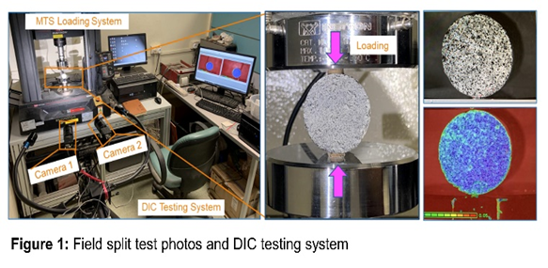
Figure 1. Field split test photos and DIC testing system.
Findings: An increase in the volume fraction of corrugated steel fibers led to a significant improvement in all mechanical properties. In addition to the negative impact of using rubber on compressive strength and high temperature resistance, other performance indicators of CSFRRuC samples, such as flexural strength, impact resistance and splitting tensile strength values, were significantly improved with the use of rubber.
Conclusion: The usage of waste rubber fibers in the production of CSRRuC was advantageous in terms of some mechanical and durability properties. The sustainable applications can be further explored with the combination of corrugated steel fiber and recycled rubber aggregate.
Biography
Baodong Liu has professional knowledge of bridge engineering materials and is keen to improve the anti-collision and durability of bridges. Based on the energy consumption characteristics of rubber concrete materials, it provides a new way for scientific disposal of waste tires. Based on the theory and practice, a reasonable scheme of rubber concrete cladding in the collision and vibration reduction of beam bridges is proposed. He has accumulated many years of experience in the research, teaching and management of educational institutions and proposed the calculation method of energy consumption of rubber concrete materials and the optimization design method of collision and vibration reduction of rubber concrete coating. This method can effectively reduce the damage of the bridge under vehicle impact and earthquake and improve the resilience of the bridge.

