Complete valorization of lignocellulosic and industrial wastes for lactic acid production: Process optimization, kinetic assessment and artificial intelligence modeling
Anthea Naomi David
University of KwaZulu-Natal, South Africa
Abstract
Microbial conversion of waste-derived-lignocellulosic biomass to high value bioproducts such as Lactic Acid (LA) has become an emerging concept in the race towards a more sustainable future. However, lignocellulosic bioprocessing units often demand expensive and resource intensive pretreatment and fermentation technologies that lead to low product yields. To address these issues, this study developed and optimized two complete Kraft waste-based lignocellulosic pretreatments, namely, (1) Steam-assisted Green Liquor Dregs and Paper Waste Water (SGLD-PWW) and (2) Microwave-assisted Green Liquor Dregs and Paper Waste Water (MGLD-PWW) methods for enhanced sugar release from Corn Cob Wastes (CCW). The data recorded maximum reducing sugar (>1 g/g) and glucose yields (>0.5 g/g) for both the SGLD-PWW and MGLD-PWW pretreatments. Interestingly, the reducing sugar and glucose yields increased by 32% and 40%, respectively, for the SGLD-PWW pretreatment compared to the MGLD-PWW pretreatment. Moreover, the Kraft waste-based pretreatment outputs were used to develop a process model from machine learning for accurate glucose yield prediction. Following pretreatment, the co-valorization of dairy wastewater and SGLD-PWW pretreated CCW for simultaneous saccharification and Lactic Acid (LA) production (sDWW-SSF) was modelled and optimized with a LA concentration and conversion of 11.15 ± 0.42 g/L and 18.90 ± 0.75%, respectively. Subsequently, microbial cell growth and LA production kinetics were determined. Further optimization studies were undertaken for improvement of LA production using liming and nanoparticle supplementation. These factors contributed to a >2-fold LA concentration increase in comparison to the sDWW-SSF process. Findings from this study demonstrate significant potential to tackle global challenges centered around food, energy and water by: (1) utilizing lignocellulosic wastes that do not impact food security, (2) applying Kraft and dairy wastes that eliminate chemicals and/or fresh water usage during pretreatment and fermentation, (3) generating high sugar for the microbial production of value-added compounds (LA) and (4) speeding up the trajectory of industrial implementation using prediction tools (Figure 1).
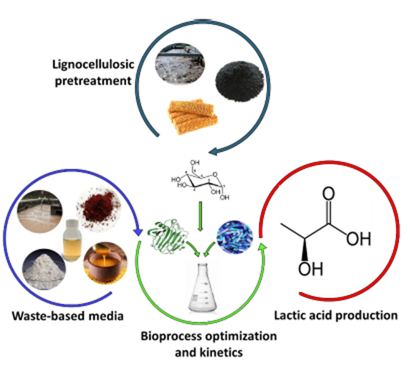
Figure 1. Overview of the lignocellulosic biorefinery process.
Biography
Anthea David is pursuing her Doctoral degree at the University of KwaZulu-Natal in South Africa. She is currently working on waste valorization and production of value-added bio-products. As part of her research, she aimed to establish a novel pretreatment strategy using green liquor dregs for enhanced glucose recovery from lignocellulosic biomass as well as process optimization and kinetic assessment on various bioethanol fermentation processes. Moreover, she has extended working in this research by engaging in a complete waste-based pretreatment method using Kraft waste (green liquor dregs and paper wastewater) as a chemical and freshwater replacement. Furthermore, a co-valorization concept was initialized from pretreated corn cobs and dairy wastewater for simultaneous saccharification and lactic acid production. This concept has bought about 4 publications in high impact, DoHET accredited journals for bioprocessing and biotechnology. Her enthusiasm for research has become an integral part of her decisions to further work towards her PhD research and academia.

