Cardioprotective effect of c-kit^{ve} amniotic fluid mesenchymal stem cells in an in-vitro model of myocardial ischemia reperfusion injury
Manali Jain
Sanjay Gandhi Postgraduate Institute of Medical Sciences, India
Abstract
Myocardial Ischemia-Reperfusion Injury (MIRI) is the main pathological manifestation of heart failure. Recently, c-kit^{ve} Amniotic Fluid Mesenchymal Stem Cells (c-Kit^{+ve} AF-MSC) have been shown to have cardiomyogenic potential under in vitro conditions. While the c-Kit^{+ve} AF-MSC demonstrated limited homing and differentiation within cardiac tissue, there was still enhanced vascularization of ischemic cardiac tissue. Thus, it has proposed that beneficial effects of these cells are attributable to their modulatory paracrine factors rather than directly from transplanted cells. However, no direct comparison between c-Kit^{+ve} AF-MSC cell based and cell-free therapy has been reported till date. Therefore, in this study, we have evaluated the cardioprotective effect of the c-Kit^{+ve} AF-MSC and their derived secretome and Extracellular Vesicles (EVs) in an in vitro model of MIRI. To establish an in vitro model of MIRI injury, primary human cardiomyocytes were subjected to oxygen (1% oxygen, 94% nitrogen and 5% CO₂), glucose (1%) deprivation (OGD), followed by reoxygenation (12 h). Cell viability was assessed by MTT assay and cell apoptosis TUNEL assay on days 1,3 and 5 of co-culture with c-Kit^{+ve} AF-MSC, Secretome and EVs. The findings revealed that I/R injury resulted in a significant decrease in cell survival rate in cardiomyocytes. When injured cardiomyocytes are co-cultured with c-Kit^{+ve} AF-MSC and their derived secretome and EVs, there is an increase in cell survival after 1,3 and 5 days. However, co-culture with c-Kit^{+ve} AF-MSC secretome significantly rescued the cells after MIRI compared with c-Kit^{+ve} AF-MSCs. Moreover, apoptosis was low in healthy cardiomyocytes but increased after I/R injury (Figure 1). Following co-culture with c-Kit^{+ve} AF-MSC, secretome and EVs; there was a significant reduction of these TUNEL-positive cells on days 1,3 and 5. Overall, our study highlights that secretome-derived c-Kit^{+ve} AF-MSC is a better source to rescue the I/R induced injury of cardiomyocytes than c-Kit^{+ve} AF-MSC or EVs, suggesting that the paracrine factors released by c-Kit^{+ve} AF-MSC may be sufficient to ameliorate the in-vitro MIRI.
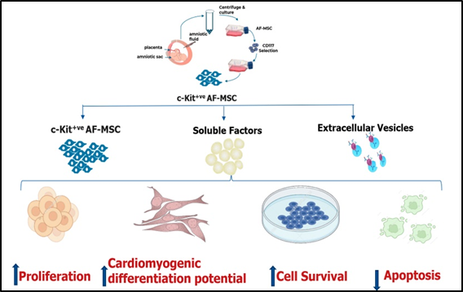
Figure 1. c-Kit^{+ve} AF-MSC possesses significantly high in-vitro differentiation potential and secretome derived c-Kit^{+ve} AF-MSC derived is a better source to rescue the hypoxia induced injury of cardiomyocytes than c-Kit^{+ve} AF-MSC or EVs, suggesting that the paracrine factors released by c-Kit^{+ve} AF-MSC may be sufficient to ameliorate the cardiac injury in-vitro.
Biography
Manali Jain is a PhD Scholar in the department of Haematology, Sanjay Gandhi Post-Graduate Institute of Medical Sciences, Lucknow, India. She is presently working in the field of cardiac regenerative potential of amniotic fluid stem cell.

