Pharmacokinetics of intradermal administration of Recombinant Human Growth Hormone (RHGH) using microneedle delivery system and its comparison with intramuscular administration as well as intradermal administration using conventional needle: A preclinical study
Bajwa Ishumeet K
Post Graduate Institute of Medical Education & Research, India
Abstract
Statement of the problem: Microneedles facilitate drug delivery into the dermis layer of skin, with minimum pain. To study the safety and efficacy of indigenously developed microneedles, we evaluated the pharmacokinetics of a test drug in guinea pigs, in comparison to intramuscular and intradermal administration using conventional hypodermic needles.
Methodology: Thirty animals were injected commercially available rhGH (somatropin) 1 mg/kg either Intra-Muscularly (IM) using 23G needle, Intra Dermally (ID) using 26G needle, or intradermally using Micro-Needle (MN). Plasma GH levels were measured serially over 24 hours using electrochemiluminescene assay and Pharmacokinetic (PK) parameters were calculated.
Findings: The test drug was successfully delivered through the microneedles. The median (IQR) wheal size was comparable to that with conventional intradermal injection (0.19 vs. 0.1). There were no adverse events viz. bleeding, erythema, swelling, induration, sign of pain, anxiety or discomfort, confirming safety. Mean (SD) bioavailability calculated using AUC was 444.7 (± 45.88 SD) ng.h/ml, 348.72 (± 81.23 SD) ng.h/ml and 705.71 (± 254.78 SD) ng.h/ml for ID, MN and IM injection respectively. The respective mean (SD) Tmax values were 75 min, 78 min, 120 min These differences were not statistically significant, AUC for MN vs. ID (p value=0.49); for MN vs. IM (p value=0.30); and for ID vs. IM (p value=0.53) and Tmax for MN vs. ID (p value=0.85); for MN vs. IM (p value=0.01); and for ID vs. IM (p value=0.0008) [Figure 1].
Conclusion: These data confirm that intradermal injection through microneedles is safe and efficacious, paving the way for clinical studies in human subjects.
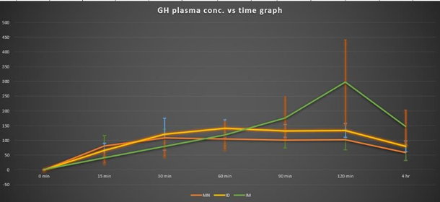
Figure 1. Image depicting the GH plasma concentration vs. time graph and error bars representing the standard deviation obtained by GH delivery through MN, ID and IM at above time points in guinea pigs.
Biography
Ishumeet Kaur Bajwa completed her Master’s in Pharmacology and is pursuing PhD at the Post Graduate Institute of Medical Education and Research, Chandigarh, India. She has worked and developed various animal models including Alzheimer’s disease, wound healing and Diabetes and has 6 years of experience in the field of research and preclinical studies. She is currently working on novel drug and vaccine delivery system using microneedles in animal models of guinea pigs, rats and mice. Her thesis focuses on the evaluation of pharmacokinetics and pharmacodynamics of the drug and immunogenicity of vaccine delivered through intradermal route using novel microneedle systems. Her future goal is to take her study to the next level of clinical trials which could revolutionize childhood vaccination program.

