Poly(ionic liquid)s for photocatalytic CO₂ conversion
Chengcheng Liu
Shandong University, China
Abstract
Poly-Ionic Liquids (PILs) refer to polymers polymerized by Ionic Liquids (ILs) monomers. ILs and PILs have been widely used in CO₂ conversion. Their ionic microenvironment and special hydrogen bonds can enrich and activate CO₂ efficiently, thus facilitating the conversion of CO₂ under mild conditions. At present, the applications of PILs in CO₂ conversion mainly focus on thermal catalysis and electrocatalytic CO₂ conversion. Their applications in photocatalytic CO₂ conversion are rarely reported. Photocatalytic CO₂ conversion can convert CO₂ into high value-added fuel and store solar energy in the fuel, which is one of the important means to overcome the energy crisis and reduce environmental pollution. However, due to the high C=O dissociation energy of CO₂, photocatalytic CO₂ conversion still faces the problems of low conversion rate and serious hydrogen evolution side reactions. Due to its unique ion pair structure and strong structural design ability, PILs have great potentials in photocatalytic CO₂ conversion. The main limiting factor for applications in photocatalysis is the poor photoexcitation ability of PILs. In the previous studies, the author found that the introduction of electron donor-acceptor structure into PILs can significantly improve the separation and migration rate of photogenerated carriers in the PILs structure [Figure 1]. The synthesized PILs show high catalytic activity in both photocatalytic CO₂ reduction and photo-driven CO₂ cycloaddition reactions. Through the transient absorption and other spectral studies combined with the Density Functional Theory (DFT) and Time-Dependent Density Functional Theory (TD-DFT) calculations, it was found that there was a strong built-in electric field in the designed PILs molecules. The built-in electric field could provide a driving force for the separation and directional transmission of photo-carriers in PILs, thus promoting the photo-catalyzed/photo-induced CO₂ conversion.
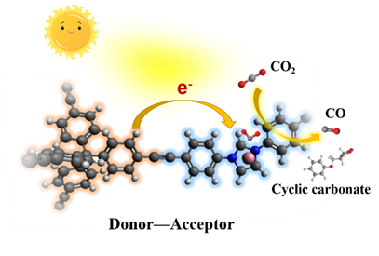
Figure 1. PILs with donor-acceptor structures for photocatalytic CO₂ conversion.
Biography
Chengcheng Liu is an associate researcher at the Institute of Frontier and Interdisciplinary Science, Shandong University. She received her PhD degree in materials science under the supervision of Prof. Buxing Han and Jianling Zhang from Institute of Chemistry, Chinese Academy of Sciences (ICCAS) in 2017. Then she worked as a postdoctoral researcher at the University of Manchester (2017-2019). Her research interest is developing functional porous materials toward their applications in energy fields.

