Is upper medial canthus compression enough during filler injection in glabella?
Ahmad Nazari
Tehran University of Medical Science, Iran
Abstract
Hyaluronic Acid (HA) fillers have been widely used for reversing the signs of the aging face. Injectable fillers are particularly effective in treating vertical glabellar wrinkles. One of the dangerous complications of this injection is blindness. While many studies suggest compressing the upper medial canthus region with a non-dominant finger while injecting in the vertical wrinkles of the glabella region, we investigated by ultrasound how effective the compression is in this region in avoiding retrograde embolism (Figure 1).
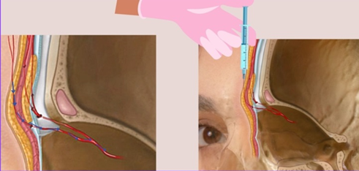
Figure 1. Retrograde embolism mechanism.
165 clients of an Aesthetic clinic from September 2022 to November 2022 were randomly subjected to 20 MHz high frequency power Doppler imaging (clarius L20 HD3, Canada). First, ultrasound was performed transversely in the glabella area to determine the prevalence of central and paracentral arteries. In cases where the artery was within one centimeter of the midline of the glabella region, simultaneously with the placement of the probe transversely (Figure 2), the area above the Medial canthus was compressed with the index figure (Figure 3).
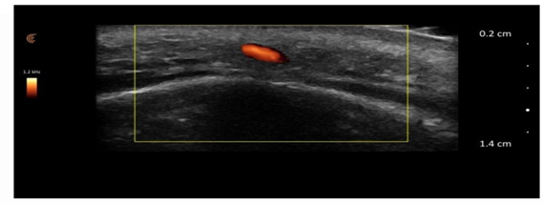
Figure 2. Transverse ultrasound in the line between the two eyebrows. No compression on the upper area or medial the medial canthus.
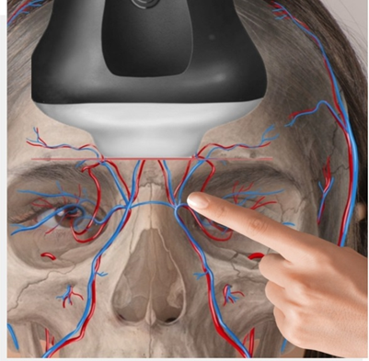
Figure 3. Compressing region above the medial canthus.
If the blood flow was still visible in the power Doppler like (Figure 4), the medial area was pressed to the inner canthus with another finger and the blood flow was checked in the power Doppler (Figure 5).
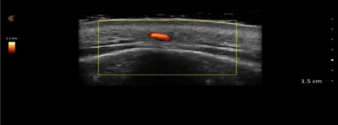
Figure 4. Transverse ultrasound on the line between the two eyebrows simultaneously with compression on the area above the medial canthus. Blood flow is observed.
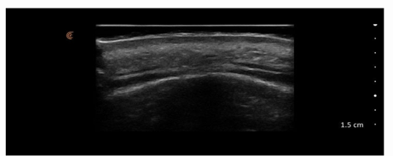
Figure 5. Transverse ultrasound on the line between the two eyebrows simultaneously with compression on the area above and inner the medial canthus. Blood flow is not observed.
The purpose of doing this study was to determine whether it is sufficient to compress the area above the medial canthus alone, or whether the area medial to the medial canthus should also be compressed. In 48 cases (29%) of 165 cases, the artery was located within 1 cm of the midline of the glabella region. One artery was observed in 23 cases (13.9%), two arteries in 15 cases (9%), three arteries in 7 cases (4.2%) and four arteries in 3 cases (1.8%). In all the cases where the artery was within 1 cm of the midline, only in 60% of the cases, by compressing the upper part of the internal canthus, the blood flow of the glabella region was stopped in Power Doppler and in all cases, by compressing the upper part and inside the medial canthus, blood flow was not observed in the glabella region. The results of these observations suggest that the compression of the upper part of the medial canthus alone is not enough to avoid retrograde embolism and it is better to also compress the inner part of the medial canthus during filler injection in the glabella region.
Biography
Ahmad Nazari is an Assistant Professor of Sports Medicine School of Medicine Iran University of Medical Sciences, Iran. He is an Aesthetic Trainer for more than 1000 medical Doctors at CROMA-Austria from 2022 to until now, CLARIUS-Canada from 2022 to until now and TUMS Aesthetic course training from 2019–2022. He is an Ultrasound Trainer at Clarius-Canada/Iran. He has experience in neuroimaging at fMRI and Neurotract, Iran. He has 6 years’ experience in Aesthetic Clinics, Iran. He has given more than 10 Seminar as Speaker. He has published more than 30 Articles and few are under review. He is writing a chapter in a book in Maxillofacial for Springer.

