Changes in body composition and atherosclerosis parameter in elderly during the COVID-19 pandemic
Bomin Kim* and Young Jin Tak
Pusan National University Hospital, South Korea
Abstract
Introduction: The COVID-19 pandemic had a significant impact on public health globally, including in South Korea. The implemented government measures such as lockdowns and social distancing resulted in poor dietary and exercise habits among the elderly population, leading to various detrimental health outcomes. This study aims to investigate objective changes in body composition values and atherosclerosis parameters among the elderly during the pandemic.
Methods: This retrospective cohort study involved 145 adults aged 65 years or older. Medical data from the Health Promotion Center of Pusan National University Hospital were collected for two time intervals: the year prior to the COVID-19 (January 01 2017 to December 31 2019) and the year during the pandemic (January 01 2020 to December 31 2022). We analyzed the mean differences in weight, body mass index, muscle and fat percentage, arterial stiffness (ABI, brachial-ankle PWV) and laboratory results including lipid profile.
Results: The average age was 70.2 years with baseline underlying diseases of diabetes, hypertension and dyslipidemia. As a result, the body fat mass increased by 1.10 ± 1.41 kg and the waist circumference also increased by 0.479 ± 1.61 cm, whereas muscle mass decreased by -1.72 ± 1.72 kg. Regarding the atherosclerotic components, baPWV level increased by 169.12 ± 5.51 cm/s during the pandemic (all p<0.05) (Table 1). Pearson correlation showed that comorbidities, smoking history and lack of physical activity levels were all negatively associated with changes in body composition and atherosclerotic values, respectively.
Table 1. Changes in body compositions and laboratory results and atherosclerotic index in COVID-19.
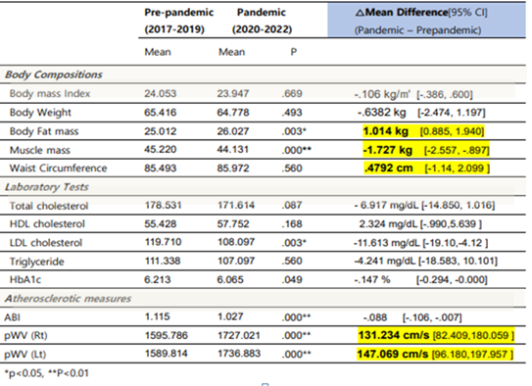
Conclusions: The study demonstrated a significant increase in waist circumference, body fat percentage and arterial stiffness in adults aged over 65 during the COVID-19. The dangerous combination of geriatric obesity and sarcopenia exacerbated during the pandemic, leading to an increased risk of metabolic and cardiovascular disease in Korea. These landmark results suggest an implementation of precise quarantine guidelines and preventive care plans for geriatric health.
Biography
Bomin Kim is an aspiring young family medicine doctor with a genuine passion for comprehensive primary healthcare. After completing her medical degree at Pusan National University, she is pursuing her last residency year with broad range of skills in managing chronic illnesses, as well as focusing on preventative care and health maintenance. With variety of experience in the last five years, she has gained valuable experience and has established herself as a trusted, compassionate and skillful physician in her clinic. Inspired by expert senior associates in her hospital, she plans to continue her specialty and PhD degree on obesity and geriatric medicine.

