Isolation of mutants from random mutagenesis library using yeast surface display of stem-derived immunogen of influenza A H1N1 viruses
Nisha Bhandari*, Poorigali Raghavendra Rao and Raghavan Varadarajan
Indian Institute of Science, India
Abstract
The conserved stem region of surface glycoprotein hemagglutinin (HA) of the influenza virus is one of the primary targets for designing an effective universal influenza vaccine, as it can elicit broadly cross-reactive antibodies against different HA subtypes. We designed a ‘headless’ HA stem immunogen H1HA21F (F:Foldon) based on the HA sequence from A/Brisbane/59/2007. Upon FACS analysis, binding to stem-directed bnAbs CR9114 and CR6261 without foldon was higher than with foldon. To further improve the biophysical properties and, thus, the immunogenicity of this stem-derived immunogen, we constructed a random mutagenesis library [Figure 1] on the background of H1HA21. The library was displayed on the yeast cell surface; after multiple rounds of enrichment for enhanced binding to the bnAb CR9114, we isolated H1HA21-3P and H1HA21-4P mutants. Mutants and wild-type stem immunogens were expressed and purified from E. coli and will be tested for immunogenicity and protective efficacy in mice.
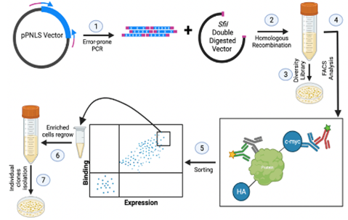
Figure 1. Random mutagenesis library.
Biography
Nisha Bhandari is in the final year of PhD studying influenza vaccine design at IISc, India, under Prof. Raghavan Varadarajan (Department: Molecular Biophysics Unit). Her primary research interest lies in developing a universal vaccine against the influenza virus. Her research involves subjecting the 'headless' HA stem immunogen to a random mutagenesis library to improve its biophysical properties and immunogenicity. To achieve this, she used yeast cells to display the immunogen and conducted FACS sorting and analysis for further characterisation.

