The immunoregulation effect of TFEB in dendritic cells on asthma
Fengxia Ding* and Bo Liu
Chongqing Medical University, China
Abstract
Introduction: Asthma is a common chronic disease in children and Dendritic Cells (DCs) play a crucial role in the immunoregulation of asthma. It’s reported that overexpression of the Transcription Factor EB (TFEB) alters lysosomal activity and function, enhances MHC II antigen presentation, activates CD4⁺ effector T cells (Teffs), thus promotes immune activation. Therefore, TFEB may play a critical role in DCs antigen presentation and Teffs activation. However, the immunoregulation role of TFEB in asthma has not been reported.
Methods: Peripheral blood was collected from asthmatic children and TFEB mRNA was detected. A House Dust Mite (HDM)-induced asthma model was established to detect the TFEB, the MHC II and costimulatory molecules (CD40, CD80 and CD86) in DCs and the CD4⁺ effector T cells (Teffs), including Th1, Th2 and Th17 in vivo. After TFEB was inhibited, the expression levels of MHC II and costimulatory molecules (CD40, CD80 and CD86) in DCs, the Teffs and asthma phenotype were detected. Further, the specific mechanisms were further explored.
Results: TFEB mRNA expression levels in peripheral blood of asthmatic children were significantly higher compared with healthy controls. In vivo and in vitro experiments showed that TFEB expression levels in lung tissues and DCs of asthmatic mice increased significantly after HDM treatment. Inhibiting TFEB expression resulted in a decrease in MHC II and CD40 expression in DCs, as well as a decrease in Th1, Th2 and Th17 cell subsets. Meanwhile, inhibiting TFEB expression levels decreased airway hyper responsiveness, airway inflammation, serum IgE, eosinophil and total cell count in alveolar lavage fluid in the asthma model [Figure 1].
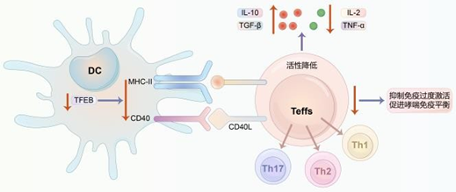
Figure 1. The immune balance in asthma promoted by down-regulation of TFEB in Dendritic Cells (DCs).
Conclusion: TFEB expression is increased in asthma. Inhibiting TFEB expression levels in asthma can protect against immune over activation by suppressing MHC II and CD40 in DCs and reducing the activation of Teffs, thus playing a protective role in asthma.
Biography
Fengxia Ding is a respiratory medicine physician and pediatrician from Children's Hospital of Chongqing Medical University, one of the top three children's hospitals in China. Now she is working as a post doctor in Great Ormond Street Institute of Child Health, University College London (UCL). She has been working as a pediatrician for 7 years in Children's Hospital of Chongqing Medical University and there are more than 19,000 outpatient pediatric patients visit she every year. She got a patent in respiratory diseases and she has over 30 publications focusing on respiratory disease and asthma. She has presented her clinical and research work at many conferences and got many grand’s on her researchers.

