Regulation of metabolic reprogramming in alveolar macrophages alleviates lipopolysaccgaride-induced acute respiratory distress syndrome
Bo Liu*, Fengxia Ding, Yan Li, Hongbo Li, Yonggang Li, Chun Wu and Zhengxia Pan
Chongqing Medical University, China
Abstract
Introduction: Acute Respiratory Distress Syndrome (ARDS) is a common clinical critical illness with a high mortality rate and currently lacks effective prevention and treatment measures. Imbalance in alveolar macrophage polarization plays a crucial role in the occurrence and development of ARDS, but the specific mechanisms underlying alveolar macrophage polarization are still unclear.
Methods: In vivo experiments were conducted using intratracheal administration of LPS to establish an ARDS mouse model, while in vitro experiments utilized LPS-induced MH-S mouse alveolar macrophages to observe changes in metabolism and phenotype during ARDS. The therapeutic effects of the addition of the glycolysis inhibitor 2-DG were observed and the specific mechanisms were explored.
Results: In LPS-induced ARDS mice, significant inflammatory responses and lung tissue damage were observed, accompanied by an increase in glycolysis levels. The addition of 2-DG markedly alleviated LPS-induced lung injury and reduced inflammation. Mechanistically, LPS induction increased glycolysis levels in alveolar macrophages, promoting polarization towards the M1 pro-inflammatory phenotype. Inhibiting glycolysis shifted alveolar macrophages from the M1 pro-inflammatory phenotype to the M2 anti-inflammatory phenotype [Figure 1].
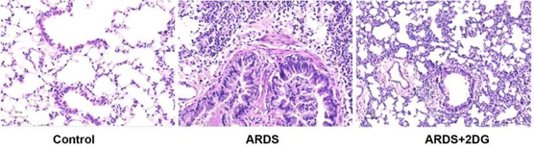
Figure 1. In the lung tissue of ARDS mice, there is evident infiltration of inflammatory cells, thickening of alveolar septa and interstitial edema. The glycolysis inhibitor 2-DG can alleviate these pathological changes.
Conclusions: Metabolic reprogramming, represented by glycolysis, plays a significant role in alveolar macrophage polarization and modulating the metabolism of alveolar macrophages may be a potential therapeutic approach for ARDS.
Biography
Bo Liu is a cardiothoracic surgeon who has been working at the Children's Hospital of Chongqing Medical University for 7 years. His primary responsibilities include providing diagnosis and treatment for thoracic and cardiovascular-related diseases, training and educating medical students and conducting research on the mechanisms and prevention of acute lung injury. Over the course of his career, he has published numerous research articles in reputable medical journals and has been invited to speak at various international conferences. He is highly respected among his peers and patients alike for his dedication to providing high-quality medical care and his commitment to advancing medical knowledge through research and education.

