A systematic review and meta-analysis of prophylactic fluconazole for invasive candidiasis in preterm infants
Marfel Coleen P. Vergara*, Shiela Marie A. Galang and Mariene Jhane R. Semilla
National Children’s Hospital, Philippines
Abstract
Rationale: Invasive candidiasis is a serious condition that occurs more commonly in vulnerable populations, such as in preterm neonates especially those in intensive care units. Antifungal prophylaxis has been suggested to decrease mortality in this vulnerable population, with fluconazole as the drug of choice because of its ability to treat more than 90% of Candida species isolates.
Objective: To determine the efficacy and safety of fluconazole in preventing invasive candidiasis in preterm infants.
Methodology: Publications were searched through PubMed, Cochrane, HERDIN plus, Google Scholar, ResearchGate, ClinicalTrials.gov, medRxiv, Epistemonikos, WHO International Clinical Trials Registry and ALIBATA, without language restriction. Randomized controlled trials that compared the effect of prophylactic oral or systemic fluconazole versus placebo in preterm infants, done from January 2000 until present, were included. The methodological quality of the studies were assessed based on the (1) randomization process, (2) deviations from intended interventions, (3) missing outcome data, (4) measurement of the outcome and (5) selection of the reported result and a meta-analysis was conducted using STATA [Figure 1].
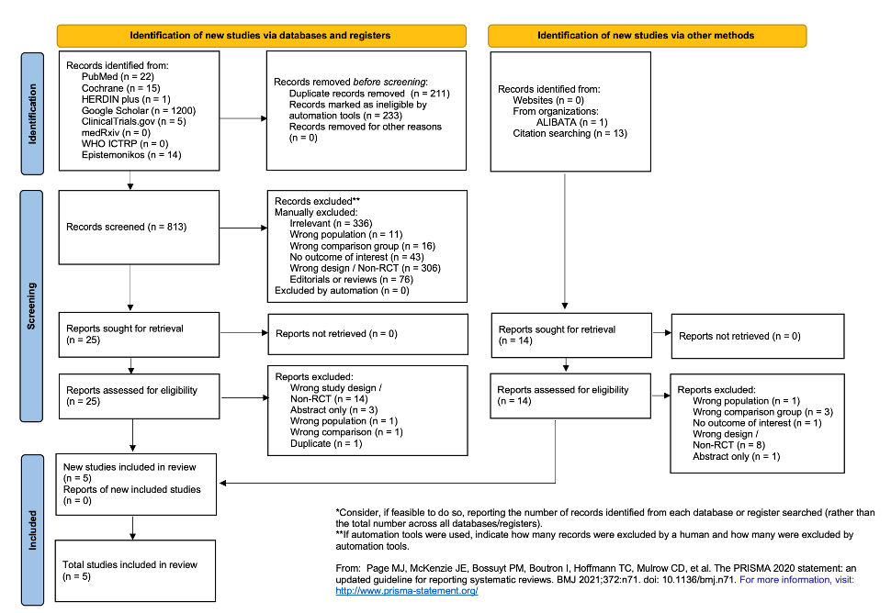
Figure 1. PRISMA 2020 flow diagram.
Results: A total of 5 studies were included, with a total of 1084 preterm infants. Prophylactic fluconazole significantly reduced the incidence of invasive candidiasis by 60% (RR=0.40; 95% CI: 0.21, 0.77; p=0.006). The incidence of mortality (RR=0.84; 95% CI: 0.6, 1.2; p=0.324) and necrotizing enterocolitis (RR=0.94; 95% CI: 0.61, 1.44; p=0.770) did not increase among infants give fluconazole prophylaxis as compared to placebo. Fluconazole prophylaxis resulted to a higher mean length of hospital stay versus placebo (SMD=0.16; 95% CI: 0.02, 0.30; p=0.022). Decrease in the incidence of IC also did not depend on the age at first dosage, whether given at 72nd or 120th hour of life (p=0.047, p=0.035), or the dosage used, whether given at 3 mg/kg or 6 mg/kg (p=0.0043, p=0.0002) [Figure 2].
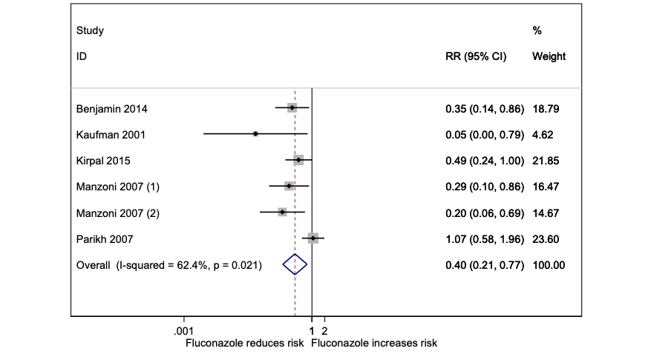
Figure 2. The efficacy of fluconazole vs. placebo on invasive fungal infection.
Conclusion: The use of prophylactic fluconazole decrease invasive fungal infection in preterm infants. While there is no noted increase in mortality and adverse effects, larger clinical trials with longer follow-up periods are still recommended to comprehensively assess the safety profile of fluconazole prophylaxis among preterm infants.
Biography
Marfel Coleen P. Vergara is a pediatrician from National Children’s Hospital, Philippines. She received a bachelor’s degree in cell and molecular biology from University of the Philippines and finished Doctor of Medicine program at St. Luke’s Medical Center College of Medicine in Metro Manila, Philippines. She is currently in the Department of Health, serving a local hospital to help the needs and improve the health and wellbeing of the poor Filipino children.

