A green and facile approach for synthesis of 1,3-disubstituted triazoles using magnetic nanocomposite in aqueous media
Yachana Jain¹* and Ragini Gupta²
¹S.S. Jain Subodh P.G. Mahila Mahavidyalaya, India
²Malaviya National Institute of Technology Jaipur, India
Abstract
A simple sonochemical technique for fabrication of a magnetic nanocomposite of GO-Fe₃O₄@CuO and magnificently used synthesis of regioselective 1,4-disubstituted 1,2,3-triazoles. This catalyst easily separated from the reaction media using an external magnet and recycled up to eight consecutive runs without noticeable drop in the desired product yield. Other noteworthy features of this green protocol are negligible metal leaching from the support during reaction, high yield in lesser time, aqueous media and good results with gram scale synthesis. Representative compounds were also screened for their cytotoxic activity against PC-12 cell line using standard MTT assay and flow cytometry. Trifuoromethyl group containing triazole derivative (3f) displayed cytotoxic activity (IC₅₀ 8.3 µg/mL) comparable to the standard drug cisplatin (IC₅₀ 5.8 µg/mL) [Figure 1].
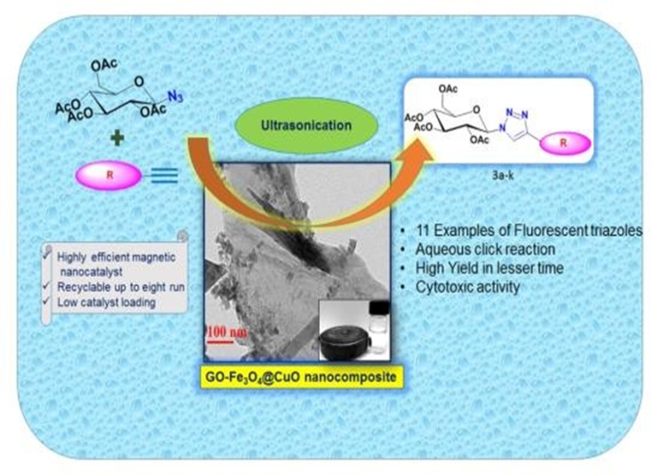
Figure 1. Graphical abstract.
Biography
Yachana Jain was born in Ajmer, Rajasthan in 1986. She has graduated in Science (Zoology, Botany and Chemistry) from Savitri Girls College affiliated to MDS University, Ajmer. She has pursued her Master’s degree in Chemistry from Government College, Ajmer during 2008-2010. After completing master’s degree, she cleared GATE exam. She joined the research group of Dr. Ragini Gupta, Professor, Malaviya National Institute of Technology Jaipur, Jaipur on July, 2013 and started her research work on “Green Protocols for the Synthesis of Fluorescent Coumarin Linked Sugar/Amino acid 1,4-Disubstituted 1,2,3-Triazoles via Click Reaction”. She presented research work in various national and international conferences. She also has fifteen publications (research articles and review) in international journals of repute in the area of Chemistry.

