Alterations in diversity of gut microbiome during schizophrenia
Ayesha Ameen
University of Management and Technology, Pakistan
Abstract
The gut microbiome, which refers to the collection of microorganisms that reside in the digestive tract, is thought to have a significant role in the emergence of neurological disorders, including schizophrenia. Recent studies indicate that people with schizophrenia exhibit changes in their gut microbiomes, characterized by lower levels of beneficial bacteria like Bifidobacterium and Lactobacillus and higher levels of potentially harmful bacteria such as Proteobacteria. Additionally, research reveals that the communication between the gut and the brain, known as the gut-brain axis, is disrupted in individuals with schizophrenia. Although the exact mechanisms connecting the gut microbiome and schizophrenia are not yet fully comprehended, scientists propose that alterations in the gut microbiome could impact the immune system and neurotransmitters, thereby contributing to the development of the disorder. Interventions targeting the gut microbiome, such as probiotics and the Mediterranean diet, present a promising therapeutic approach for individuals with schizophrenia. However, further investigation is necessary to fully understand the intricate interplay between the gut microbiome and schizophrenia, including the specific mechanisms through which the gut microbiome influences the development of the disorder [Figure 1].
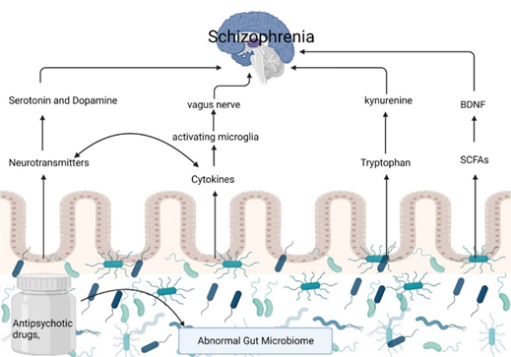
Figure 1. Illustration of different metabolites production in SCZ patients and their gut.
Biography
Ayesha Ameen is a Pakistani biotechnologist and lecturer of biotechnology at University of Management and Technology, Lahore, Pakistan. Her research interests include study of gut microbial diversity, identification of new strains of bacteria and waste management strategies to eliminate pollution from environment. She has published 14 research and review papers in good impact factor and Scopus index journals. She also holds one national patent. She received a master's degree in biotechnology from Forman Christian College University.

