Fabrication of phenolic lipid based anticorrosive coatings: Effect of aldehyde, amine and metal on film performance
Fahmina Zafar
Jamia Millia Islamia, India
Abstract
Statement of the problem: Mild steel is an inevitable component of oil, gas, chemical and construction industry due to high tensile and impact strength, good malleability, ductility, weldability and other properties. However, it is highly vulnerable to corrosion, triggered by mere presence of water with dissolved acids, oxygen and salts, involving “simple chemistry with devastating effects”. Corrosion, a silent metallic killer and a leading problem worldwide, damages industrial equipment’s or infrastructures, causes staggering global economic impact, with billions of dollars spent on its monitoring, control, damage repairs and replacements annually. Its global cost is estimated as 2.5 trillion dollars (3.4 % of GDP), in 2013 and 70.3 billion dollars in India (impacting 4.2 % of GDP), thus requiring urgent appropriate measures. The purpose of this study is to utilize CNSL (an agro byproduct and waste material) for the development of advanced anticorrosive and antibacterial coating material. It is a very cheap natural product and rich in functional attributes and therefore suitable for versatile applications via several chemical transformations.
Methodology & theoretical orientation: Firstly, ligands were prepared by chemical reactions of an aromatic ring, hydroxyl group and side chain of CNSL (Cardanol, phenolic lipid) followed by the incorporation of nanosized entity via reaction of metal salts. The all the reactions were following the principle of green chemistry. The structure of the synthesized materials and their coatings formulation were confirmed by FTIR-ATR. The present work also reports the effect of aldehyde, amine and metal on film performance. Morphology of the materials was confirmed by XRD, SEM and TEM analysis. Standard physico-mechanical, electrochemical, thermal and anticorrosive methods were used to characterize the coatings. The types and ratio/amount of contents like aldehydes, amines and metals significantly affect the film/coating performances. The results also reveal the formation of infusible, hydrophobic thermoset, mechanically robust, anticorrosive and antibacterial coatings that can be used in the field of protective coating applications [Figure 1].
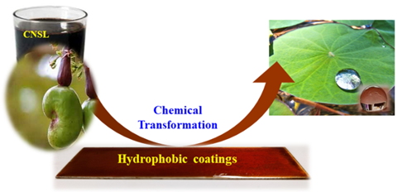
Figure 1. CNSL (cardanol) was chemically tuned into value added product for protective applications.
Conclusion: The present work proposes value-addition to an abundantly available biological feedstock in the field of anticorrosive and antibacterial coatings. The use of these CNSL based materials that synthesized in solvent free method provide an interesting approach to new and environmentally friendly anti-corrosive and antibacterial treatment of metal. It will attain a renewed interest for reasons of economy and environmental friendliness and contributes well to green chemistry practices.
Biography
Fahmina Zafar is a senior researcher working at the Department of Chemistry, JMI, New Delhi, India. She has received her PhD (2006) and MSc (1999) degree in Chemistry from JMI. She has worked as a PI (DST WOS A), postdoctoral fellow (UGC Kothari Postdoctoral Fellowship) along with Scientist Pool, Research Associate and Senior Research Fellow (CSIR) at the same Department. She has >100 publications in peer-reviewed journals and books and has presented >50 research papers in national and international conferences. Her research work involves the development of bio-based polymers, metallopolymers, organic-inorganic hybrids, coordination polymers, metal organic frameworks and nanocomposites for green environment in different fields including adsorption, antimicrobial and corrosion-protective applications.

