New ab initio calculations and collisional properties of closed shell NCCP (¹Σ⁺) by collisions with He (¹S)
Ritika and TJ Dhilip Kumar
Indian Institute of Technology Ropar, India
Abstract
In the last century, the knowledge of the Inter-Stellar Medium (ISM) has changed significantly. From the concept of vacuum between stars, modern astro-chemistry has helped us to gain a thorough knowledge of the main physical and chemical processes in various interstellar environments. By the 1960s, it had become clear that the ISM is host to a rich chemistry. In a typical interstellar cloud, the two processes that are more important for transitions between internal levels of molecules are radiative and collisional in nature with the most widespread neutral species (H, He and H₂). The analysis of the collisional processes requires information of the rate coefficients of the discovered interstellar molecules with the most abundant colliders in the ISM, which are usually unknown. Information of the collisional rate between the fixed quantum levels is necessary for the analysis of observed spectra. This makes the study of molecular collision dynamics of the utmost significance using quantum chemistry methods.
The present work deals with the quantum dynamics of collisions of interstellar molecules, NCCP with Helium (He). To begin with the construction of Potential Energy Surface (PES), dynamical studies are carried out for collisions occurring at low temperatures. An ab initio PES of NCCP-He (Figure 1) complex has a well-depth of -46.40 cm⁻¹ at the CCSD(T)-F12a/aug-cc-pVTZ level of theory. Utilizing the multiple expansions, collisional cross-sections have been determined for total energies up to 550 cm⁻¹ by close-coupling method that depicts high resonances below 80 cm⁻¹. Rotational deexcitation rates are further worked out with averaging the calculated cross-sections at temperatures below 200 K. The rate coefficients are greater for ∆j=-2 transitions in comparison to other transitions. The collision rates and other dynamical attributes between He and the molecule computed at cold temperatures will lead to model its abundance in ISM.
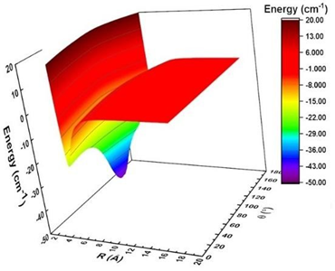
Figure 1. Potential energy surface of NCCP-He complex.
Biography
Ritika is a PhD scholar at Indian Institute of Technology, Ropar. Her research focuses on computational and theoretical chemistry. She works in the domain of ultracold chemistry and astro-chemistry. Her research interest focuses on connecting ab initio electronic structure methods with thermodynamic stabilities and kinetic rates of molecules. She uses state-of-the-art electronic structure methods (Coupled-Cluster and Multi-reference configuration interaction theories) in combination with a wide variety of techniques from quantum mechanics to solve relevant problems in chemistry. Her research topic is “Electronic structure calculations and quantum dynamical study of neutral molecule-atom collisions”.

