Ocular surface mucosal immunology in ocular graft-versus-host disease and its clinical implication
Yoko Ogawa
Keio University School of Medicine, Japan
Abstract
Ocular GVHD-related inflammation and fibrosis can be an early sign of the onset and also affects the later stage for the long term for many recipients after HSCT as irreversible consequences. Pathogenic fibrosis by interacting between immune cells and mesenchymal cells leads to ocular surface deterioration including cornea, conjunctiva, meibomian glands and lacrimal glands, resulting in a special subtype of severe and intractable dry eye disease [Figure 1]. There are no approved topical medications for severe immune-mediated fibrosis on the ocular surface at present time. We report various patterns on ocular surface fibrosis with ocular GVHD after long-term follow-up in patients after subsiding systemic cGVHD. The timing of starting treatment on ocular GVHD is limited and very narrow window of opportunity. Therefore, proper diagnosis and treatment at early stage is important to prevent severe dry eye disease related to GVHD.
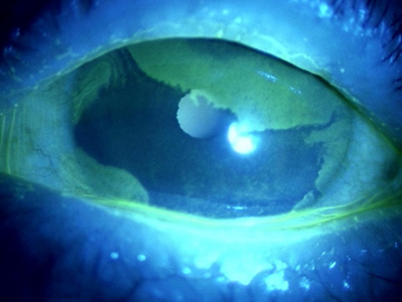
Figure 1. Irregularity of lid margin and conjunctivalization from the limbal region. Chronic diffuse abnormality accompanied with fibrotic changes seen of meibomian glands in eyelids. Conjunctivalization derived from multiple locations of the limbal region.
Biography
Yoko Ogawa has her expertise in ocular graft-versus-host disease. Recent Research Topics: Fibrosis and chronic inflammation of organs are observed in systemic autoimmune disease and graft-versus-host disease after hematopoietic stem cell transplantation. Using a scleroderma mouse, we showed that transplantation of MHC compatible, minor antigen mismatched Bone Marrow Stromal/Stem Cells (BMSCs) play a role in the pathogenesis of fibrosis. In addition, we are investigating whether senescent cells including macrophages and other immune competent cells are involved in chronic ocular graft-versus-host disease as well as other immune-mediated diseases.

