A study on hydroimplantation of Intra-Ocular Lens (IOL) in cataract surgery using anterior chamber maintainer
Tanisha Chaudhary
Guru Gobindsingh Government Hospital, India
Abstract
Statement of the study: Hydroimplantation is a technique for implantation of 1 piece acrylic foldable Intra-Ocular Lens (IOL) using an irrigating cannula of the Phacomachine also known as Anterior Chamber Maintainer (ACM) without using an Ophthalmic Viscosurgical Device (OVD). The irrigating cannula introduced through a side port provides excellent stability and positioning of the eye; if required, the cannula tip is used to guide the leading haptic of the IOL into the capsular bag. The fluid coming from the side port via a bimanual irrigation cannula maintains adequate formation of the capsular bag and the anterior chamber while the foldable IOL is inserted.
The hydroimplantation technique has the advantage of increased efficiency, reduced surgical time and cost, no need of OVD removal from behind the IOL or for additional instrumentation, no OVD-induced intraocular pressure elevation postoperatively and no risk of early capsular bag distention syndrome. In addition, sudden delivery of IOL is prevented by the screw type mechanism which allows only a limited excrusion of the plunger.
Purpose: To study the safety of single piece, foldable Intra-Ocular Lens (IOL) Hydroimplantation and analyse the advantages and complications of the procedure.
Methodology: The study is a prospective cross-sectional study. This Interventional Study was conducted between 2020 to 2022 on 25 patients including indoor patients for cataract surgery. The study was conducted in Department of Ophthalmology, Shri M.P.Shah Government Medical College and Guru Gobind Singh Hospital, Jamnagar. Informed consent was obtained from all patients and nature of study was explained.
Findings: All patients underwent hydroimplantation of IOL using Anterior Chamber Maintainer. The time taken for surgery and post-operative IOP was noted. The mean time taken for hydroimplantation of IOL was much less compared to viscoimplantation. No post-operative intraocular pressure spikes were observed.
Conclusion: This study shows that hydroimplantation has advantages in terms of IOP changes and duration of the surgery. The degree of post-operative corneal edema at 1st operative day was low grade. Even AC inflammation was mild. In the present times where people want to be operated with less operative time and rapid post-operative visual rehabilitation, cataract surgeries including hydroimplantation of IOL is one of the best options.
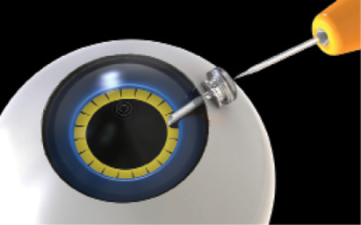
Figure 1. Trocar ACM.
Biography
Tanisha Chaudhary is presently a 3rd year resident in Ophthalmology Department, Guru Gobind Singh Hospital, Jamnagar, India. She has keen interest in the clinical practice and research work. She has been presenting posters and papers during her academic tenure and aims at improving the wellbeing of her patients and hence the society. A doctor truly empathetic and ambitious, hoping to expand the reach of recent ophthalmological practices and learning from her seniors.

