Optimization of pheromone dose and trap density for mating disruption of Chilo suppressalis (Lepidoptera; Pyriladae)
Jan Muhammad Mari* and Sajjad Ali Khuhro
Sindh Agriculture University, Pakistan
Abstract
Chilo suppressalis is an oligophagous pest that mainly feeds on rice and currently is largely controlled through the chemicals, leading to several ecological problems and often low control efficiency due to the larvae’s obscure feeding habits. The alternative techniques are urgently needed to be developed, among which the use of sex pheromones is perspective, via means of large scale of trap and kill or mating disruption. The main purpose of the present research was aimed to optimize the pheromone dose and trap density for mating disruption of C. suppressalis. In first year of trials, we tested blend mixture of two pheromones (Z11-16:Ald, Z9-16:Ald) with equal ratio (50:50) applied at different doses i.e, 50,100,200,300 and 500 µg/20 µl with various trap heights of; 3,4.5 and 6 feet. Results revealed that, 200 and 300 µg/20 µl caught significantly more numbers of C. suppressalis and resulted in lowest damage percentage (white ear and dead hearts) as compared to other doses and an insecticides treatment of Fipronal G 2%. The second year´s trials was targeting to optimizing the trap density in which 8,12,18 and 25 traps/ha were tested with a median dosage 250 µg/20 µl, based on first year’s results. It exhibited that 18 traps/ha captured maximum number of moths and reduced the significant damage symptoms followed by other 25,12 and 8 traps/ha and Fipronal G 2% (P<0.001). Therefore, 18 traps/ha with a dose of 250 µg/20 µl, could achieve better results for control the C. suppressalis in rice-growing areas and consequently minimum costs of applications as compared to the synthetic insecticide [Figure 1].
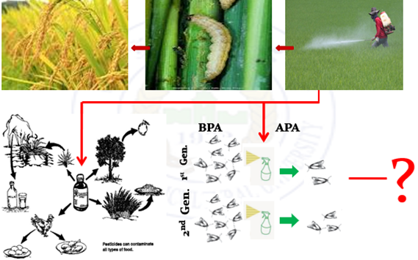
Figure 1. Graphical abstract.
Biography
Jan Mohammed Mari is currently working as First Pro-Vice Chancellor, Sindh Agriculture University Sub campus, Umerkot. His expertise is in Integrated Pest Management (IPM), biological control and ecology. During the services he taught various courses of Plant Protection and Entomology including Integrated Pest Management, Basic Ecology, Economic Entomology and IPM informatics. He also supervised a number of postgraduate students (Doctoral as well as Masters). As a Principal Investigator, he has successfully completed research projects “Documentation of Insect Pest and their Natural Enemies on Cotton crop” and “Evaluation of different hosts for the rearing of Chrysperla carnea (Stephan)”. He has also performed duty as Principal Scientist in research project “Major Insect pests of chilli in Sindh” funded by Pakistan Science Foundation (PSF), Islamabad, Pakistan. He also worked as Co-Principal Scientist in research projects “Application of Beaureria bassiania for control of pest species of gross hoppers” and “Biology and management of Chilo suppressalis by using eco-friendly tactics based on Biogenic Volatile Organic Compounds (BVOCs)” funded by Higher Education Islamabad, Pakistan.

