Green chemistry and food application: Incorporation of Rosmarinus officinalis leaves into fresh cheese
Lila Boulekbache-Makhlouf* and Hayet Himed-Idir
University of Bejaia, Algeria
Abstract
Rosmarinus officinalis L. leaves can be valorized by their uses in the production of healthy foods. Dry rosemary leaves powder and its lyophilized ethanolic extract at different concentrations (g/100 g) was used for the formulation of fresh cheeses. This study evaluated whether or not this fortification could affect some physicochemical characteristics, phenolic composition and antioxidant capacity of fresh cheeses along storage period at 5°C [Figure 1]. Results showed that this enrichment did not affect physicochemical parameters (pH, acidity, proteins, fat) of the formulated cheeses while its effect on cheese color parameters was more marked. Moreover, this incorporation has increased substantially values of Total Phenolic Content (TPC) and ABTS scavenging activity during storage period compared to the control cheese. Principal Components Analysis (PCA) was performed and results confirmed a strong relationship between antioxidant activity and these phenolic compounds. Additionally, a correlation between physicochemical parameters, antioxidant activity as well as the sensory characteristics was carried out. Cheeses fortified with 0.5%, 0.75% of powder and 0.5% of extract, were most appreciated (60%–80%) by the panelists. In conclusion, the consumers can successfully use rosemary as dairy supplements as it improves markedly the TPC and the antioxidant activity of cheese as well as a distinctive taste, aroma and acts as flavor enhancer for better acceptability.
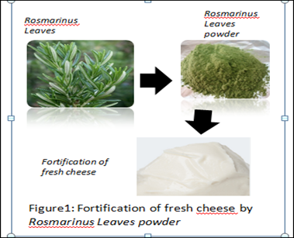
Figure 1. Fortification of fresh cheese by Rosmarinus leaves powder.
Biography
Lila Boulekbache Makhlouf has her expertise in food processing and green chemistry.

