Antimicrobial susceptibility pattern of Neisseria gonorrhoeae isolated from male patients attending Biryogo Health Centre in Kigali, Rwanda
Alain Iradukunda M
University of Nairobi, Kenya
Abstract
Background: Neisseria gonorrhea is a sexually transmitted bacterium that causes gonorrhea. Emergence and spread of drug resistance in Neisseria gonorrhea is a public health concern globally.
Objective: To determine antimicrobial susceptibility pattern of Neisseria gonorrhea isolated from male patients attending Biryogo Health Centre/Kigali-Rwanda.
Materials and methods: A descriptive cross-sectional study design was used; the target population was 385 of men attending the clinic. Penile discharge, painful urination is inclusion criteria. Questionnaires were used to collect information. Samples of urethral swabs were collected from men aged between 18-60 years old using Dacron swab and analyzed to WIWO Hospital-Kigali. Cultures were done on Thayer Martin media for Neisseria gonorrhea and E-Test strips were used perform antimicrobial susceptibility on growth culture. Significance was set at p value less than 0.05. SPSS v22 was used for data analysis.
Results: 46% of participants have not used the antimicrobial agents, 22% didn’t know the type of antibiotics taken, only 19% expect to be cured by antibiotics. People working in private were more exposed to Neisseria gonorrhea [OR 006; 95% CI=0.001-0.312; P=0.006]. No use of condom increases the risk of Neisseria gonorrhea [OR 2.33 95% CI=0.804-6.754 p=0.119]. Married people used condoms more than 4 times compared to others.
S: Sensitivity, I: Intermediate, R: Resistance.
The MIC analysis from E-Test revealed that Ceftriaxone has S:0.08, I:0.2 and R:0.8. Cefixime has S:0.1, I:0.25, R:0.78. Azithromycin has S:0.15, I:0.6 and R:1. Ciprofloxacin S:0.016, I:0.6 and R:3. Doxycycline has S:0.03, I:1.1 and R:3.1. Cefixime and ceftriaxone has the highest sensitivity and should be used in treatment of Neisseria gonorrhea. Many antibiotics showed resistance due to self-prescription.
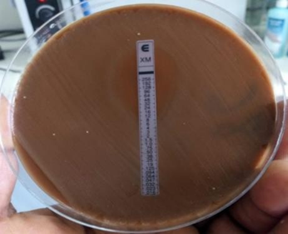
Figure 1. Tested for E-test using Cefixime.
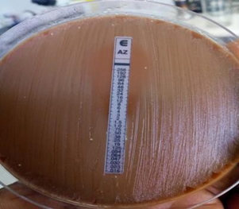
Figure 2. Tested for E-test using Azithromycin.
These are two examples of different E-tests strips used for testing antimicrobials susceptibility by determining the MICs of each drugs in this study [Figure 1-2].
Biography
Alain Iradukunda Mahoro have his expertise in evaluation and passion in improving the health and wellbeing of human, special in Antimicrobial resistance as bacterial resistance is still a global concern and in microbiology in general as Specialist. He is open and committed to acquired new knowledge and creates new pathways for improving the effectiveness of healthcare field and reduction of antimicrobial resistance in community. He has built this model with many years of experience participating in research, evaluation, teaching and administration both in hospital and education institutions.

