Climate change impact on water resources availability in the Kiltie watershed, Lake Tana Sub-Basin, Ethiopia
Melsew A Wubneh
University of Gondar, Ethiopia
Abstract
The impact of climate change on water resource availability in watersheds must be assessed to ensure multipurpose water security. For RCP4.5 and RCP8.5 of the 2040s and 2070s time periods, the influence of climate change on water availability of the Kiltie watershed was assessed using an ensemble of two global climate models (MIROC and MPI) and one Regional Climate Model (RCA4). The HBV hydrological model, which requires less data and is mostly used in data-scarce areas, was used to simulate flow. RVE (Relative Volume Error) of -1.27% and 6.93% (in the range of -10% to 10%) and NSE of 0.63 and 0.64 (higher than 0.6) are found in the model calibration and validation results, respectively. Future Seasonal Water Availability under the RCP4.5 scenario for the 2040s increase between 1.1 mm and 33.2 mm with the greatest increase in August and decrease in a range from 0.23 mm to 6.89 mm with a maximum decrease in September. For the 2070s water availability increases between 7.2 mm and 56.9 mm with maximum increments in October and decreases in July by 9 mm. For RCP8.5 of 2040s future water availability increases between 4.1 mm and 38.8 mm with maximum increment in August and decreases between 9.8 mm and 31.2 mm with maximum decrements in the spring seasons. For the 2070s of RCP8.5 water, availability increases in a range from 2.7 mm to 42.4 mm with maximum increments in August and shows decrements in a range from 1.8 mm to 80.3 mm with showing maximum decrements in June. This research found that future climate change will increase water availability during the rainy season, indicating the need for water storage structures to use excess water for dry agriculture. As future water availability reduces during the dry seasons, a water resource and land use land cover management plan for the watershed should be developed soon [Figure 1].
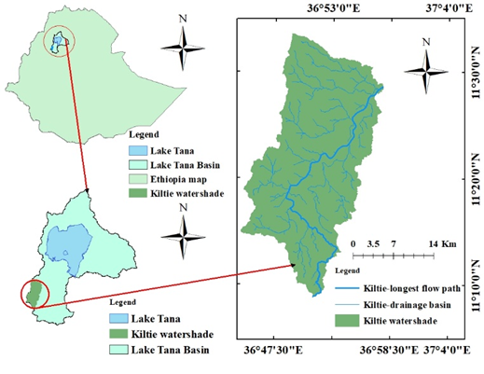
Figure 1. Description of the study area.
Biography
Melsew Amsalu wubneh is from Gondar, Ethiopia. He attended his primary and secondary school in Gondar. And after finishing secondary school he joined Wollo University and graduated in 2015 with Water resource and Irrigation Engineering Department. He graduated with his MSc degree in Hydraulic and water resource engineering at Bahir Dar University in 2020. Currently, he is working as a lecturer and researcher at the University of Gondar department of Hydraulic and water resource engineering. His task at the university is to focus on teaching, doing research and community service. Now he has published around six papers in well peer-reviewed journals. His interest is to be international researcher in the area of earth and climate change.

