Esthetics and cosmetics in prosthodontics
Eman Helal
National Research Centre, Egypt
Abstract
Our everyday lives are full of esthetic experiences. Uncountable decisions depend on the esthetic appeal of the available options. The Oxford English Dictionary (OED) defines ‘esthetic’ as “concerned with beauty or the appreciation of beauty”, Dental esthetics is the application of the principles of esthetics to the natural or artificial teeth and restorations. Nowadays, owing to patients’ increasing esthetic demands and expectations, the natural appearance of the prosthesis has become an important outcome measure for defining the success of restoration therapy.
The difference between Cosmetic and Esthetic prosthodontics is that Cosmetic prosthodontics implies treatment that is done strictly for visual appearance that may not be considered essential such as Veneers, Cosmetic crowns as well as teeth whitening. On the other hand, Esthetic prosthodontics uses an approach that helps to solve more complicated problems such as missing teeth or missing part of maxillary or mandibular jaws that both fixes the problem from a functional standpoint, but also helps the patient to look and feel better it also requires harmony and balance. In other words, esthetic prosthodontics is a more broad approach than cosmetic prosthodontics.
The demand for cosmetic dental prosthetics has grown considerably during the last few years. Rush-to-market products, media-driven ideas, as well as dentists keen to please, have formed a challenge for the dentist to calculate benefits/risks ratio for every single treatment modality. For this reason this presentation investigated the traditional and recent techniques and materials in different branches of prosthodontics that helps to give the patient the most esthetically satisfying dental experience.
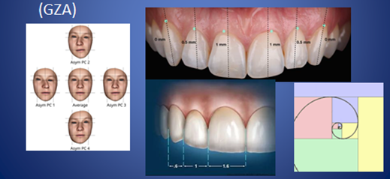
Figure 1.
Biography
Eman Helal has her expertise in prosthodontics; she earned her Master and PhD of prosthodontics (2012-2017). She taught removable prosthodontics in different universities in Egypt and United Arab Emirates, she published over fifteen papers in local and international journals.

