Assessment of antioxidant and antimicrobial activities of Ziziphus leaves extract and its pharmaceutical applications
Richa Mishra
Dr. Ramamohar Lohia Avadh University, India
Abstract
Ziziphus mauritiana, also known as Indian jujube and is a tropical fruit tree species belonging to the family Rhamnaceae. In India, there are 90 or more cultivars, varying in the habit of the tree; leaf shape; fruit form, size, color, flavor and keeping quality; and fruiting season. Plant is used in the treatment of in fever, indigestion, liver disease, diarrhea, wound healing and jaundice and have various pharmacological properties. Ziziphus mauritiana is recognized for traditional uses in different areas such as its fruits are consumed globally. The aim of the present study were to measure the presence of different bioactive compounds in leaf of Ziziphus mauritiana plant and to explore its antioxidant potential by assaying free radical scavenging activity, superoxide anion radical scavenging activity and reducing power. The study was further carried out to assay the antimicrobial properties by disc diffusion method to ascertain its pharmaceutical application. The results of the present study showed the presence of high phytochemical constituents such as ascorbic acid, total phenolic, flavonoids and carotenoids in leaf. Methanolic leaf extract showed that it has significant antioxidant potential and antibacterial activity against pathogenic bacteria. Hence, results obtained in the present study suggest that leaves of Ziziphus can be used as a source for functional ingredients for nutraceutical/pharmaceutical drug industries to treat the diseases induced by the oxidative stress [Figure 1].
Keywords: Ziziphus mauritiana, Antioxidant, Antimicrobial, Pharmaceutical.
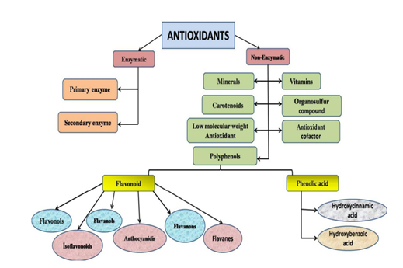
Figure 1. Classification of antioxidant.
Biography
Richa Mishra is pursuing PhD in department of Biochemistry from Dr. Rammanohar Lohia Avadh University Ayodhya Uttar Pradesh (India U.P.). Currently she is working on the ‘‘Morphological, Biochemical and Molecular characterization of Ziziphus leaves species” and complete Analysis of antioxidant and antimicrobial activities of Ziziphus leaves species.

