Density functional theory and molecular dynamics simulation support newly designed reversible tyrosine kinase inhibitors targeting double mutant Epidermal Growth Factor Receptor (EGFR)
Dorra Driss*, Fakher frikha and Mohamed Sami Aifa
University of Sfax, Tunisia
Abstract
Non-Small Cell Lung Cancer (NSCLC) is a leading cause of death in the world. Epidermal Growth Factor Receptor (EGFR) is a well-characterized oncogene that was shown to be implicated in the development of NSCLC via the acquisition of the L858R activating substitution. In this work, we aimed to identify novel reversible double mutant EGFR TKIs via an in silico approach. First, a compound library containing more than 150000 kinase inhibitor analogs was subjected to an initial filtering step. The remaining molecules were tested via high-throughput virtual screening that was carried out to identify the best inhibitors. Following this, a total of 15 hits were retained and their binding interactions and ADMET properties were determined. Finally, molecular dynamic studies were performed for the top 10 scoring compounds. Simulation analysis revealed that both molecules possessed interesting characteristics in terms of RMSD, RMSF, radius of gyration and hydrogen bonds formation. Of note, this study evaluated and established a library of compounds, top ranked virtual hit compounds binding reversibly to the double mutant EGFR enzyme can act as potent newly designed EGFR inhibitors in management of mutations of non-small cell lung cancer [Figure 1].
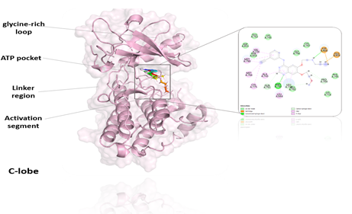
Figure 1. Simulation interaction diagram (2D) of best hit with the protein. Interactions that occur more than 30.0% of the simulation time in the selected trajectory (0.00 through 100.00 nanosecond).
Biography
Dorra Driss is currently working as an assistant Researcher at Centre of Biotechnology of Sfax CBS-Sfax, University of Sfax. She does research in Engineering, Biochemistry Computer Science and Signaling pathways science. Hers current projects are Targeting EGFR family kinases: development of new molecules: design, synthesis and in vitro assays and Generating Active Human Kinases (ERBB family) Using Pichia Pastoris As A Host For Functional Assays And For Drug Discovery Purposes Investigating Possible Inhibitors That Can Be Used As Anticancer Agents.

