Replacing animal protein with soy-pea protein in an "American Diet" controls murine crohn disease-like ileitis regardless of firmicutes: Bacteroidetes ratio
Abigail Raffner Basson
Case Western Reserve University, USA
Abstract
Statement of the problem: The current nutritional composition of the "American Diet" (AD; also known as Western diet) has been linked to the increasing incidence of chronic diseases, including Inflammatory Bowel Disease (IBD), namely Crohn Disease (CD). This study investigated which of the 3 major macronutrients (protein, fat, carbohydrates) in the AD has the greatest impact on preventing chronic inflammation in experimental IBD mouse models.
Methodology: We compared 5 rodent diets designed to mirror the 2011-2012 "What We Eat in America" NHANES. Each diet had 1 macronutrient dietary source replaced. The diets were AD, ADsoy-pea (animal protein replaced by soy+pea protein), AD-CHO ("refined carbohydrate" by polysaccharides), AD-fat [redistribution of n-6:n-3 PUFA ratio: ̴10:1 to 1:1] and AD-mix (all 3 "healthier" macronutrients combined). In 3 separate experiments, 8-wk-old germfree SAMP1/YitFC mice (SAMP) colonized with human gut microbiota ("hGF-SAMP") from CD or healthy donors were fed an AD, an AD- "modified," or chow diet for 24 wk. Two subsequent dextran sodium sulfate-colitis experiments in hGF-SAMP (12-wk-old) and Specific Pathogen-Free (SPF) C57BL/6 (20-wk-old) mice and a 6-wk feeding trial in 24-wk-old SPF SAMP were performed [Figure 1].
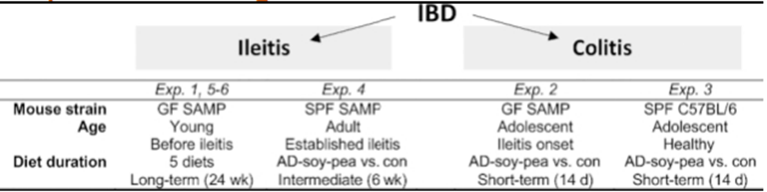
Figure 1. Experimental design.
Findings: The AD-soy-pea diet resulted in lower histology scores [mean ± SD (56.1% ± 20.7% reduction)] in all feeding trials and IBD mouse models than did other diets (P<0.05). Compared with the AD, the AD-soy-pea correlated with increased abundance in Lactobacillaceae and Leuconostraceae (1.5-4.7 log2 and 3.0-5.1 log2 difference, respectively), glutamine (6.5 ± 0.8 compared with 3.9 ± 0.3 ng/μg stool, P=0.0005) and butyric acid (4:0; 3.3 ± 0.5 compared with 2.54 ± 0.4 ng/μg stool, P=0.006) concentrations and decreased linoleic acid (18:2n-6; 5.4 ± 0.4 compared with 8.6 ± 0.3 ng/μL plasma, P=0.01).
Conclusion: Replacement of animal protein in an AD by plant-based sources reduced the severity of experimental IBD in all mouse models studied, suggesting that similar, feasible adjustments to human diets could help control/prevent IBD in humans.
Biography
Abigail R Basson is a registered dietitian and NIH-funded instructor in the Department of Nutrition and Division of Gastroenterology at Case Western Reserve University and a clinical dietitian for the Preventive Medicine Center at Cleveland Clinic, Cleveland USA. Her expertise is in basic mechanisms of inflammatory bowel disease and dietary manipulation of disease severity in mouse models and in human clinical trials. The overarching goal of her work is to translate scientific knowledge and discoveries into applied knowledge that can be disseminated at the community level. Her work challenges the traditional paradigm of a ‘one size fits all’ diet approach and underscores the importance of quantifying person-specific host and microbiota dietary responses into personalized diets that are of benefit to the individual.

