Effect of different machining processes on the bearing strength of pin-loaded textile composite panels for automotive: Experimental and FEM analysis
Sandeep Olhan* and BK Behera
Indian Institute of Technology Delhi, India
Abstract
This research examines the influence of various machinability processes, including drilling, abrasive water jet machining and laser beam machining along with various fibre architectures on the behavior of machined holes, bearing strength and failure mechanisms of various textile structural composites produced from different textile structures such as chopped fibre, Unidirectional (UD), Bidirectional (2D) and Three-Dimensional (3D) orthogonal woven structures using glass, basalt and sisal fibres suitable for automotive applications. Optical microscopic examination was used to evaluate morphological damage and fractography of the produced composite materials. In comparison to glass fibre reinforced textile structural composites and sisal fibre reinforced textile structural composites, experimental findings showed that basalt fibre reinforced textile structural composite specimens had the highest bearing strength for all processes. The bearing strength of composites was in the order of 3D>chopped>2D>UD, respectively. In addition, a novel systematic mechanics-based approach was developed using SOLIDWORKS to create a mesoscale finite element model to analyse the bearing strength of pin-loaded textile structural composites. The woven-based composite material damage modes were predicted using the well-known 3D Hashin's failure and Puck's failure models, which were implemented via a user subroutine in conjunction with LS-DYNA. The bearing response predicted by the FEM simulation was found in a good agreement with the experimental findings (Figure 1).
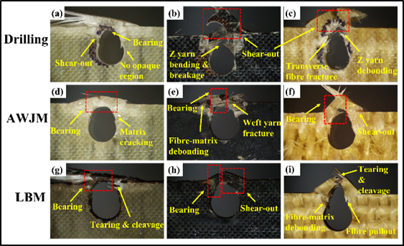
Figure 1. Microscopic fracture images of different 3D composites machined by drilling, AWJM and LBM process: (a) DG-3D; (b) DB-3D; (c) DS-3D; (d) WG-3D; (e)WB-3D; (f) WS-3D; (g) LG-3D; (h) LB-3D; (i) LS-3D.
Biography
Sandeep Olhan is pursuing a PhD at the Indian Institute of Technology (IIT), Delhi. He obtained M. Tech Degree in Mechanical Engineering (2011). He completed graduation in Mechanical Engineering (B. Tech) in 2009. His current research focuses on the development of textile fibre reinforced polymeric composites, metal matrix composites, hybrid composites, nanocomposites, natural fibre reinforced composites and 3-D composites for automotive applications. He has authored five peer-reviewed papers published in International Journal publications, one book chapter and several others under communications. He has visited the Technical University of Liberec (TUL), Czech Republic and Kyoto Institute of Technology, Japan, to attend the International Conference (TRS) in 2019 and 2022. He has a rich blend of teaching and technical experience in the field of mechanical engineering, material testing and composite processing and characterization. He was awarded a gold medal for his commendable performance during his M. Tech from university.

