Inhibitory effect of natural honey on the growth of Rhizopus stolonifer, Mucor spp. and Aspergillus niger
Sarah Saad Alamer¹*, Sozan Mohamed Fadl¹ and Reham Mosleh Alahmadi²
¹AlMaarefa University, Saudi Arabia
²King Saud University, Saudi Arabia
Abstract
Honey is used in many countries as an antiseptic and therapeutic agent for many infections. The chemical and physical properties of honey have inhibitory effects on a lot of microorganisms including fungi. Rhizopus stolonifer, Mucor and Aspergillus niger are common bread molds. During growth on bread, they produce large numbers of spores that cause different types of infections especially in immuno-compromised patients. To evaluate the effect of natural honey on the growth of Rhizopus stolonifer, Mucor spp. and Aspergillus niger fungi. To determine the minimal inhibitory concentration of honey that can suppress the growth of these fungi. This was an experimental study conducted in College of Sciences in King Saud University during the period between August and November 2021 in Riyadh, KSA. Multifloral honey was diluted in sterile distilled water volume to volume (%, v/v) in series concentrations: 5%, 15%, 30%, 45% and 60%. It was then added to Potato Dextrose Agar (PDA). Measured parts of the colonies of Rhizopus stolonifer, Mucor and Aspergillus niger, were cultured on the prepared plates in duplications and were incubated at room temperature (25 ± 2°C). Fungal growth was monitored daily for three months. The 5%, 15%, 35% concentrations of honey mixed with PDA did not inhibit the fungal growth, the fungi started to grow within the first 24 h. On the other hand, the 60% dilute concentration killed the three fungi and completely inhibited their growth, the fungi were monitored for 3 months and during that time they did not grow (Figure 1). This study confirms that honey has a strong inhibitory effect on the growth of Rhizopus stolonifer, Mucor spp. and Aspergillus niger when used in concentration of 60% or above. Accordingly based on these findings we determine that the Minimal Inhibitory Concentration (MIC) of multifloral honey on bread fungi is 60%.
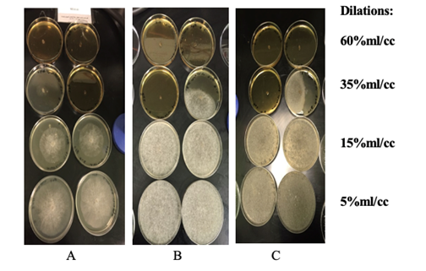
Figure 1. Evaluation of the antifungal activity of agar dilution by 5%, 15%, 35% and 60% ml/cc concentration of honey against Rhizopus stolonifer fungi. (A) Fungal growth after 24 h, (B) Fungal growth after 48 h, (C) Fungal growth after 72 h.
Biography
Sarah Alamer is affiliated to Almaarefa University, team leader in Almaarefa Medical Student Committee, interested in research and presentations, college of medicine leader in Almaarefa University student council.

