Related factors of bleeding events in ticagrelor-treated elderly patients with coronary artery disease
Shizhao Zhang* and Tong Yin
Chinese PLA General Hospital, China
Abstract
Objective: To analyze the related factors of bleeding events in ticagrelor-treated elderly patients with coronary artery disease.
Method: Patients aged ≥ 65 years diagnosed with coronary artery disease and treated with ticagrelor were enrolled. All patients were followed up to observe the occurrence of Bleeding Academic Research Consortium (BARC) ≥ 2 requiring clinical intervention within 1 year. Patients were divided into bleeding group (n=55) and bleeding-free group (n=328) according to the occurrence of BARC ≥ 2 bleeding events. Multivariate regression analysis was applied to analyze the related factors of bleeding events during ticagrelor treatment [Table 1].
Table 1. Baseline clinical characteristics of elderly patients treated with ticagrelor.
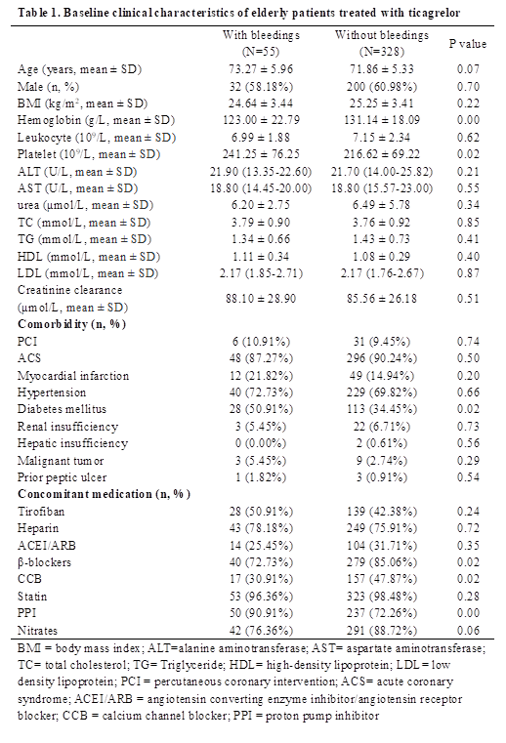
Results: A total of 383 patients with coronary artery disease were recruited in this study, with 39 cases (10.18%) diagnosed with stable coronary artery disease, 344 cases (89.82%) diagnosed with the acute coronary syndrome and 37 cases (9.66%) received PCI. The serum level of hemoglobin and ratio of used β-blockers and calcium ion channel blocking agents were significantly lower while the platelet count, incidence of type 2 diabetes and ratio of used proton pump inhibitors were significantly higher in bleeding group than in bleeding free group. Among the eligible patients, 55 (14.36%) had BARC ≥ 2 bleeding events [Figure 1] and 10 patients (2.61%) had BARC ≥ 3 bleeding events during a 1-year follow-up. Gastrointestinal bleeding was the most common bleeding event (47.27%, n=26). Multivariate regression analysis found that decreased hemoglobin content (OR:0.98, 95% CI:0.96-1.00, P=0.02), type 2 diabetes (OR:2.46, 95% CI:1.29-4.69, P=0.01), application of proton pump inhibitors (OR:4.53, 95% CI:1.62-12.72, P<0.01) and application of β-blockers (OR:0.42, 95% CI:0.20-0.89, P=0.02) were independently associated with BARC ≥ 2 bleeding events [Table 2].
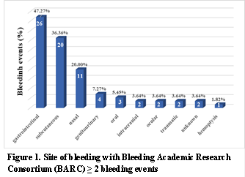
Figure 1. Site of bleeding with Bleeding Academic Research Consortium (BARC) ≥ 2 bleeding events.
Table 2. Effects of the related factors on the risk of bleeding events.
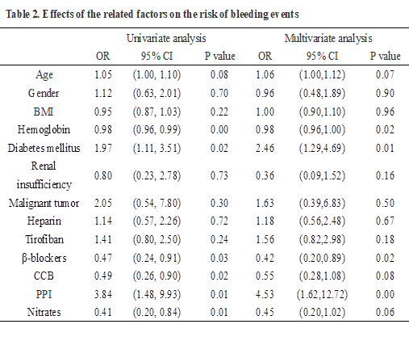
Conclusions: Hemoglobin, diabetes and concomitant medications are associated with the bleeding events in ticagrelor-treated elderly patients with coronary artery disease.
Biography
Shizhao Zhang has his expertise in evaluation and passion in investigating precision medicine for elderly patients diagnosed with coronary artery disease. He has formulated individualized polypharmacy for elderly patients based on the effect of gene mutations, so as to prevent potential drug–drug–gene interactions and improve the clinical outcomes.

