WPW syndrome: A mimicker for ventricular tachycardia
Indrajeet Mahata
University of Missouri, USA
Abstract
The accurate diagnosis and initial evaluation of Wide Complex Tachycardia (WCT) has been a clinical dilemma. The differential diagnosis includes Ventricular Tachycardia (VT), Supra-Ventricular Tachycardia (SVT with aberration and SVT with pre-excitation. Identifying the etiology of a WCT is important to provide appropriate therapy.
We are presenting a case of 69-year-old female who presented with cardiac arrest. She had a past medical history of morbid obesity, sleep apnea, hypertension and diabetes. She was found to have wide complex tachycardia; she had resuscitation per ACLS protocol with shock. She was transferred to our hospital for a defibrillator evaluation. Her echo showed left ventricular ejection fraction of 50%, which is low normal but otherwise normal. Coronary angiography revealed non obstructive coronary artery disease.
Her Electro-Cardio-Graphy (ECG) showed Sinus rhythm with a short PR and a delta wave (Figure 1). Further, review of sentinel event suggested WCT but that there was beat to beat variation. Further the QRS duration varied from beat to beat. These findings suggested atrial fibrillation with pre-excitation. This was called Wolf Parkinson white syndrome in the past. She was subsequently taken for an Electro-Physiology Study (EPS). During her EPS she was found to have anterograde conduction from the atrium to the ventricular through an accessory pathway. Meticulous 3D mapping localized the accessory pathway to be in infero-septal region. Radiofrequency ablation was performed at this region to eliminate the accessory pathway. Subsequently she did not develop any wide complex tachycardia.
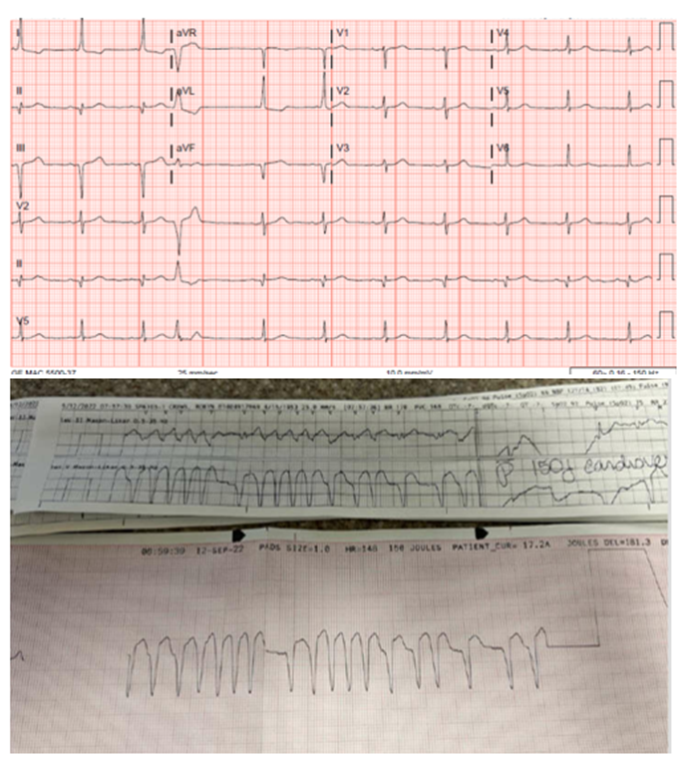
Figure 1. Electro-Cardio-Graphy (ECG) showing sinus rhythm with a short PR and a delta wave.
Conclusion: The differential diagnosis of WCT might be challenging and includes both ventricular and supraventricular tachycardia’s. The awareness of this ECG finding needs to be spread in practicing physicians. If the initial ECG poses a diagnostic challenge then an EP study should be offered before ICD implantation.
Biography
Indrajeet Mahata is an Assistant Professor at University of Missoui, MO, USA. He has been in academics for the last 15 years. He completed his Medicine residency at University of Illinois; he completed a fellowship in cardiology at Tulane University and then went on to pursue a fellowship in Electrophysiology in Ochsner medical Centre/University of Queensland. He has been teaching students since. He is a full member of Sigma XI. Also he holds a FACC and FHRS certification. He is passionate about SVT and atrial fibrillaton and the diagnosis and treatment of the same.

