Contact lens as evidence in crime scene: A way to identify gender
Manisai Koduri*, Pravallika Vataparthi, Nikhila Bolleda, Vijaya laxmi Golla, Sravani Mereddy, and Sony Gunaganti
Centurion University, India
Abstract
Introduction: Identifying Barr bodies' presence has a significant diagnostic value in multifaceted science disciplines. Testing Barr bodies found to be important in diagnosing infertility, a syndromic association such as Klinefelter and psychopathic disorders, and Disorders of Sex Development (DSD). It also plays a role in cancer detection in the uterine cervix, identifying transplanted retinal pigment epithelium in porcine models. Identifying the gender of victims or criminals becomes a fundamental requirement in any forensic analysis of a crime scene. The current study hypothesizes identifying the gender using Barr body detection from collected contact lens samples and tries to establish disposed soft contact lenses to consider as evidence found at the crime scene.
Methods: A total of 120 (60 males and 60 females) were included in the study; from each subject, contact lens and Buccal samples were collected using sterile wooden toothpicks and soft contact lenses after insertion and removal. Both the buccal and contact lens samples were built into two smears staining with Saffranine and Methylene blue stains. The smears underwent cytological assessment by two examiners using a binocular microscope at 40X. The details of findings were graded on a scale of 1 to 5 based on visualization of Barr bodies seen [Figure 1].
Results: The mean rank and median scores of grading for higher using saffranine among females across both the samples. The sensitivity is higher at 100% for both the stains among contact lens samples and specificity is higher among buccal samples, 93% for saffranine and 90% for methylene blue.
Conclusion: Overall, it is conspicuous that contact lenses can be considered as evidence found in the crime scene in identifying the gender using Barr body detection.
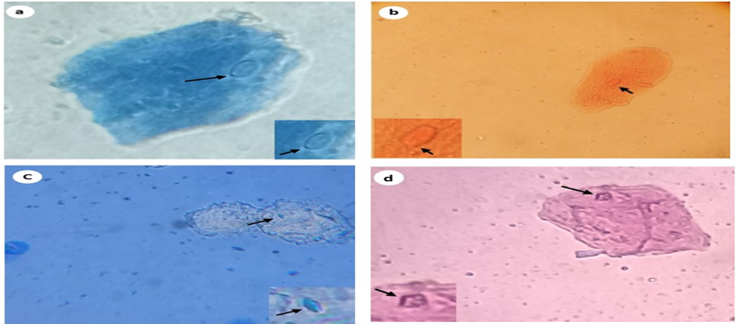
Figure 1. Cytological smears with cells positive for Barr bodies (X40). (a) Methylene Blue stain Buccal cells with Barr Body. (b) Saffranine stained Buccal cells with Barr body. (c) Methylene Blue stained ocular surface cells from contact lens with Barr body. (d) Saffranine stained ocular surface cell from contact lens evidencing Barr body. The insets show the nuclei with Barr body of the respective cells.
Biography
Manisai Koduri is a university gold medalist. He completed his Integrated Master of Science in Optometry and Vision Science from the University of Hyderabad. He was exposed to his Initial clinical career at LV Prasad Eye Institute, Hyderabad. He is passionate about academics, clinics, and research. He aims to extract novel research data findings without using sophisticated instrumentation and takes the help of basic instrumentation. Currently, he is an assistant professor in the department of Optometry at Centurion University. He teaches Clinical examination of Visual system, Advanced Contact lens fittings in addition to his research activities at the department. His current areas of research are Drug toxicity, Pesticide toxicity, Dry eye, Multidisciplinary forensic approach etc.

