Aerobic exercise training: Prevention of atherogenesis induced by low-sodium diet in LDL receptor knockout mice
Ana Paula Garcia Bochi
University of Sao Paulo, Brazil
Abstract
Objective: To investigate the efficacy of Aerobic Exercise Training (AET) in the prevention of dyslipidemia, Insulin Resistance (IR), and atherogenesis induced by severe Low-Sodium (LS) diet.
Approach and results: LDL Receptor Knockout (LDLR KO) mice were fed a Low-Sodium (LS) (0.15% NaCl) or Normal-Sodium (NS; 1.27% NaCl) diet, submitted to AET in a treadmill, 5 times/week, 60 min/day, 15 m/min, for 90 days, or kept sedentary. Blood Pressure (BP), plasma Total Cholesterol (TC) and Triglyceride (TG) concentrations, lipoprotein profile, and insulin sensitivity were evaluated at the end of the AET protocol. Lipid infiltration, Angiotensin II type 1 receptor (AT1), Receptor for Advanced Glycation End products (RAGE), Carboxymethyllysine (CML), and 4-hydroxynonenal (4-HNE) contents as well as gene expression were determined in the brachiocephalic trunk. BP and TC and gene expression were similar among groups. Compared to the NS diet, the LS diet increased vascular lipid infiltration, CML, RAGE, 4-HNE, plasma TG, LDL-cholesterol, and VLDL-TG. Conversely, the LS diet reduced vascular AT1 receptor, insulin sensitivity, HDL-cholesterol, and HDL-TG. AET prevented arterial lipid infiltration; increases in CML, RAGE, and 4-HNE contents; and reduced AT1 levels and improved LS-induced peripheral IR [Figure 1].
Conclusion: The current study showed that AET counteracted the deleterious effects of chronic LS diet in an atherogenesis-prone model by ameliorating peripheral IR, lipid infiltration, CML, RAGE, 4-HNE, and AT1 receptor in the intima-media of the brachiocephalic trunk. These events occurred independently of the amelioration of plasma-lipid profile, which was negatively affected by the severe dietary-sodium restriction.
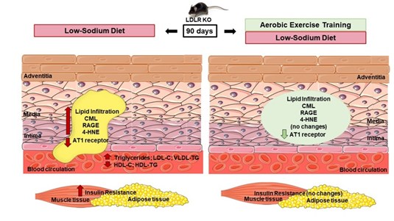
Figure 1. Effects of low-salt diet and aerobic exercise training on arterial wall, muscle and adipose tissue in LDLR KO mice. On the left side: low-sodium (LS) diet increased vascular lipid infiltration, CML, RAGE, 4-HNE, plasma TG, LDL-C, VLDL-TG and peripheral IR in LDLR KO mice. Conversely, LS diet reduced vascular AT1 receptor, HDL-C and HDL-TG. On the right side: AET prevented the LS-induced arterial lipid infiltration, the increase in CML, RAGE and 4-HNE contents, reduced AT1 receptor level and improved LS-induced peripheral IR, after 90 days of intervention.
Biography
Ana Paula Garcia Bochi studied veterinary medicine with a specialization in endocrinology and metabology in dogs and cats. She holds a master's degree in science from the endocrinology program of the medicine department of the University of Sao Paulo. She has been working as a veterinary doctor at her own clinic. She has been working on research at University of Sao Paulo (Brazil) in the area of low-salt diet, atherogenesis and physical exercise, since 2014. She has published in co-authorship on this line of research in hepatic and muscular tissue.

