Innervational surgery for supranuclear monocular elevation deficiency with horizontal strabismus: A paediatric case report and review of the literature
Lin Chen* and Xiao jiao Tang
Children's Hospital of Chongqing Medical University, China
Abstract
Monocular Elevation Deficiency (MED) is an ocular motility disorder characterized by the inability to elevate one eye in abduction, adduction and primary gaze, previously known as Double Elevator Palsy (DEP). Various surgeries include Knapp procedure or modified Knapp, inferior rectus recession, Modified Nishida’s procedure and superior rectus recession on the contralateral eye depending on the classification. A paediatric case of Supra Nuclear Palsy (SNP) MED associated with significant horizontal deviation and co-existent the Inferior Oblique Muscle Overaction (IOOA) in the contralateral eye is described. We corrected 40 Prism Diopter (PD) of horizontal deviation and 25 PD of vertical deviation and simultaneously corrected IOOA with an innervational surgery combination with horizontal rectus recession [Figure 1].
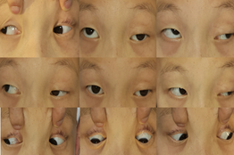
Figure 1. Preoperative photos.
Contralateral superior rectus recession based on innervational principle provides an appealing alternative treatment for SNP MED and MED with significant horizontal deviation cases [Figure 2].
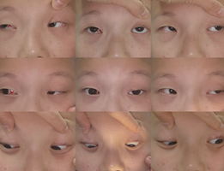
Figure 2. Postoperative photos.
Biography
Lin Chen, Doctor Degree in Ophthalmology, professional postgraduate tutor. She has been engaged in clinical and basic research of children's ophthalmology for 17 years. She is currently a youth member of the Ophthalmology Committee of the Chinese Women's Medical Association and the member of the pediatric ophthalmology Group of the Ophthalmology Committee of the Chongqing Medical Association. Presided and completed 1 project for the Youth Fund of the National Natural Science Foundation of China. Her research articles have been published in Am J Ophthalmol, Ophthalmology and Therapy, Eur J Ophthalmol, Acta Ophthalmol and other journals. Her research interests are in pediatric ophthalmology, ocular surface diseases, refractive errors and strabismus surgery.

